OPERATIONAL MANUAL

Supplier's Personal Office

CONTENTS
1. Purpose 3
2. Entry into the SAP NetWeaver Portal electronic platform 4
3. Overview of the contact data on the Supplier 6
4. Publishing the documentation in the Personal Office 8
5. Using the documentation from the Personal Office in SRM procedures 12
6. Sending notifications from the Personal Office 12

- Purpose
This manual defines the process of using the Supplier's Personal Office on the SAP NetWeaver Portal "NIS j.s.c. Novi Sad" electronic platform.
This manual is intended to describe the Supplier's work when performing the following activities:
- entry into the SAP NetWeaver Portal "NIS j.s.c. Novi Sad" electronic platform;
- publishing and updating the documentation in the Personal Office;
- using the documentation from the Personal Office in the MTR and Service Supplier selection procedures.

- Entry into the SAP NetWeaver Portal electronic platform
After successfully completing the registration procedure and obtaining an individual log in and password, an access to the "NIS j.s.c. Novi Sad" electronic platform is done through the link https://srm.nis.rs
The link is available for the transition to the instructions with a description of the necessary actions for work with the Supplier's Personal Office.
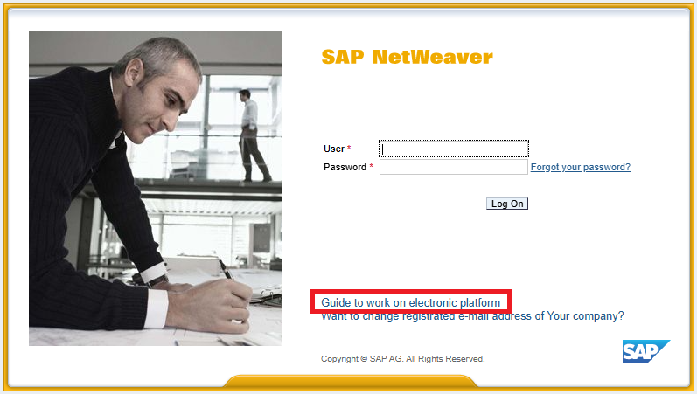
By clicking the link to view and download, special instructions for the Supplier are available, in Serbian, English and Russian.
After successful entry into the SAP NetWeaver Portal, the user receives an access to the Supplier's individual workplace on the "NIS j.s.c. Novi Sad" electronic platform, which contains several available applications for use. This manual describes the actions required for the work with the Supplier's Personal Office:
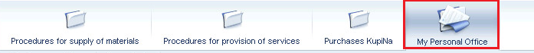
- Overview of the contact data on the Supplier
The Personal Office contains two tabs: the "My Documentation" tab, where the documentation is uploaded, which can later on be used when participating in the SRM procedures for the MTR and Service selection, and the "My Contacts" tab.
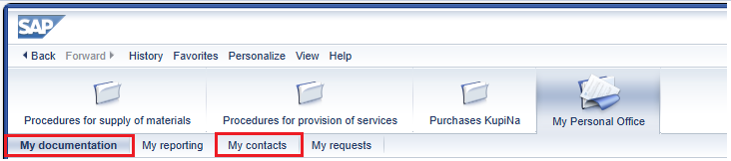
The "My Contacts" tab displays general information:
- name of the Supplier;
- list of e-mail addresses from the directory of the qualified suppliers of NIS j.s.c. Novi Sad.
This information cannot be changed. In the "My Contacts" tab, it can be set to which addresses the notifications from the Personal Office (notifications on the expiration of the validity period of the documents contained in the Personal Office) will be sent to. By default, sending is done to e-mail addresses from the directory of the qualified suppliers of NIS j.s.c. Novi Sad:
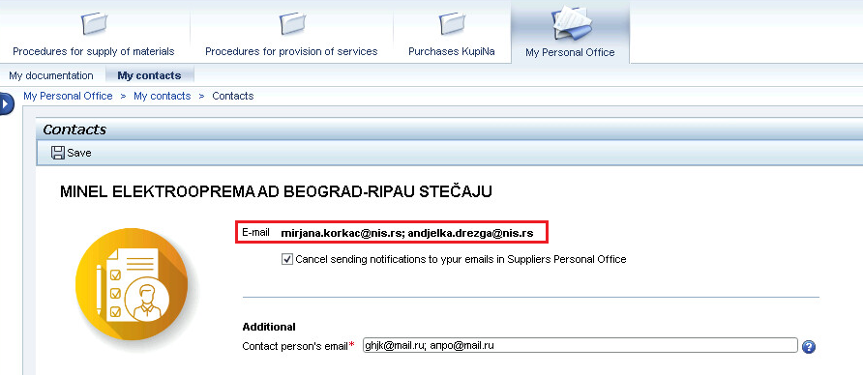
Also, it is possible to specify the additional e-mail addresses to which notifications will be sent, in the field:
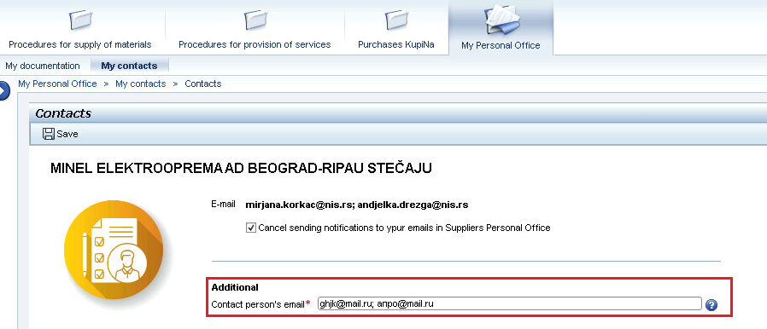
If the indicator is entered into the field, sending will be done only to the additional e-mail addresses. If the indicator is activated, then it will be mandatory to specify the additional e-mails. Otherwise, when saving data by using the button , the system displays an error message:
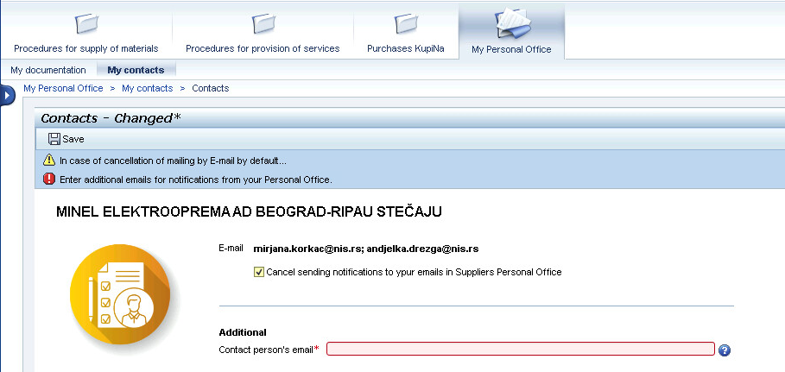
After specifying the additional e-mail addresses of the contact person, save the data by clicking the button . The information message will appear: .
In case of an inactive indicator in the field , notifications will be sent to e-mail addresses from the directory of the qualified suppliers of NIS j.s.c. Novi Sad, as well as to the additional e-mail addresses.
- Publishing the documentation in the Personal Office
The "My documentation" tab displays a list of document types for which the documentation can be published.
To upload documents, it is necessary to click the button . Depending on the type of the document, when downloading it, you need to specify the validity period of the documentation (start date and expiration date of the document) and/or select the company with which the downloaded document has been signed.
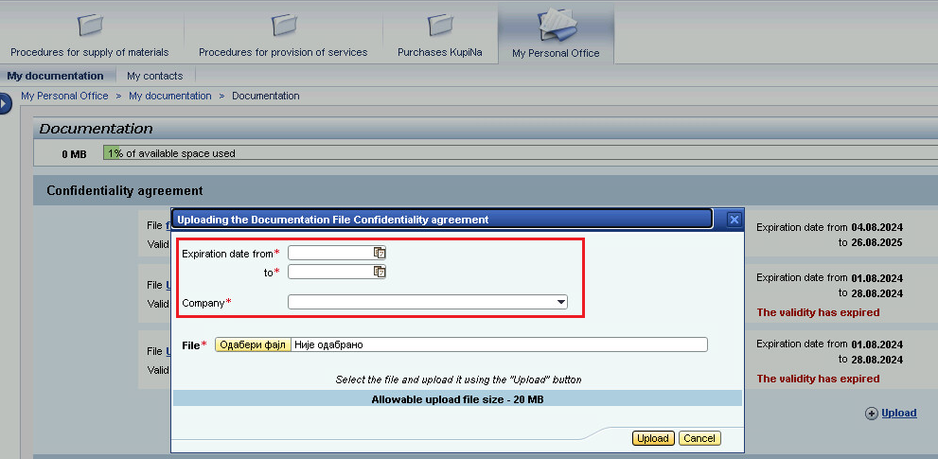
When specifying the document validity dates, the system performs a series of checks:
likewise, the obligation to fill in the field is checked:
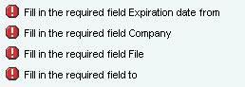
Note. The allowed size of one attached file is 20 MB, while the total size of the Personal Office storage is 250 MB.
Personal account shows the current percentage of storage used out of the total volume:
When 70% of storage is used, the line turns yellow:
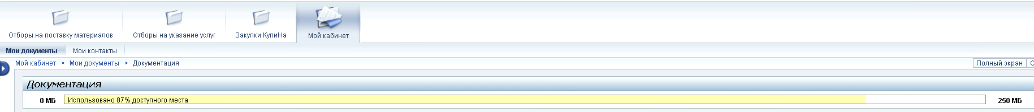
When 90% of storage is used, the line turns red:
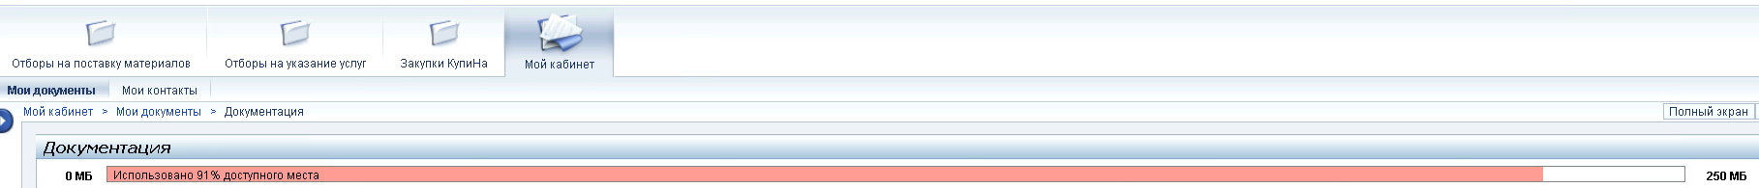
Fill in all the required fields on the File Upload screen, select the application file from your PC and click the button :
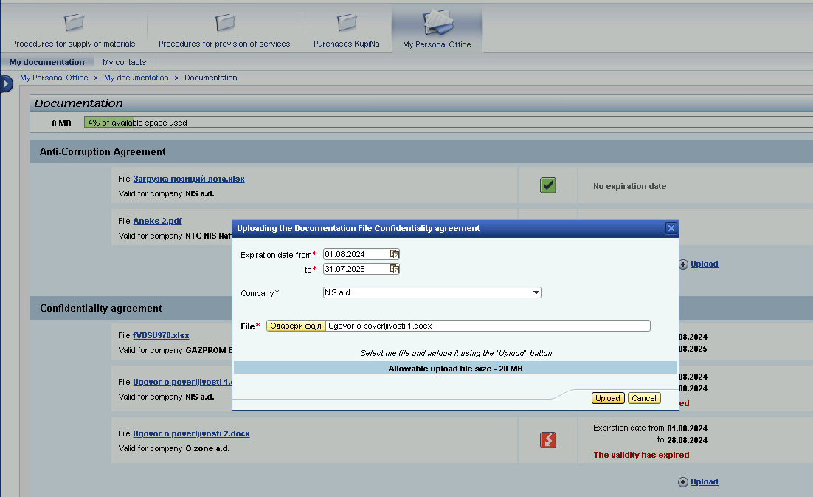
Attention! For some document types, the possibility to attach only one file for each Company may be defined. If one of the Companies already has a file loaded, then, when trying to load another one, an error message will be displayed: .
The validity periods of the attached documents are monitored in the Personal Office:
- if there is less than a month left until the expiration of the document validity period, then the following sign will appear for the document ;
- if the document has already expired, then the following sign will appear ;
- if the document is with a valid deadline, the following sign will appear ;
- if no validity period is specified for the document, then the same sign will appear .
To view the attached file, it is necessary to click the name of the document in the "File" field, the document will be opened for overview:
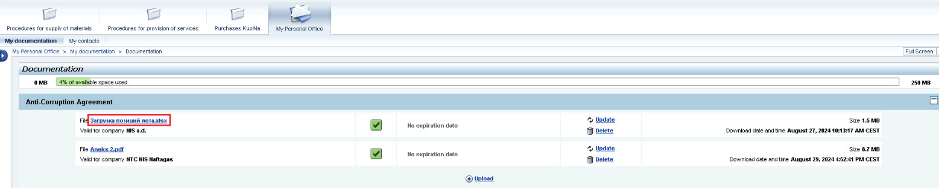
In order to update the attached file, it is necessary to click the button : a window will open for uploading a new document and indicating its current validity period, the Company code will be pre-filled with the previously entered value:
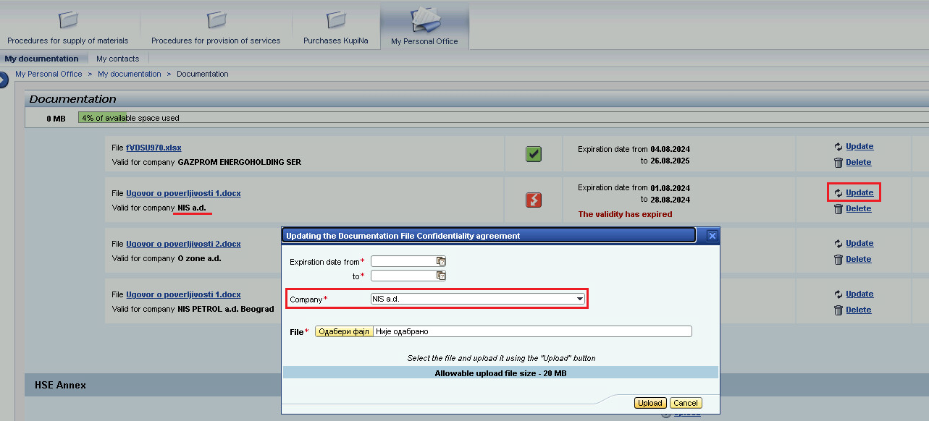
To delete the attached file, it is necessary to click the button . Confirm the deletion in the open window, after which the file will be deleted:
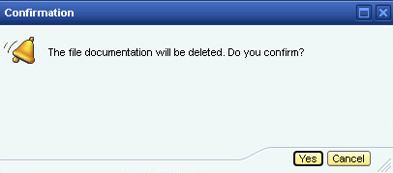
- Using the documentation from the Personal Office in SRM procedures
The documentation published in the Supplier's Personal Office can be used when submitting a proposal to participate in the SRM selection procedures for MTRs and Services - "Selection for the procurement of materials" and "Selection for the provision of services" tabs on the SAP NetWeaver Portal "NIS a.d. Novi Sad" electronic platform.
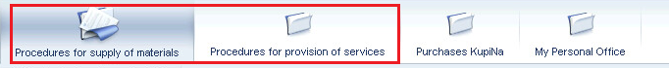
Note. A detailed description of the steps for participation in SRM procedures is given in the instruction "Instruction for suppliers SAP SRM portal usage".
- Sending notifications from the Personal Office
Notifications are sent automatically from the Supplier's Personal Office for the following events:
- there is less than a month left until the expiration of the document validity period, published in the Personal Office:
- the validity period of the documents published in the Personal Office has expired.
Notifications are sent only once for each document and event.
Examples of notifications sent are listed below.
Less than a month left until the expiration date:
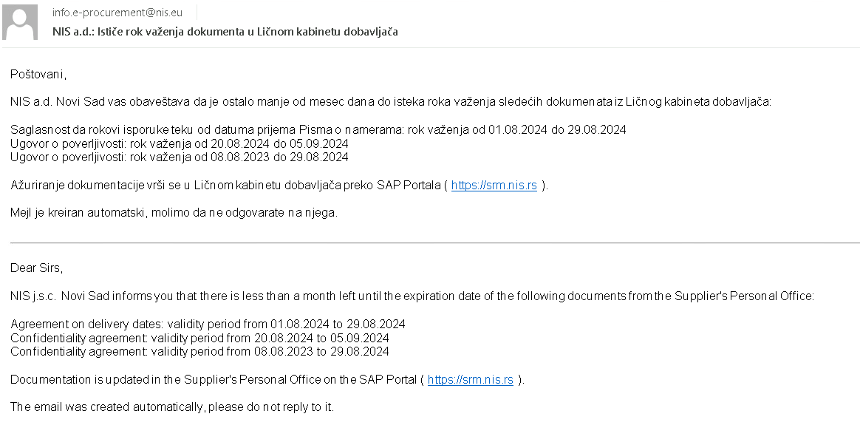
The documents have expired:
