Shortened Operating Procedure

Registration procedure and submission of bids for participation in the MTR materials supplier selection procedure

This is a shortened version of the user manual with the basic operating steps. For all detailed steps and explanations, please refer to our comprehensive instructions available on the SAP NetWeaver portal.

Table of Contents

1. Access to the SAP NetWeaver portal 3

1.1. Submitting a request for password initialization 4

1.2. Submitting a request for changing the Company email address 4

2. Work on the electronic platform SAP NetWeaver portal 5

2.1. Review of the list of MTR supplier selection procedures 5

2.2. Procedure information overview: list of lots and the organizer’s document package 5

2.3. Preparation of bids for participation in the procedure: entry of contact information 6

2.4. Preparation of the offer for participation in the procedure: completion of the survey 6

2.5. Preparation of bids for participation in the procedure: entry of packages of documents 7

2.6. Preparation of the offer for participation in the procedure: formation of the commercial part of the offer 7

3. Participation in commercial negotiations / Second round of receipt of bids 12

4. Withdrawal from participation in the MTR suppliers selection procedure 15

1. Access to the SAP NetWeaver portal

Access to the SAP NetWeaver portal is available via the following link: <https://srm.nis.rs/>

First login and password activation

Enter the username and the initial password (received via email), then change the password to your personal one.

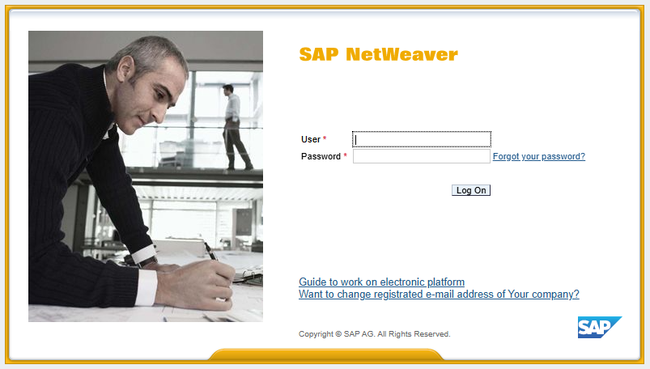

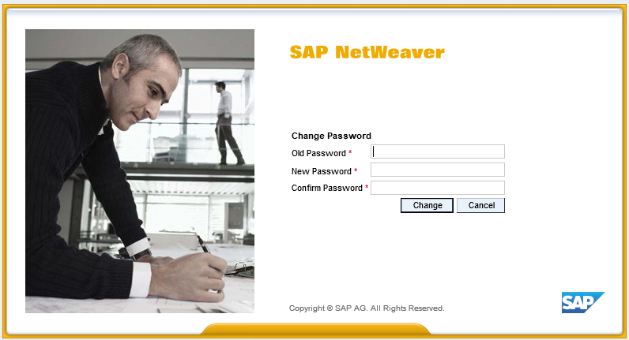

For entering a new password, the following rules shall apply:

1. minimum length is 8 characters
2. it must contain at least one digit (0 to 9)
3. it must contain at least four letters, including at least one lowercase letter
4. every 2 months (60 days) the system will ask you to change your password again.
5. in case you have not logged in to the system for more than 75 days, the old password will be deactivated, and you will need to submit a request for password initialization
6. it must not contain reserved words, such as the Company name "NIS" and the program name "SAP"
7. the new password must be different from the previous 15 passwords
8. at least three characters must be distinguished from the previous password

We recommend not using simple passwords (such as date of birth, combinations of characters obtained by pressing consecutive keys on the keyboard, like '123', '765', 'qwe', 'qaz', 'poi').

After successfully entering the new password, you will use the newly created password for future logins.

* 1. Submitting a request for password initialization

On the login page click on the **"Forgot your password?"**

Fill in the form with the required data. Fields marked with the symbol are mandatory for completion.

The new initial password will be sent to your registered email, and then you will change it as you did during the first login, following the password creation rules.

* 1. Submitting a request for changing the Company email address

On the portal access page, click on **"Want to change registrated e-mail address of your company?"**

Fill in the form and submit your request.

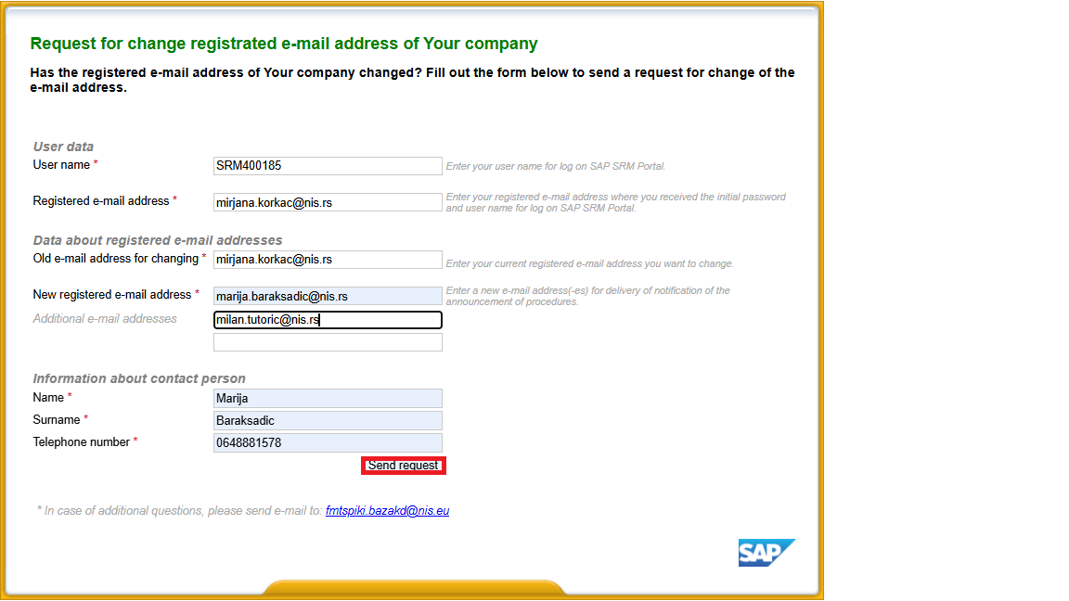

# Work on the electronic platform SAP NetWeaver portal

* 1. Review of the list of MTR supplier selection procedures

After a successful login, the user accesses their workspace on the SAP NetWeaver portal.

To go to the overview of the list of procedures for the selection of material supplier, go to the "Procedures for supply of materials" tab.

By automation, the list shows active procedures: published procedures and procedures for which the basic offers are currently being received or updated offers during commercial negotiations.

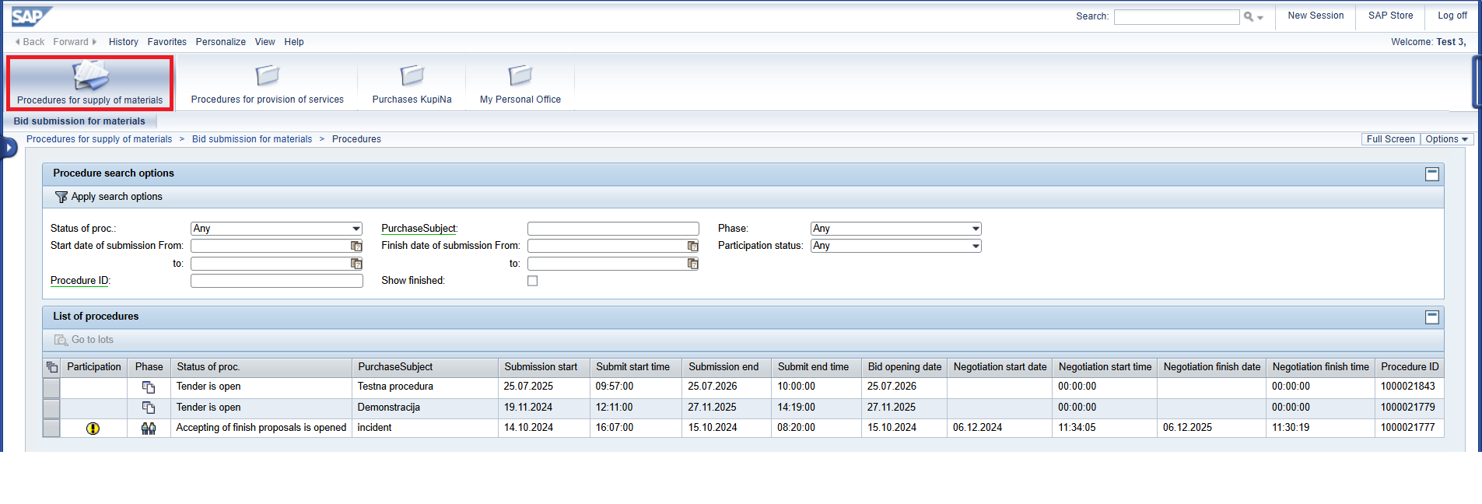

At the top of the screen, you can perform a search using filters.

To display the completed procedures, set the "Show finished" indicator.

* 1. Procedure information overview: list of lots and the organizer’s document package

In the list of procedures, find the one you want, mark the line and click on "Go to lots".



The screen with the list of lots in the upper part and the organizer's documentation in the lower part of the screen will open.

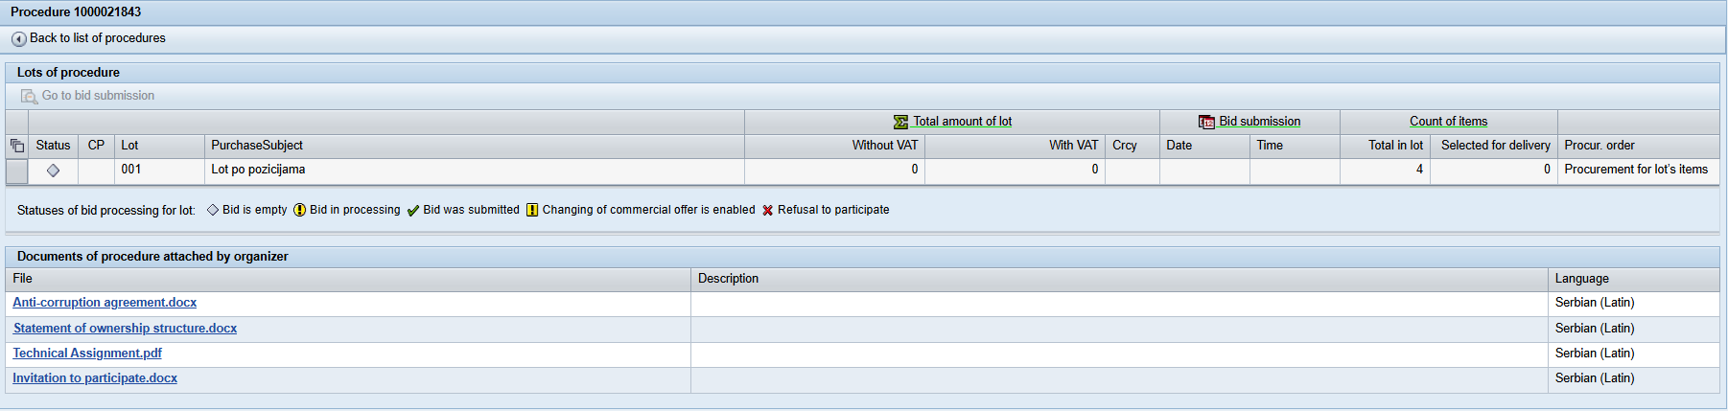

* 1. Preparation of bids for participation in the procedure: entry of contact information

To switch to the bid formation, you need to select the line with the desired lot and click on the icon .

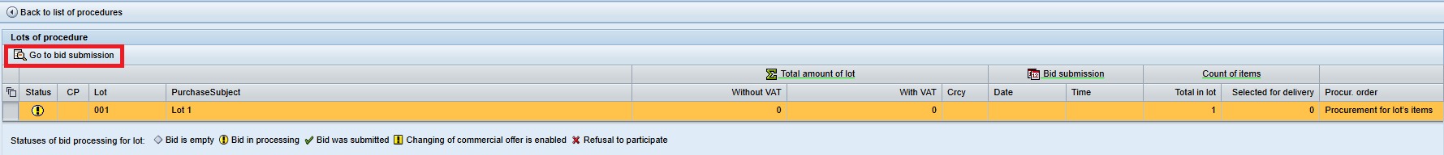

The screen that opened contains information about the offers of the selected lot and consists of four tabs:

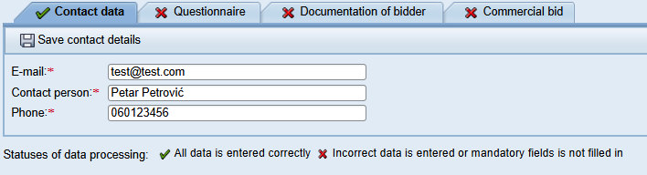

Each tab has a completion indicator:

The data has been entered accurately and completely, and the information has been saved

 The data has not been entered completely, or there is an error in the entry

Final submission of bids is only possible once all tabs containing bid information have been successfully completed, i.e., when each tab displays the symbol.

On the first tab "Contact data", it is necessary to enter the contact information of the person responsible for submitting bids and save the information.

* 1. Preparation of the offer for participation in the procedure: completion of the survey

In the "Questionnaire" tab, enter the values for each criterion:

  - according to the required units of measure

  - using the offered values (where there is a list)

The criterion confirmation document is not mandatory but it can be attached.

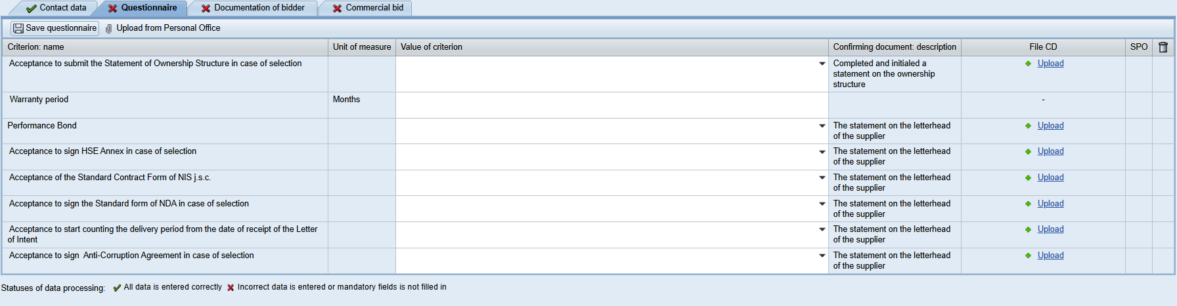

Attention: the maximum file size – 20 MB

Supporting documents for the questionnaire criteria can also be attached by uploading them from the Personal Office.

To do so, click on the button . If there are attached files for a certain type of supporting document in the My Personal Office that are valid on the bid opening date, then such documentation is automatically attached to the survey criteria with the attribute . If the document is not suitable for the validity period (its validity period ends before the opening date of the bids according to the procedure), then an indicator will be displayed .

After completing all the answers in the questionnaire, save the entered information via the icon .

* 1. Preparation of bids for participation in the procedure: entry of packages of documents

To attach the package of documents, go to the **"Documentation of bidder"** tab.

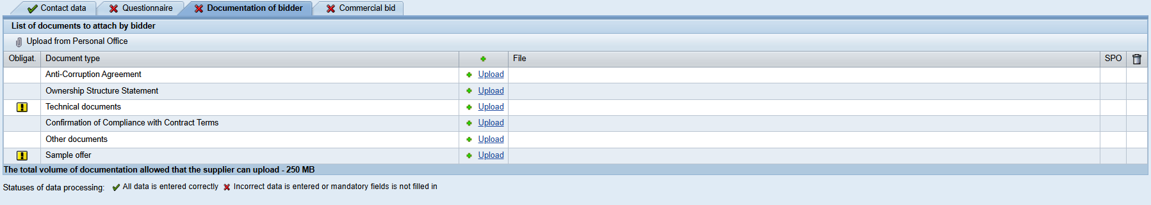

The indicator  indicates that it is mandatory to attach this type of attachment. If the Sample offer is required in the procedure, it must be attached in Excel format, while attaching it in any other format is optional.

Please note: the maximum volume of one imported file is 20 MB, the maximum volume of the document package to be imported is 250 MB.

Select the required attachment type to import and click on the «Upload» icon .

To remove the attachment, use the file removal function .

Supporting documents for the questionnaire criteria can also be attached by uploading them from the Personal Office, as described in item 2.4.

Once all documents  marked as mandatory for attachment have been uploaded, the «Documentation of bidder» tab is considered complete and automatically receives the symbol .

* 1. Preparation of the offer for participation in the procedure: formation of the commercial part of the offer

To form a commercial offer, go to the **«Commercial Bid»** tab.

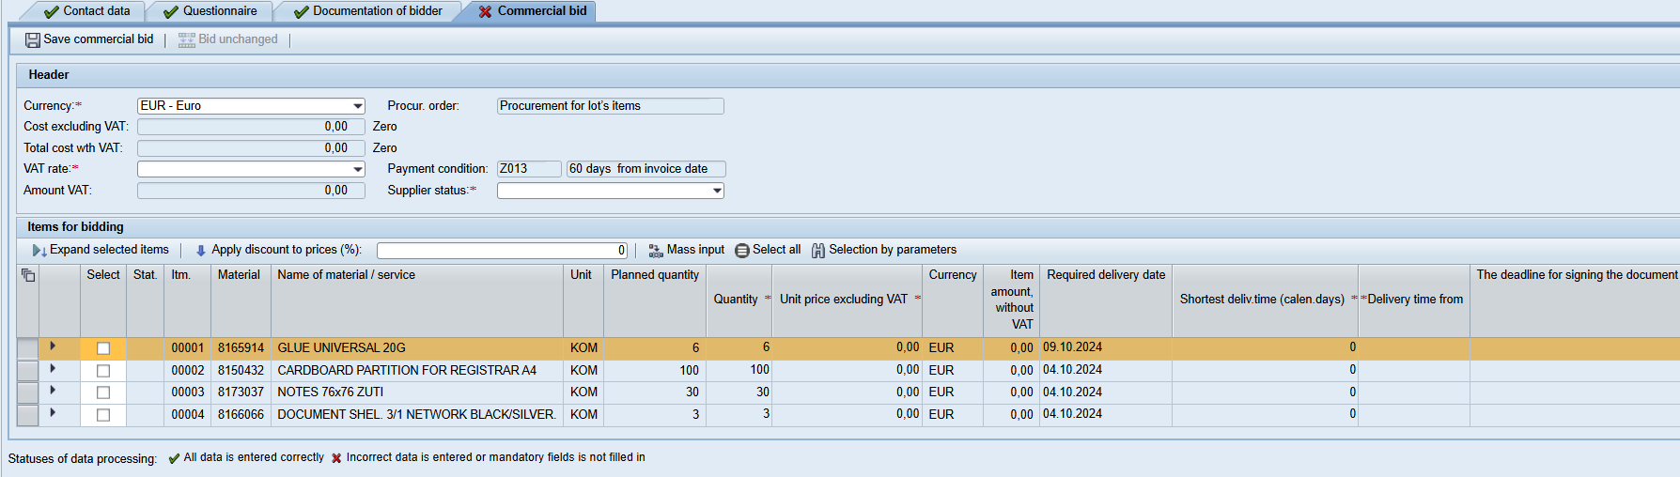

Fields that are mandatory to fill in are marked with the symbol . Select the field values from the drop-down menu in the header.

In the lower part of the screen, it is necessary to enter information about the positions of the bid. Note: If the procurement is conducted as a whole lot, it is mandatory to submit a bid for each lot position.

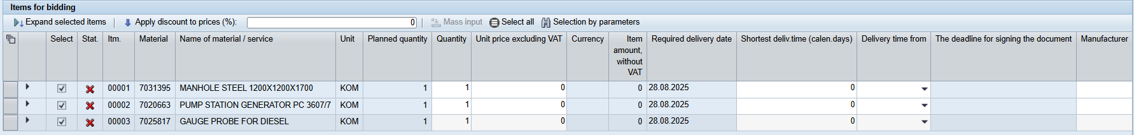

If the procurement is conducted as a lot by items, you can check in the "Selection" column the items for which you want to submit a bid:

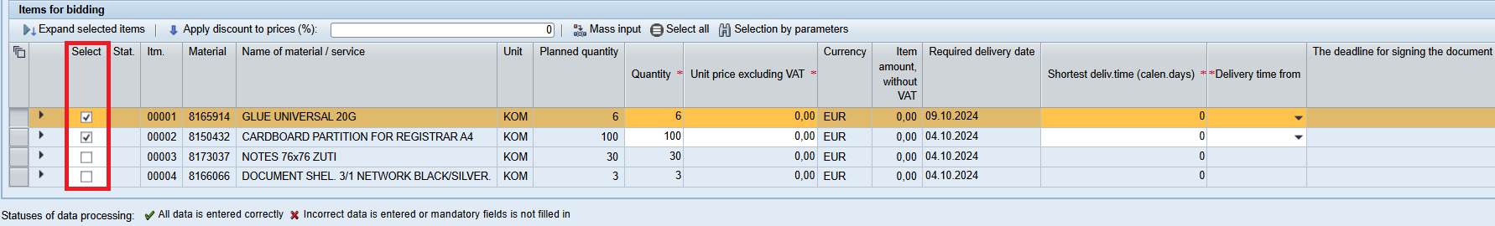

Mass Data Entry:

After selecting one or several lot positions in the "Commercial Bid" tab, clicking on the "Mass Input" button  will open a window with a list of fields available for mass entry:

1. Manufacturer (text field, to be filled in manually)
2. Country of origin (the field is filled in from the standard SAP ERP codebook)
3. Minimum number of calendar days of delivery (numeric field, to be filled in manually)
4. Calculating the delivery time from (to be filled in from the predefined list of options).

To view detailed information about an item, click on the icon . To open all selected positions, click .

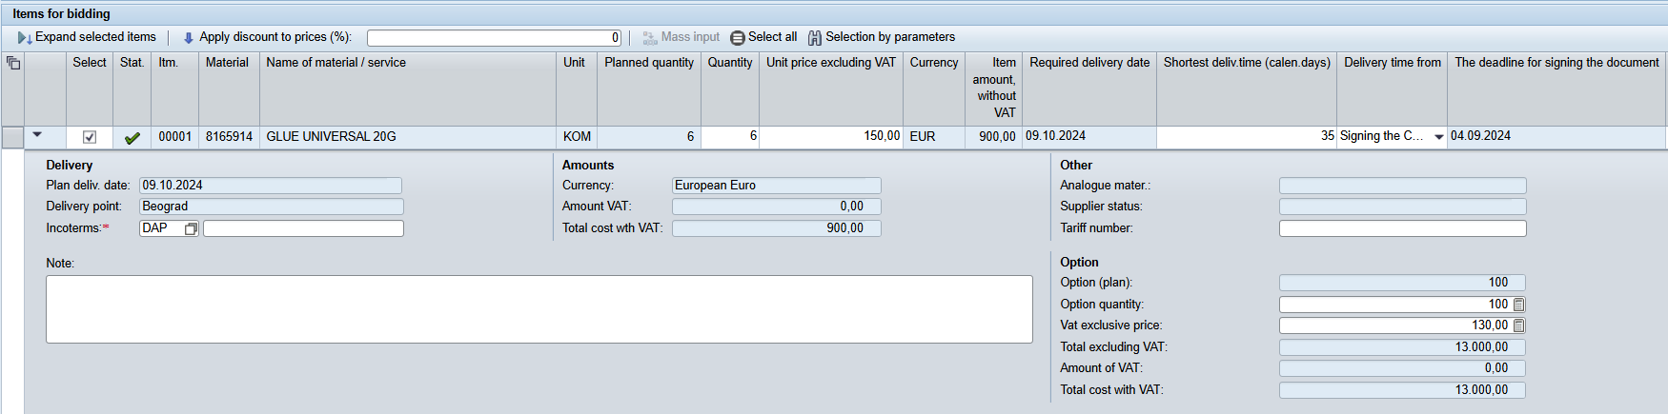

Once you have entered all the mandatory information, click on the icon «Save commercial bid» .

The bid header fields, once saved, will be automatically filled in, and the entered data will be validated:

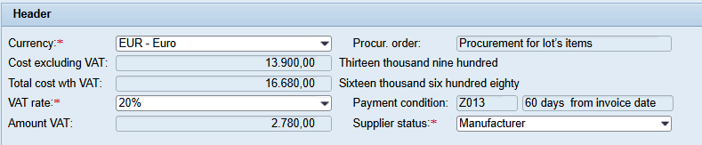

Note that the Payment condition field is available for modification if the procedure was created with this option. Otherwise, there is no possibility of modification.

Creating a bid option

In the event that the Organizer of the procedure has foreseen the possibility for the supplier to submit bid options, an icon will be additionally available on the "Commercial Bid" tab .

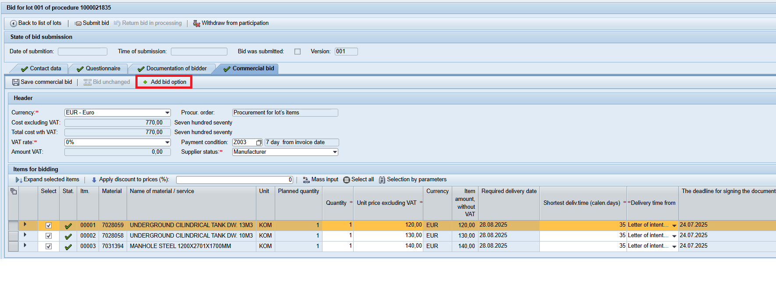

To create the offer option, click on the icon . A new tab «Bid option 1» will appear on the screen.

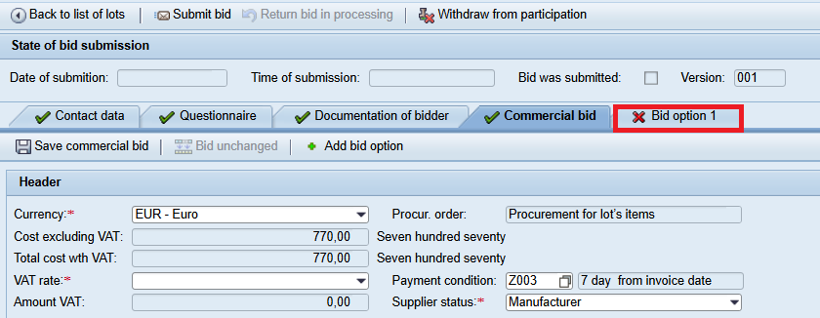

Information on the bid option shall be entered in the same manner as for the basic commercial bid, and in addition, the terms of validity of the bid option shall be specified.

**Note:** the supplier can submit up to five alternative bid options.

To remove the bid option, place the mouse cursor on the upper right corner of the bid option card and click on the  one that was displayed on that occasion. In the window that opened, select the «Yes» option. The offer option will be removed.

Submission of the bid for participation

The bid can only be submitted if all bid cards have been successfully processed.

To submit a bid, click on the icon«Submit Bid»:

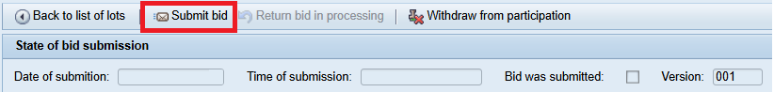

When you click the icon, the data entered in the bid will be validated.

If any errors occur while submitting the bid, they will be displayed at the top of the screen:

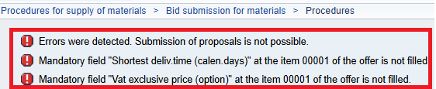

Please provide the required information, save the offer and press .

If no errors occur during bid submission, the bid will be successfully submitted. A message will appear confirming that the bid has been successfully submitted, showing the lot number and the total bid value excluding VAT:

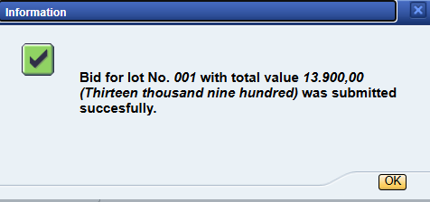

You can return to the list of procedure lots by clicking the icon .

1. Participation in commercial negotiations / Second round of receipt of bids

The procedure for which the organizer initiated the commercial negotiations phase is indicated by a special indicator on the first screen of the workplace in the list of procedures:



The commercial negotiation phase was also highlighted as a separate order in the list of lots:

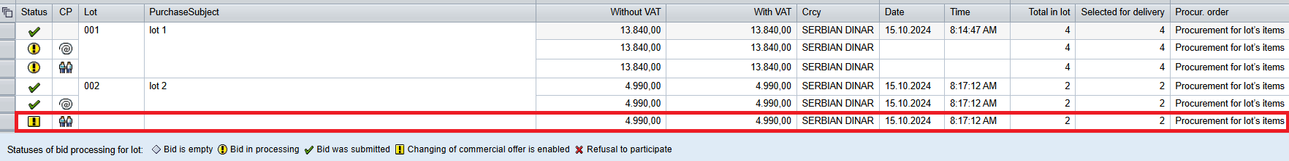

To access the submission of a new commercial bid, you need to select the row marked with .

The procedure for which the organizer initiated the second round of receipt of bids is indicated by a special indicator on the first screen of the workplace in the list of procedures:

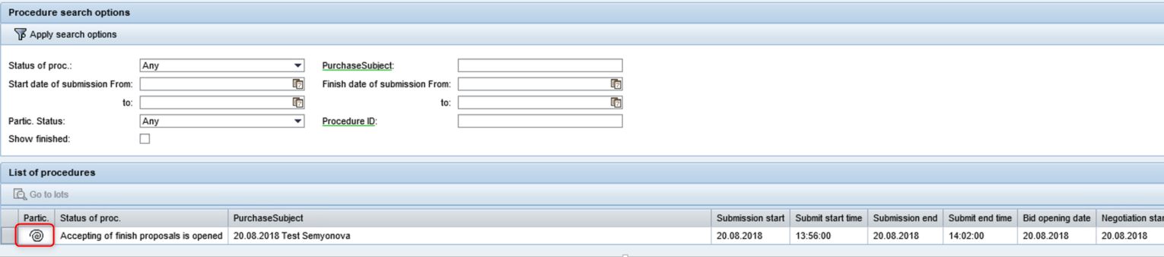

The second round of receipt of bids is also allocated in a separate row on the list of lots:

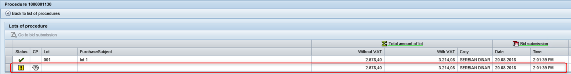

Only suppliers who have received positive technical assessment can submit a new bid.

To make a new price offer, mark the row and press .

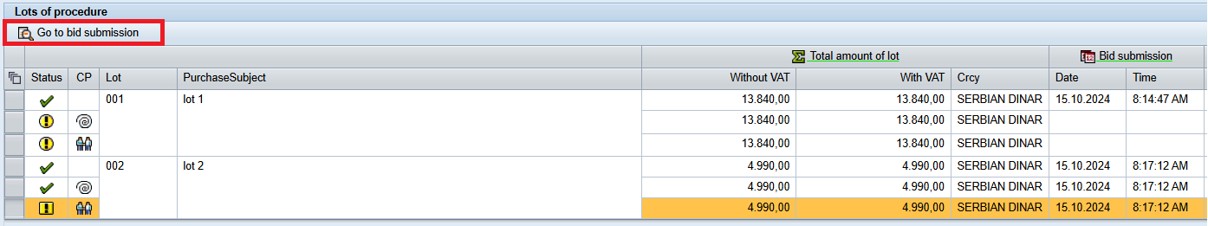

To submit a revised bid, click on :

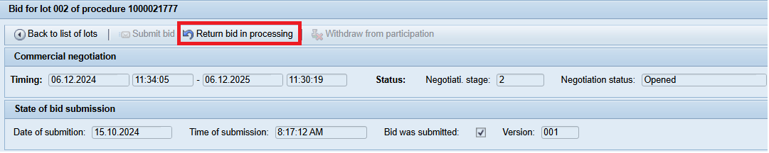

For the commercial negotiations phase, it is available to specify the information in two tabs: "Documentation of bidder" and "Commercial Bid":

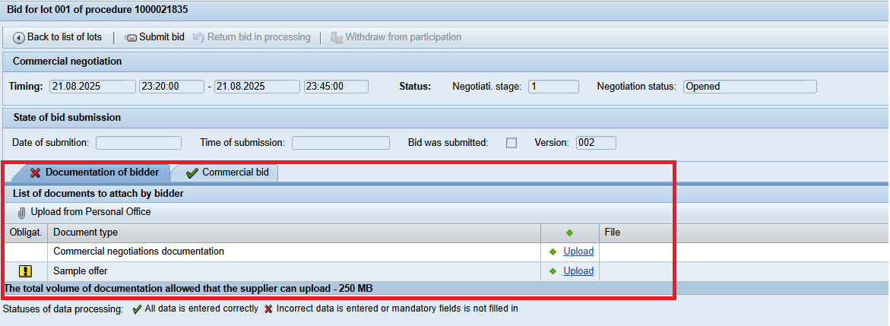

The previous version of the bid appears on the "Commercial Bid" tab. The supplier has the option to specify new unit prices and prices for optional quantities (if an option was provided). It is also possible to change the "Incoterms" field and the payment condition (if modification of payment condition is allowed):

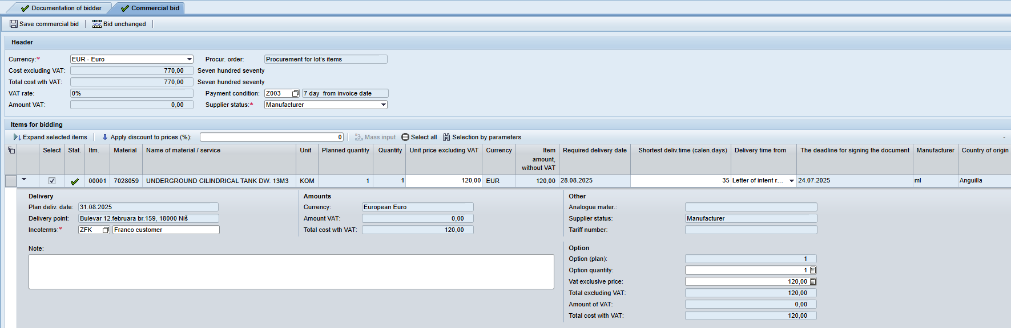

Depending on the conditions of participation defined by the lot procedure clerk, "Quantity" may be available at the CP phase for change.



When entering an updated offer, the option to enter a discount for the offer can be used. To recalculate the discounted offer price, specify the required discount value and click on the “Apply discount to prices” button.

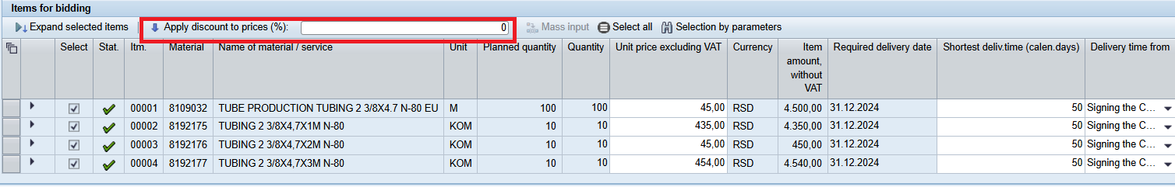

After entering the new prices, it is necessary to go to Save commercial bid, and then click on Submit bid:

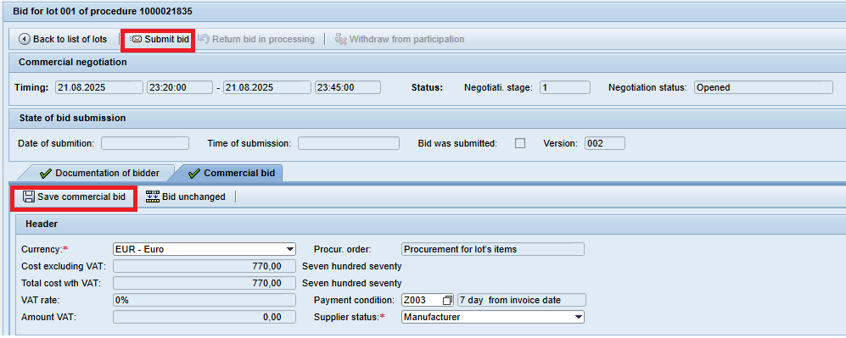

Until the deadline for submitting new bids, the supplier has the possibility to return it for processing and correct the new bid with prices.

After submitting a new bid with prices, the new prices are fixed in the list of lots for the "CP" phase:

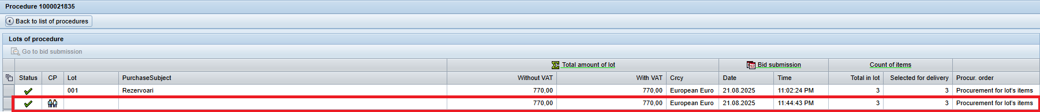

* In the event that the bid is not modified during the commercial negotiations, there is an option to copy the previous bid: click the icon  on the top panel. When the icon is clicked, the values from the bids of the previous phase of the procedure will be displayed automatically.
* To make a bid, press the icon «Submit Bid»

1. Withdrawal from participation in the MTR suppliers selection procedure

To withdraw from the procedure, click the "Withdraw from participation" icon on the bid editing screen:

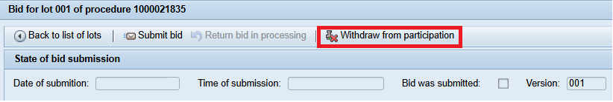

A window for confirming the withdrawal from participation and to enter the reason for withdrawal:

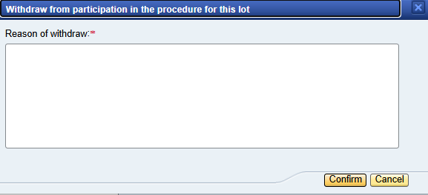

The withdrawal from participation will be processed, and an informational message will appear at the top of the screen .