SHORT USER MANUAL

Supplier's Personal Office

This is a shortened version of the user manual with the basic operating steps. For all detailed steps and explanations, please refer to our comprehensive instructions available on the SAP NetWeaver portal.

1. Entry into the SAP Portal

The SAP portal, through which procurement is carried out in "NIS j.s.c. Novi Sad" and its subsidiaries, can be accessed via the link [**https://srm.nis.rs**](https://srm.nis.rs)

After successful login, several tabs are available on the SAP Portal.

This manual describes the actions required for the work with the Supplier's Personal Office:

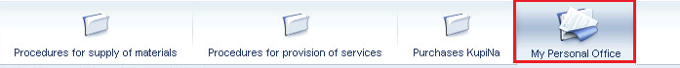

**2. Overview of the contact data on the Supplier**

The Personal Office contains two tabs: the "My Documentation" tab, where the documentation is uploaded, which can later on be used when participating in the SRM procedures for the MTO and Service selection, and the "My Contacts" tab.

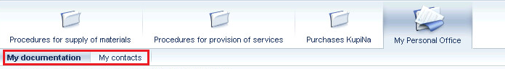

The "My Contacts" tab displays general information:

* name of the Supplier;
* list of e-mail addresses from the directory of the qualified suppliers of NIS j.s.c. Novi Sad.

3. Publishing the documentation in the Personal Office

The "My documentation" tab displays a list of document types for which the documentation can be published.

To upload documents, it is necessary to click the button . Depending on the type of the document, when downloading it, you need to specify the validity period of the documentation and/or select the company with which the downloaded document has been signed.

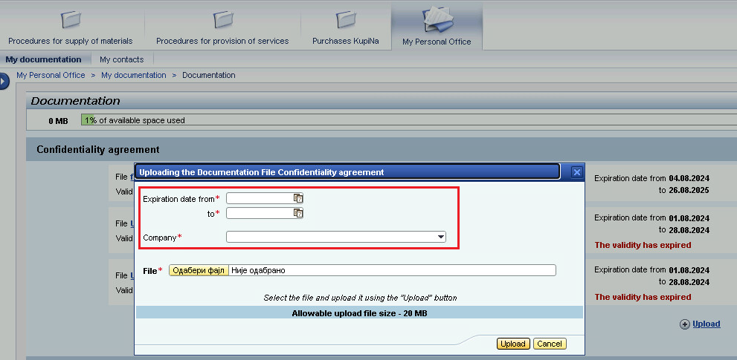

**Note.** The allowed size of one attached file is 20 MB, while the total size of the Personal Office storage is 250 MB.

Personal account shows the current percentage of storage used out of the total volume:



Fill in all the required fields on the File Upload screen, select the application file from your PC and click the button :

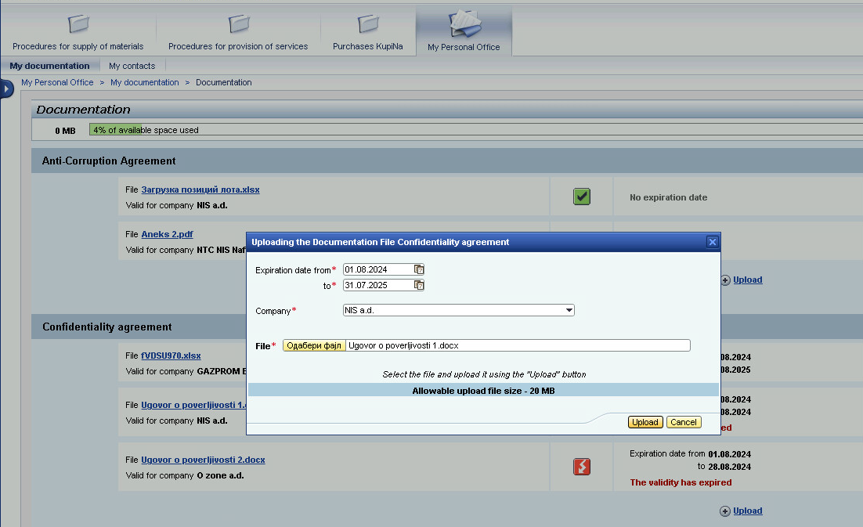

**Attention!** For some document types, the possibility to attach only one file for each Company may be defined.

The validity periods of the attached documents are monitored in the Personal Office:

* if there is less than a month left until the expiration of the document validity period, then the following sign will appear for the document ;
* if the document has already expired, then the following sign will appear  ;
* if the document is with a valid deadline, the following sign will appear ;
* if no validity period is specified for the document, then the same sign will appear  .

To view the attached file, it is necessary to click the name of the document in the "File" field, the document will be opened for overview:

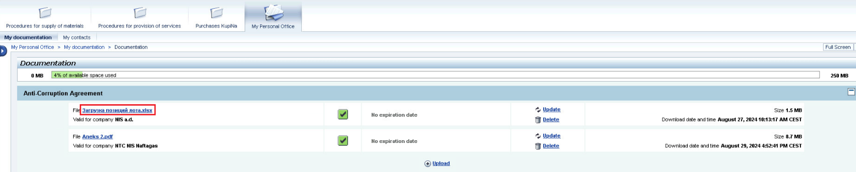

In order to update the attached file, it is necessary to click the button :a window will open for uploading a new document and indicating its current validity period, the Company code will be pre-filled with the previously entered value:

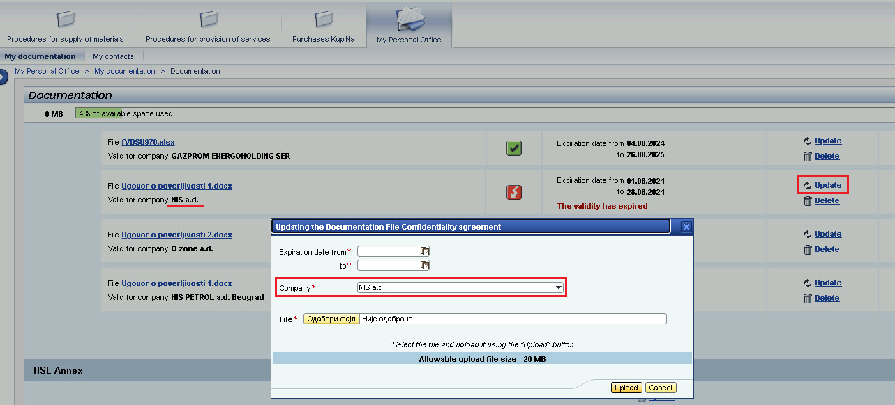

To delete the attached file, it is necessary to click the button . Confirm the deletion in the open window, after which the file will be deleted.

4. Using the documentation from the Personal Office in SRM procedures

The documentation published in the Supplier's Personal Office can be used when submitting a proposal to participate in the SRM selection procedures on the SAP Portal.

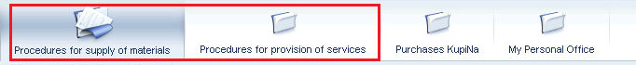

**Note.** A detailed description of the steps for participation in SRM procedures is given in the instruction "Registration and submission of proposals for participation in the supplier selection procedure".