**SHORT OPERATING INSTRUCTION**

**Processing of Purchase Orders by Supplier through KupiNA Portal**

This is a shortened version of the user manual with the basic operating steps. For all detailed steps and explanations, please refer to our comprehensive instructions available on the SAP NetWeaver portal.

# Logging in to SAP Portal

The SAP portal is accessed via the link [**https://srm.nis.rs**](https://srm.nis.rs)

# Processing Purchase Orders via KupiNA Portal

# Reviewing Purchase Order List

In order to review the purchase orders, which have arrived for Supplier’s review and confirmation, go to “Purchases KupiNa” tab.

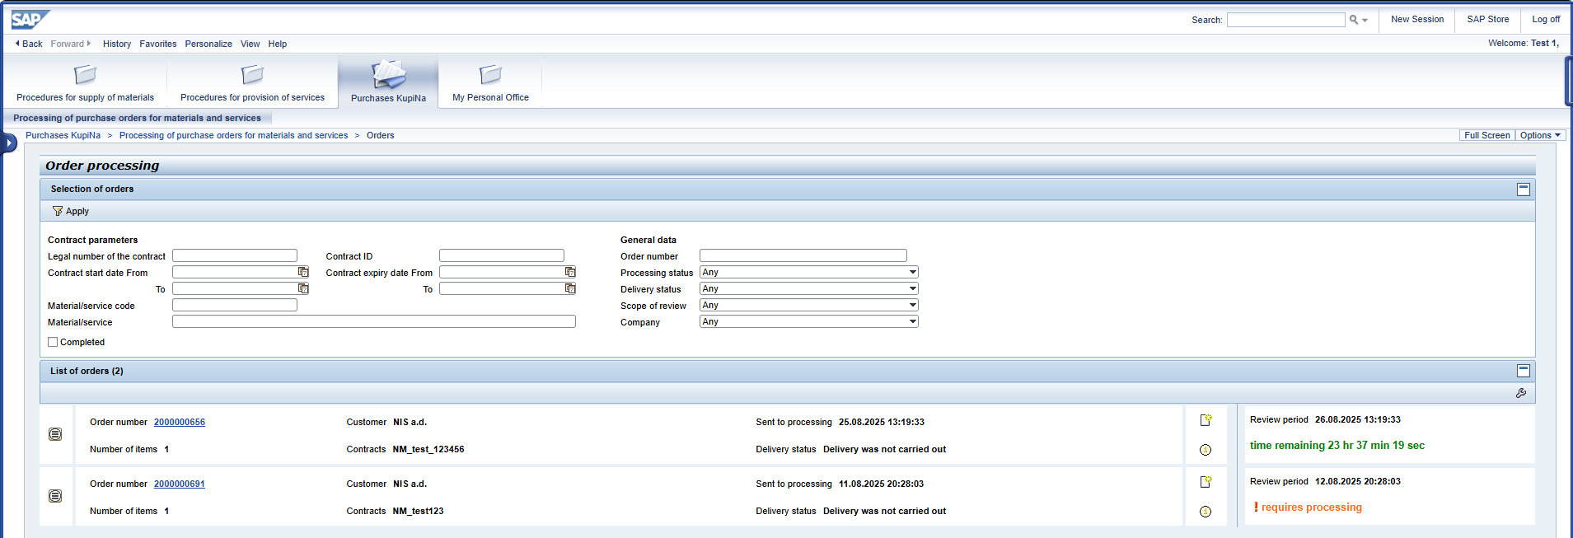

In the upper part of the screen, there is a list of filters for various attributes of KupiNa orders.

In the bottom part is the list of active KupiNa orders which have not yet been processed by Supplier.

For each purchase order, the deadline (date and time) by which the purchase order processing must be completed according to the regulatory deadline is displayed. After the regulatory deadline has passed and the purchase order has not been processed, the "Requires processing" indicator is displayed in the column.

Note: After the deadline for processing a purchase order has expired, it is still possible to access it and complete processing.

To display KupiNa orders which have already been processed, tick .

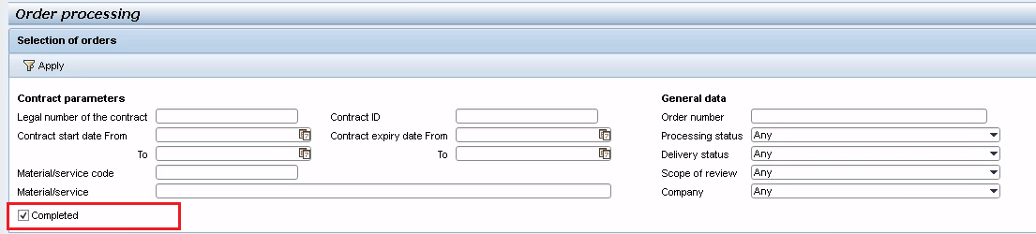

# KupiNa Order Review

To review KupiNa orders, click the order number:



A screen containing information on the selected KupiNa order, which is divided into two parts, will be displayed:

1)   In the upper part – general information on the order;

2)   In the lower part – table with the list of items of the selected order.

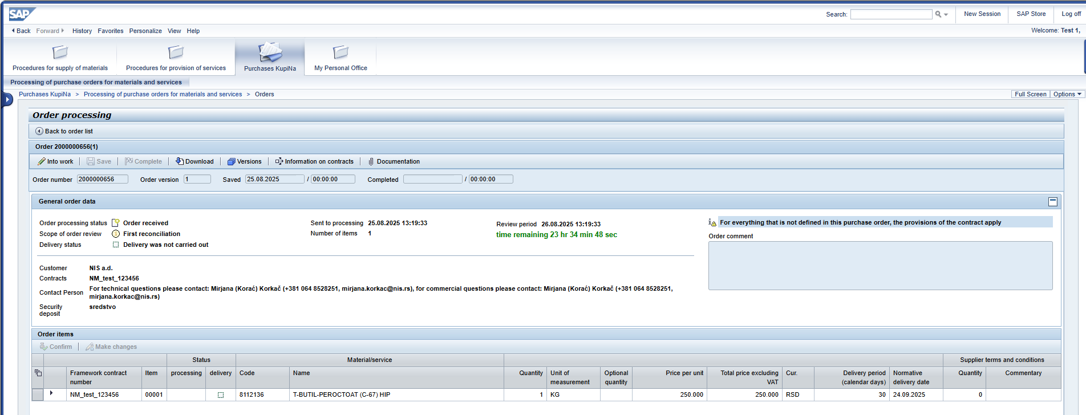

To show the part with additional information on order item, extend the description by clicking .

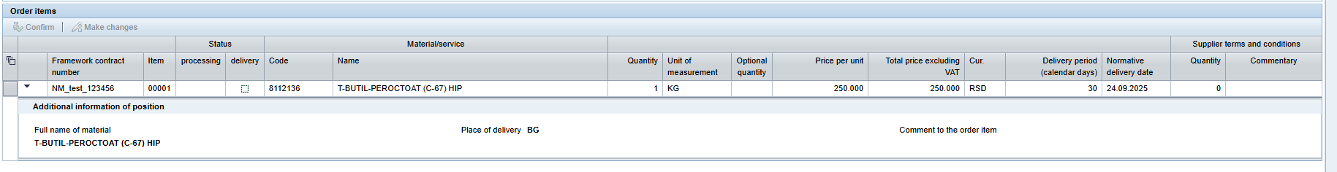

# Reviewing Documents Enclosed with KupiNa Orders

To review the documentation enclosed by the Customer with the KupiNa order, click 

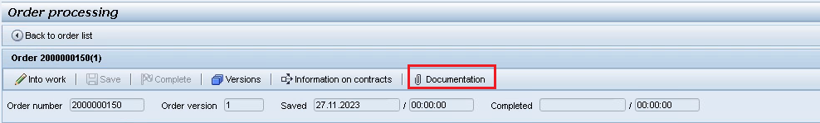

# Reviewing Information on Contracts

To review information on contract/contracts, the items of which are included in the order, click 

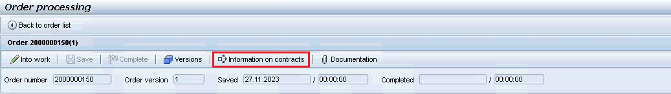

# KupiNa Order Processing

To transfer the KupiNa order status to “Into work”, click

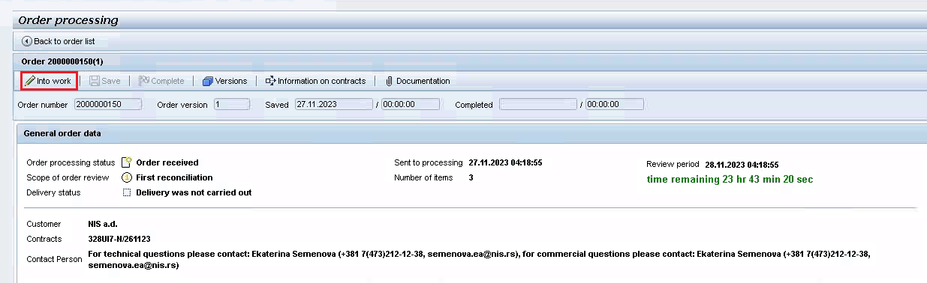

When transferring the order into work, message  will show, order processing status will change to “Take into processing” and the “Into work” button will become inactive  . Buttons for order processing will be available.

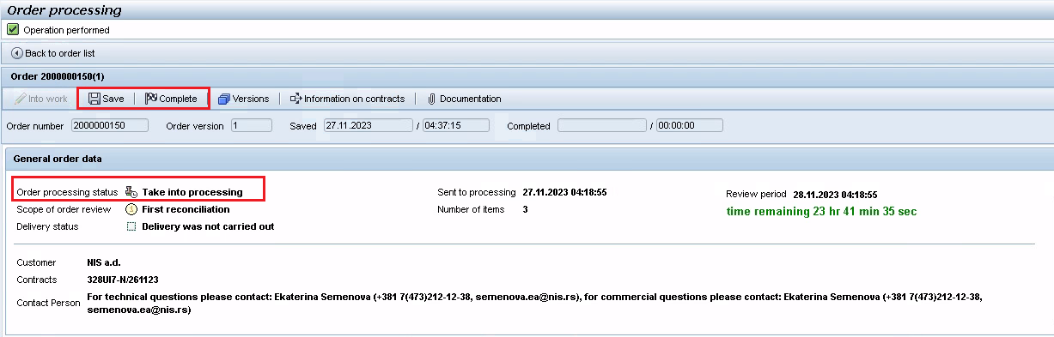

# Order Item Confirmation

To confirm the order items, select the item/items and click 

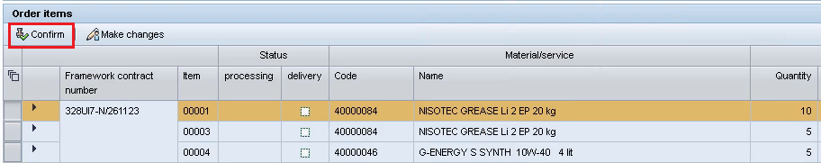

Order item will show processing status  "Confirmed".

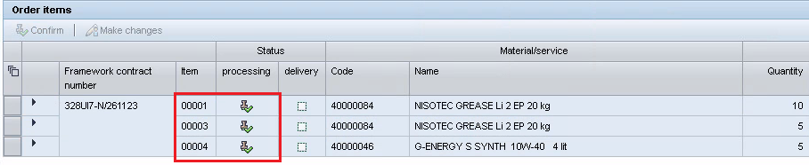

To change the order item, select the item/items and click 

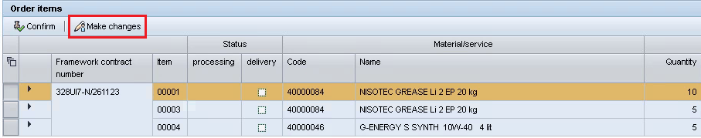

Order item will show processing status  "Not confirmed".

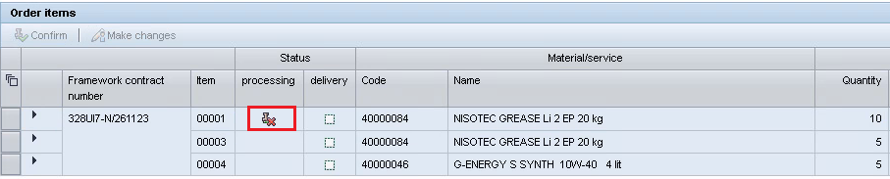

If the Supplier has not confirmed the terms and conditions which have been specified by the Customer for the order item, Supplier must include a comment and/or proposed its terms and conditions for the delivery quantity.

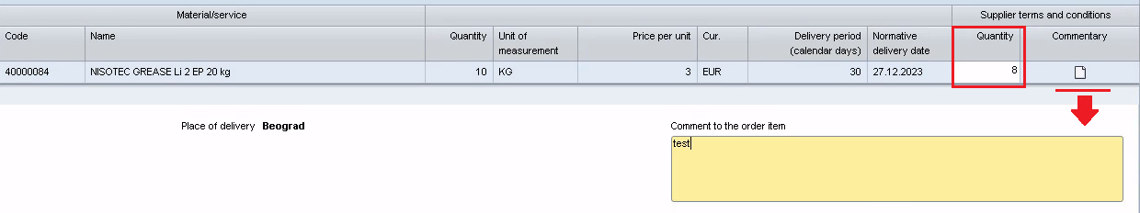

To save the changes entered in the order, click 

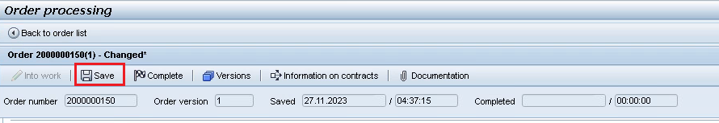

# Order Processing Completion

To complete order processing, click 

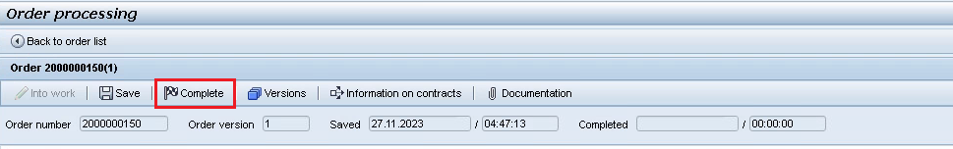

If all items have been confirmed (processing status  “Confirmed”), upon completion of processing, the order will be fully confirmed.

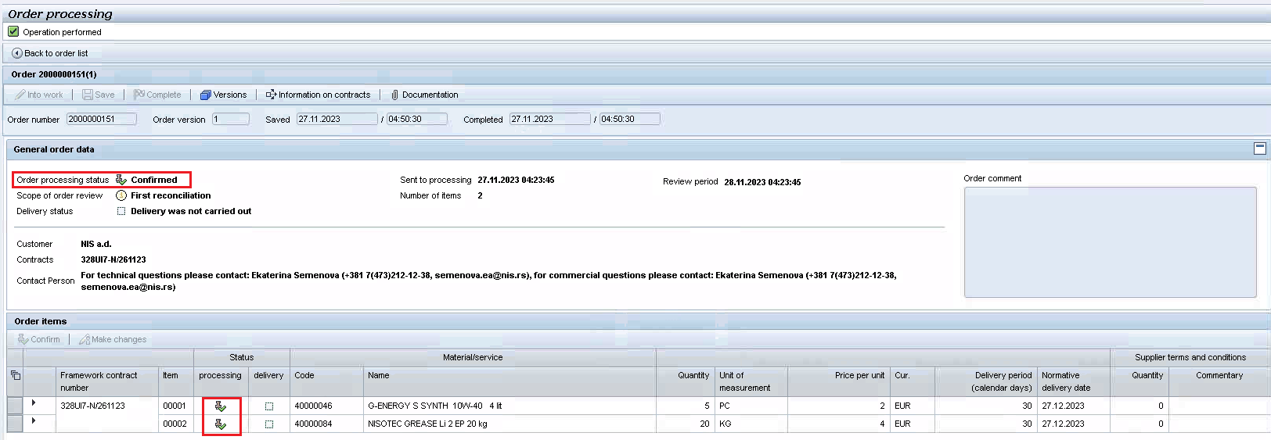

**Information on KupiNa order confirmation by the Supplier will be automatically sent to the Customer.**

If an item/items have not been confirmed (processing status  “Not confirmed”), upon completion of processing, a check is run to establish whether Supplier’s terms and conditions are entered (quantity proposed by the Supplier and/or commentary):



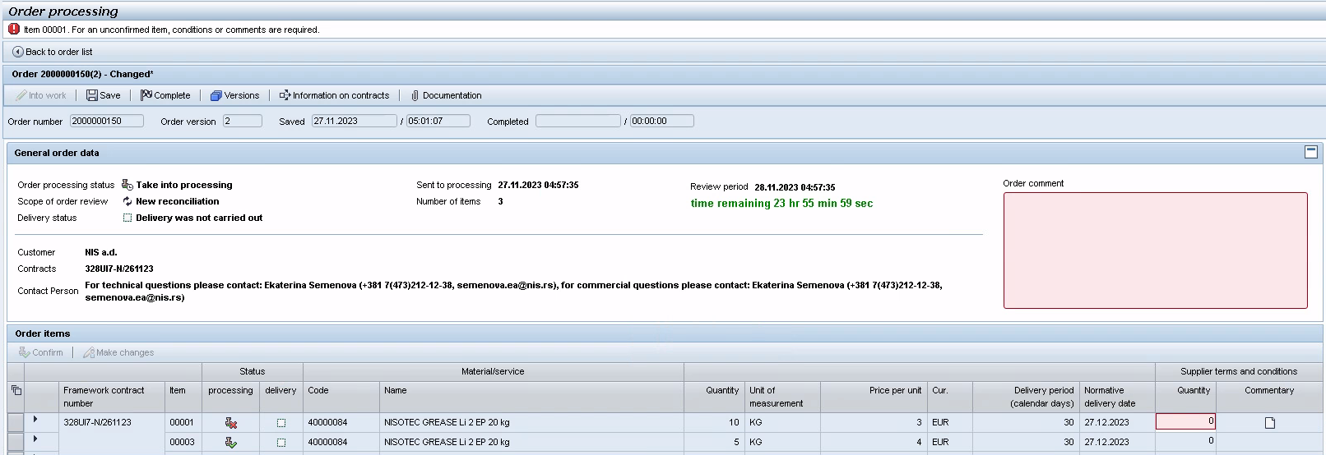

Supplier’s commentary can be specified either for an order item or for the item as a whole.

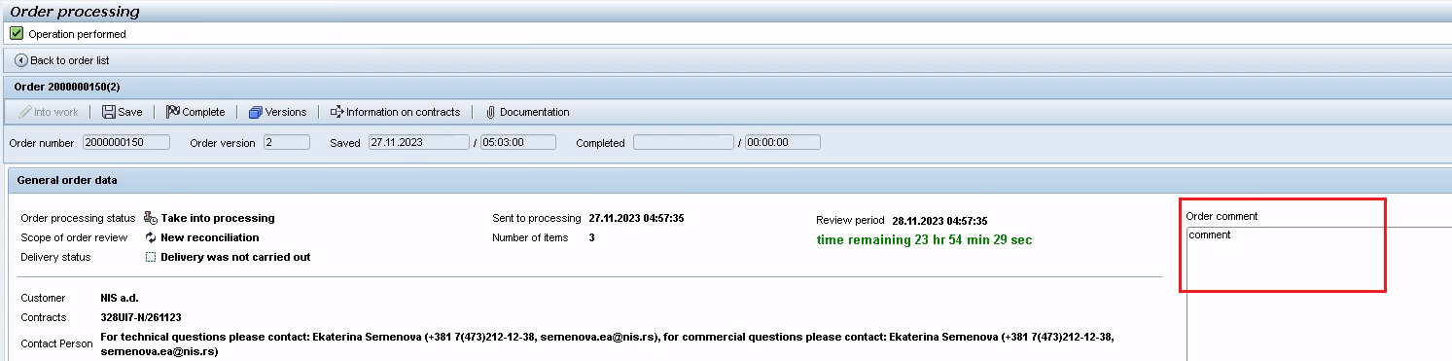

**Important:** an order for which the terms and conditions are not confirmed by the Supplier and for which Supplier has entered its comments and suggestions, will be delivered to the Customer for consideration and approval upon completion of processing.

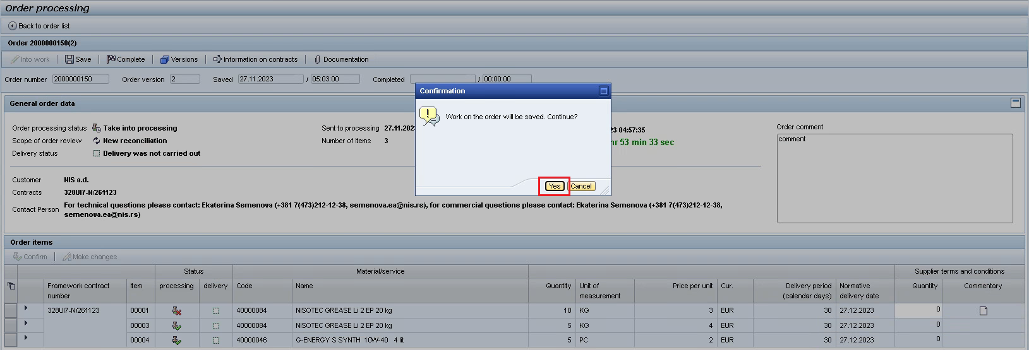

The order status is set to “Sent to the Customer for approval”.

