OPERATING INSTRUCTION

Processing of Purchase Orders by Supplier through KupiNA Portal

CONTENTS
1. Purpose 3
2. Logging in to SAP NetWeaver Portal 4
3. Processing Purchase Orders via KupiNA Portal 5
3.1. Reviewing Purchase Order List 5
3.2. KupiNa Order Review 8
3.3. Reviewing Documents Enclosed with KupiNa Orders 12
3.4. Reviewing Information on Contracts 12
3.5. KupiNa Order Processing 13
3.6. Order Item Confirmation 14
3.7. Order Item Change 14
3.8. Order Processing Completion 16
3.9. New Reconciliation of Order, Review of Order Versions 19

Purpose
This instruction provides for the Supplier’s activities in relation to confirmation of purchase orders for materials and services through KupiNA Portal.
This instruction provides a description of Supplier’s work during performance of the following activities:
- logging in to the SAP NetWeaver Portal “Nis j.s.c. Novi Sad”;
- reviewing purchase order list;
- reviewing KupiNa orders;
- reviewing documents enclosed with KupiNa orders;
- processing and confirming KupiNa orders.

Logging in to SAP NetWeaver Portal
After successful registration process and after receiving individual log in and password, electronic platform of “NIS j.s.c. Novi Sad” is accessed via link https://srm.nis.rs
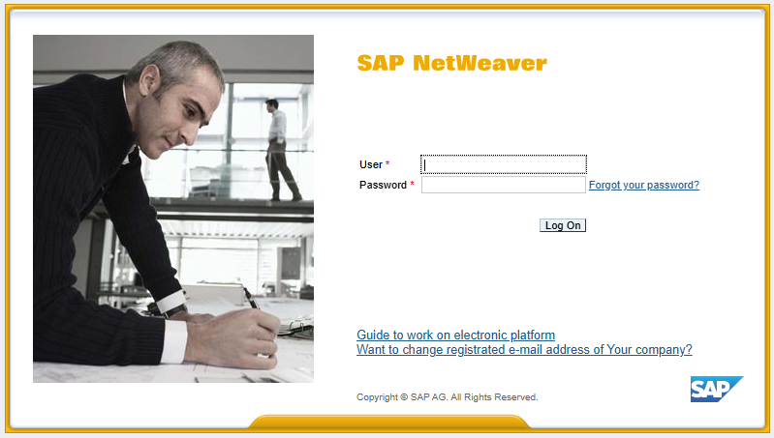
There is an available link to the instructions containing descriptions of operations required when submitting quotes for participation in the selection of suppliers of materials and services, as well as instructions for processing and confirmation of purchase orders by Suppliers via KupiNA Portal.
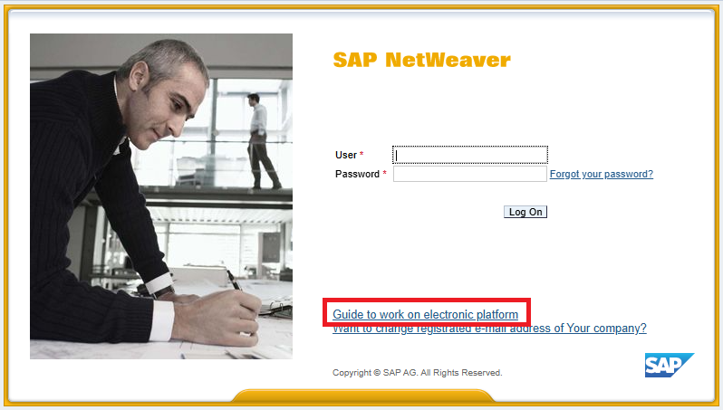
When clicking the link for purposes of reviewing and loading instructions, there are some supplier instructions available in Serbian, English and Russian language.
After successful logging in to SAP NetWeaver Portal, user will gain access to individual work position for the purpose of participating in the procedure for election of suppliers of materials and services, and for purposes of processing purchase orders via KupiNA Portal.
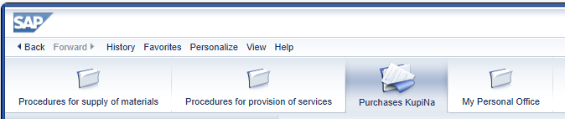

Processing Purchase Orders via KupiNA Portal

Reviewing Purchase Order List
In order to review the purchase orders, which have arrived for Supplier’s review and confirmation, go to “Purchases KupiNa” tab.

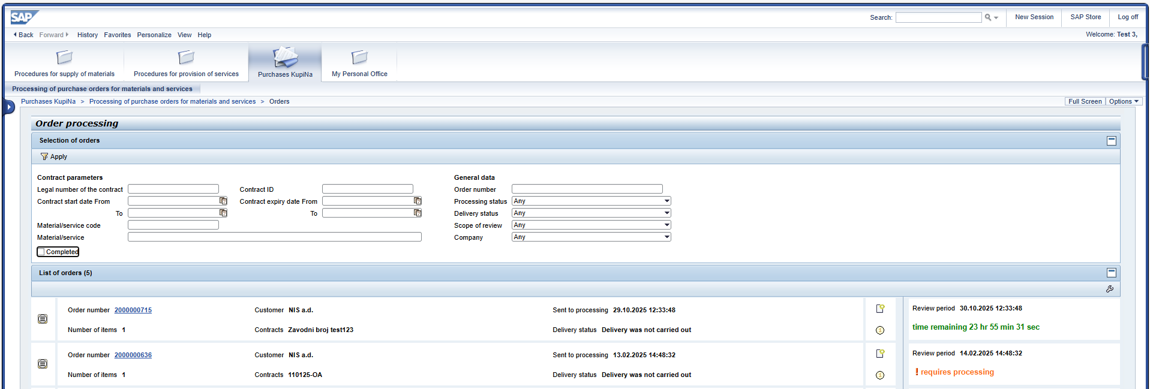
In the upper part of the screen, there is a list of filters for various attributes of KupiNa orders (contract parameters, order parameters, material/service code, etc.):
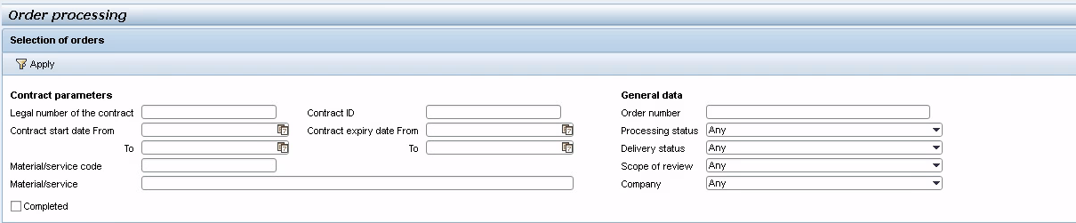
At default, the list shows active KupiNa orders which have not yet been processed by Supplier.
List of orders on the screen will be sorted by date and time of sending for processing, from the earliest to the latest.
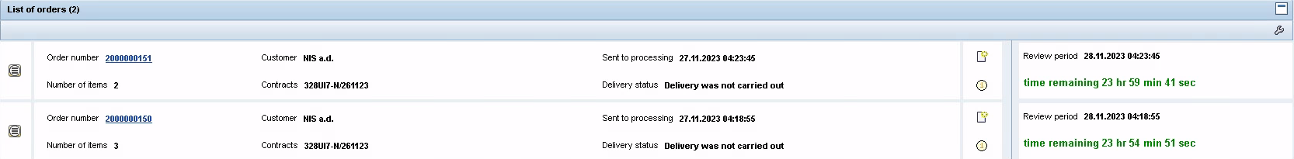
“List of orders” bar is a table listing orders, which contains the following fields:
Field | Commentary
Order number | KupiNa order number
Item number | Item number in KupiNa order
Customer | Name of company with which Supplier has entered into framework contract on supply of materials/services
Legal number of the contract | Legal numbers of framework contracts of Suppliers items of which are included in the order
Date and time the order is sent to processing | Shows the date and time of sending the KupiNa order to the Supplier for processing
Processing status | In the column for each order, its current processing status is shown:  - “Order received”  - “Taken into processing”  - “Confirmed”  - “Sent to Customer for approval”
Scope of review | - “First reconciliation”  - “New reconciliation”
Review period | Shows the delivery date (date and time) in which order processing should be completed in accordance with normative delivery date (+1 business day from the moment of sending the order to Supplier) / remaining time until expiry of normative delivery date.  After the expiry of the normative delivery date, if the order is not processed, the column will show “Requires processing”
In order to use the filters, set the value in the required field and click
“Selection of orders” bar contains the following fields:
- Legal number of the contract
- Contract ID
- Contract start date
- Contract expiry date
- Materials/service code
- Materials/service
- Order number
- Processing status with dropdown menu:
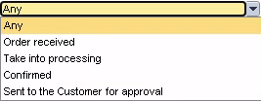
- Delivery status with dropdown menu:
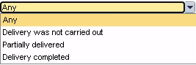
- Scope of review
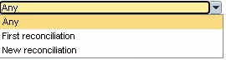
- Customer (Company codes)
- Indicator “Completed”
To display KupiNa orders which have already been processed, tick .
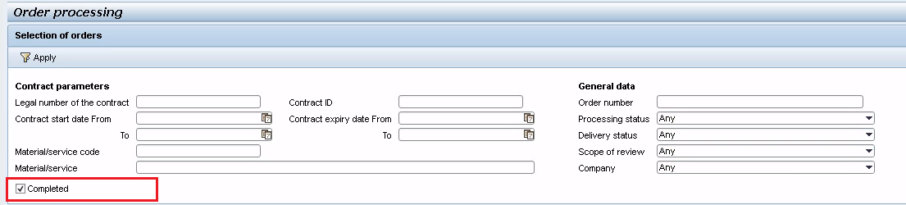
List of KupiNa orders which have been processed by the Supplier will be displayed.
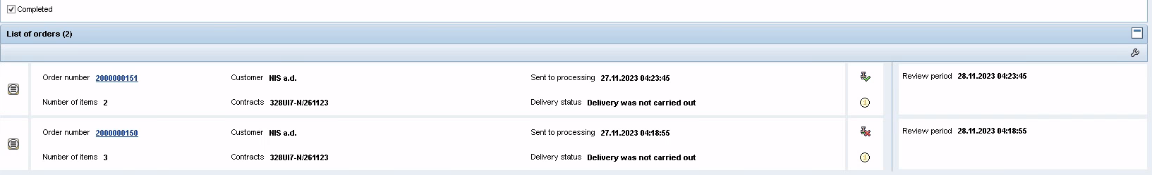

KupiNa Order Review
To review KupiNa orders, click the order number:
A screen containing information on the selected KupiNa order, which is divided into two parts, will be displayed:
1) In the upper part – general information on the order;
2) In the lower part – table with the list of items of the selected order.
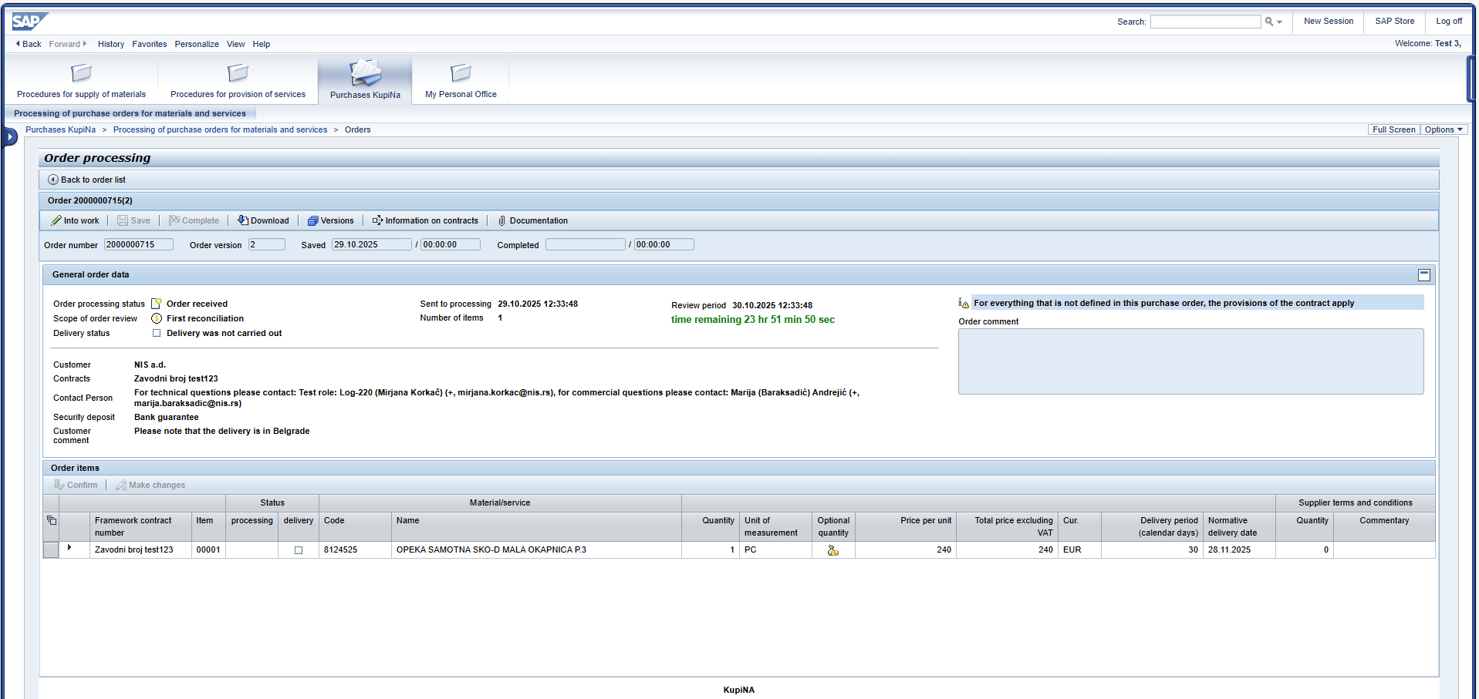
Upper part of the screen contains fields given in the table below:
Field | Commentary
Order number | KupiNa order number
Item number | Item number in KupiNa order
Customer | Name of company with which Supplier has entered into framework contract on supply of materials/services
Legal number of the contract | Legal numbers of framework contracts of Suppliers items of which are included in the order
Date and time the order is sent to processing | Shows the date and time of sending the KupiNa order to the Supplier for processing
Processing status | In the column for each order, its current processing status is shown:  - “Order received”  - “Taken into processing”  - “Confirmed”  - “Sent to Customer for approval”
Scope of review | - “First reconciliation”  - “New reconciliation”
Review period | Shows the delivery period (date and time) in which order processing should be completed in accordance with normative delivery date (+1 business day from the moment of sending the order to Supplier) / remaining time until expiry of normative delivery date.  After the expiry of the normative delivery date, if the order is not processed, the column will show “Requires processing”
Order version | Order version number
Date and time of saving | Date and time of the last saving of order processing are shown
Date and time of completion | Date and time of completion of order processing are shown
Order commentary | Supplier’s commentary concerning the order is shown
Contact person | Information of the contact person for technical matters and of the contact person for commercial matters is shown
Security deposit | Information entered by the procurement officer in accordance with the concluded contract.
Customer comment | An additional note entered by the Customer into the purchase order for the Supplier.
Bottom part of the screen is a table containing the list of order items.
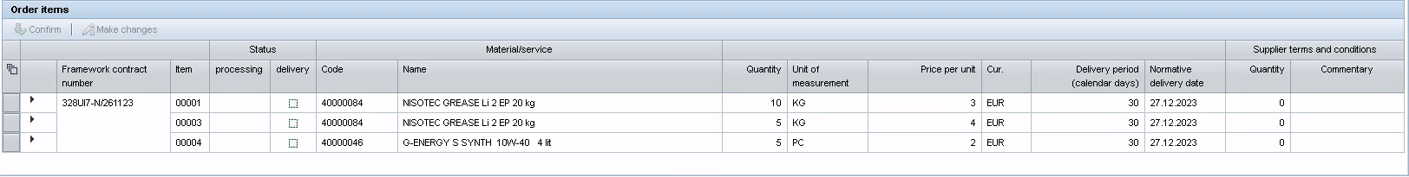
To show the part with additional information on order item, extend the description by clicking.
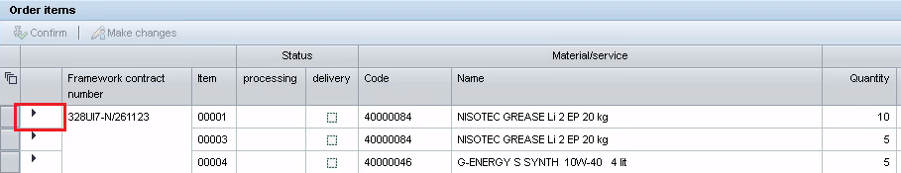
To collapse the part with additional information on order item, click .
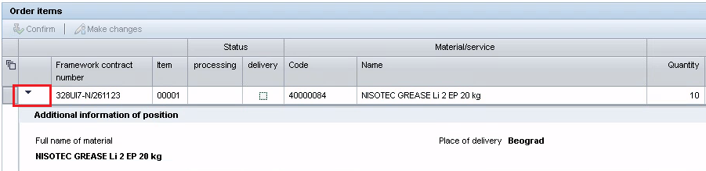
To select all order items simultaneously, click .
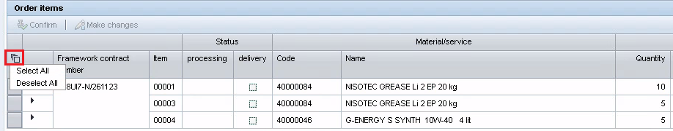
The order items table contains the following fields:
Field | Description
Framework contract number | Number of framework contract the items of which are contained in the KupiNa order
Item number | Item number
Item processing status | In the column for each order item, the status of its processing by the Supplier is shown:  - “Confirmed”  - “Not confirmed”
Delivery status | In the column for each order item, the status of its delivery is shown:  - “Delivery was not carried out”  - “Partially delivered”  - “Delivery completed”
Materials/service code | Materials/service code for order item is shown
Materials/service | Name of materials/service for order item is shown
Detailed name of material | This field is shown when order item line is opened
Price for unit | Price for unit of materials/service for order item
Quantity | Quantity of materials/service requested for delivery
Unit of Measure | Unit of measure of materials/service for order item
Delivery period (calendar days) | Shows the normative delivery date of materials/service
Normative delivery date | Normative delivery date per number of calendar days is shown
Place of delivery | This field is shown when the row containing the order item is opened only for items of the “Material” type orders
Place of provision of services | This field is shown when the row containing the order item is opened only for items of the “Service” type orders
Quantity | This field is completed by the Supplier
Commentary | This field is completed by the Supplier
In order to return to the KupiNa order list screen, click “Back to order list”.
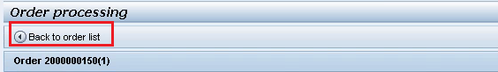

Reviewing Documents Enclosed with KupiNa Orders
To review the documentation enclosed by the Customer with the KupiNa order, click
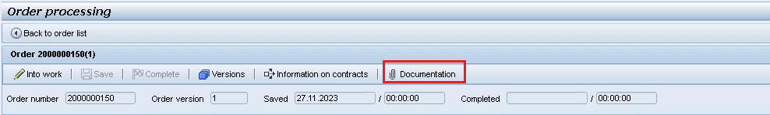
“Documentation” window will open, which contains the list of documents enclosed by the Customer that are marked as “Send to Supplier” and commentaries to enclosed files.

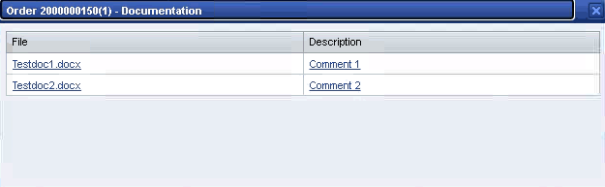

When you click the file name in the “Documentation File” field, downloading of the enclosed document will start.
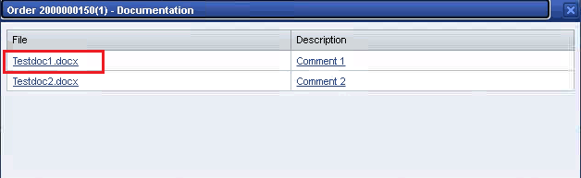

Reviewing Information on Contracts
To review information on contract/contracts, the items of which are included in the order, click
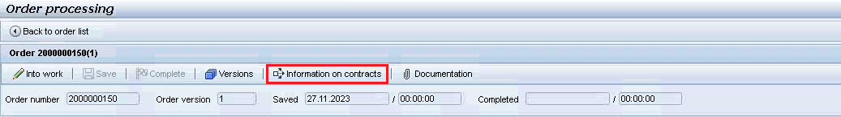
“Information on contracts” window will open, which contains information on the contract and on the status of its performance.
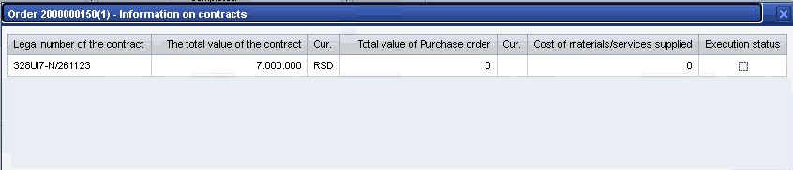

KupiNa Order Processing
To transfer the KupiNa order status to “Into work”, click
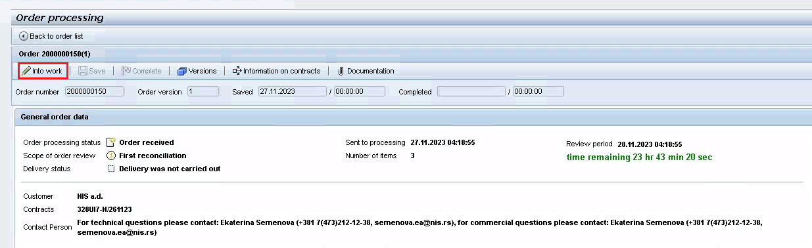
When transferring the order into work, message will show, order processing status will change to “Take into processing” and the “Into work” button will become inactive
Buttons for order processing will be available.
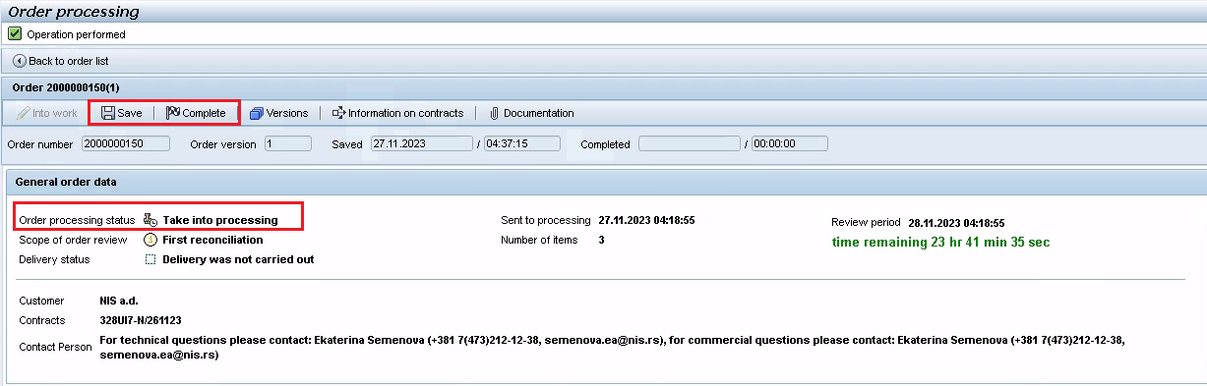

Order Item Confirmation
To confirm the order items, select the item/items and click
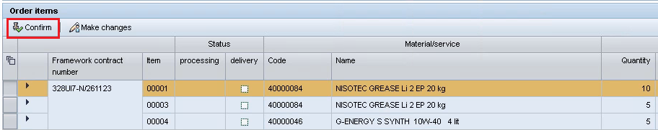
Order item will show processing status "Confirmed".
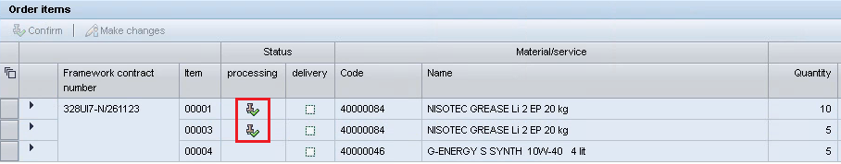
Important: the order will be deemed confirmed if all order items are confirmed.
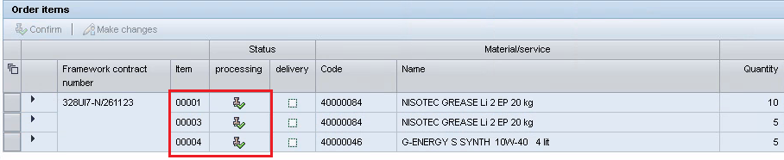

Order Item Change
To change the order item, select the item/items and click
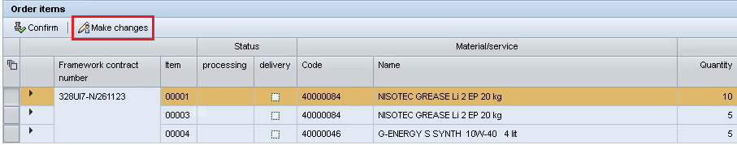
Order item will show processing status "Not confirmed".
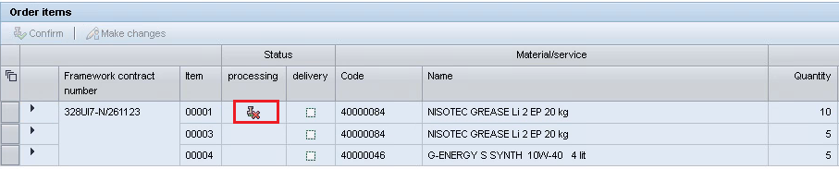
Fields in the “Supplier terms and conditions” section will be available for input:
- Quantity
- Commentary
If the Supplier has not confirmed the terms and conditions which have been specified by the Customer for the order item, Supplier must include a comment and/or proposed its terms and conditions for the delivery quantity.
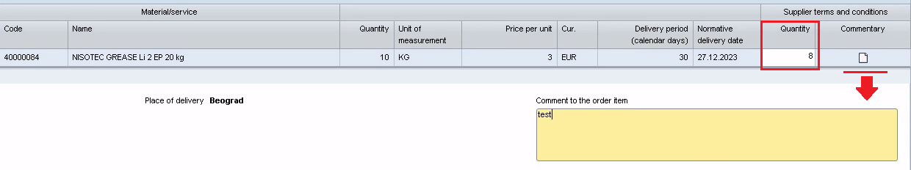
To save the changes entered in the order, click
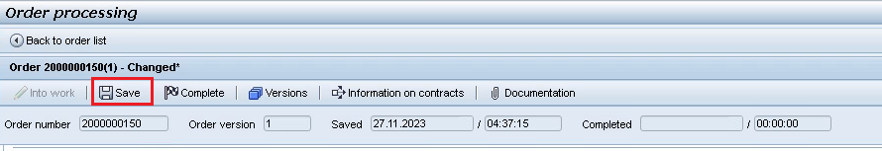
Important: if the Customer set the permitted % of tolerance for an order (for more than 10% of the quantity requested by the Customer for delivery per item) upon saving the terms and conditions entered by the Supplier, permissible quantity check will be made. If the quantity specified by the Supplier is not within the permitted range, when saving the order, error message will appear.
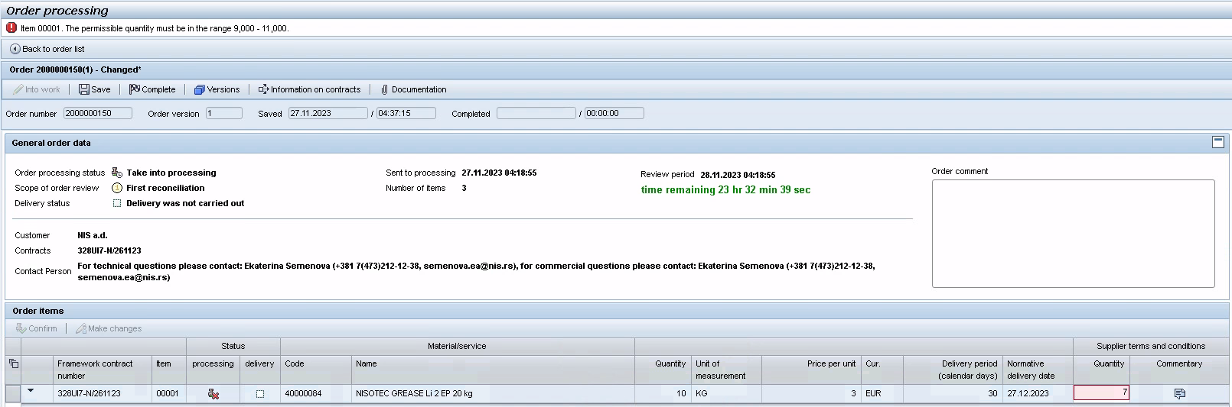

Order Processing Completion
To complete order processing, click
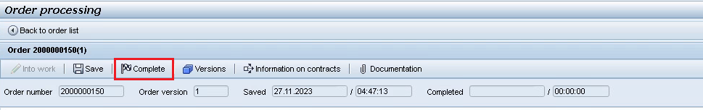
Action confirmation dialogue box will appear.
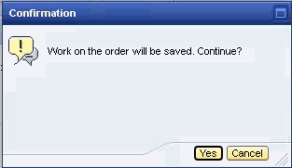
Upon completion of order processing, a check is run to establish whether all items of the order have been processed. If an item/items are not processed, error message will appear:
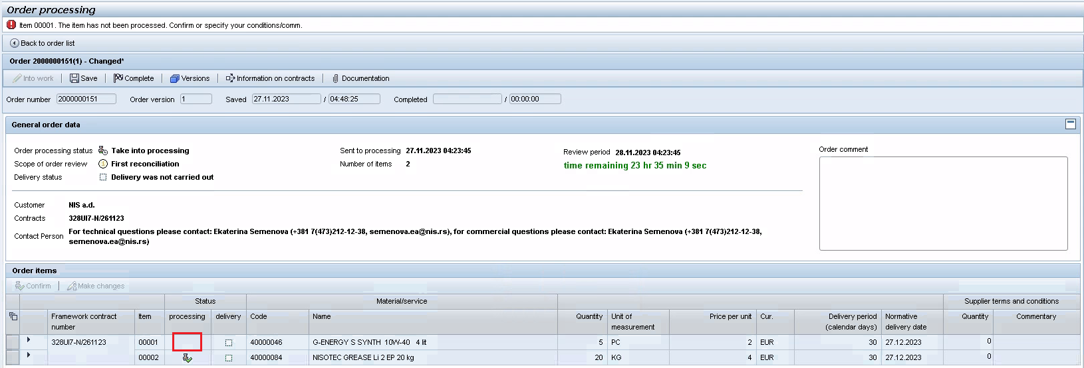
If all items have been confirmed (processing status “Confirmed”), upon completion of processing, the order will be fully confirmed.
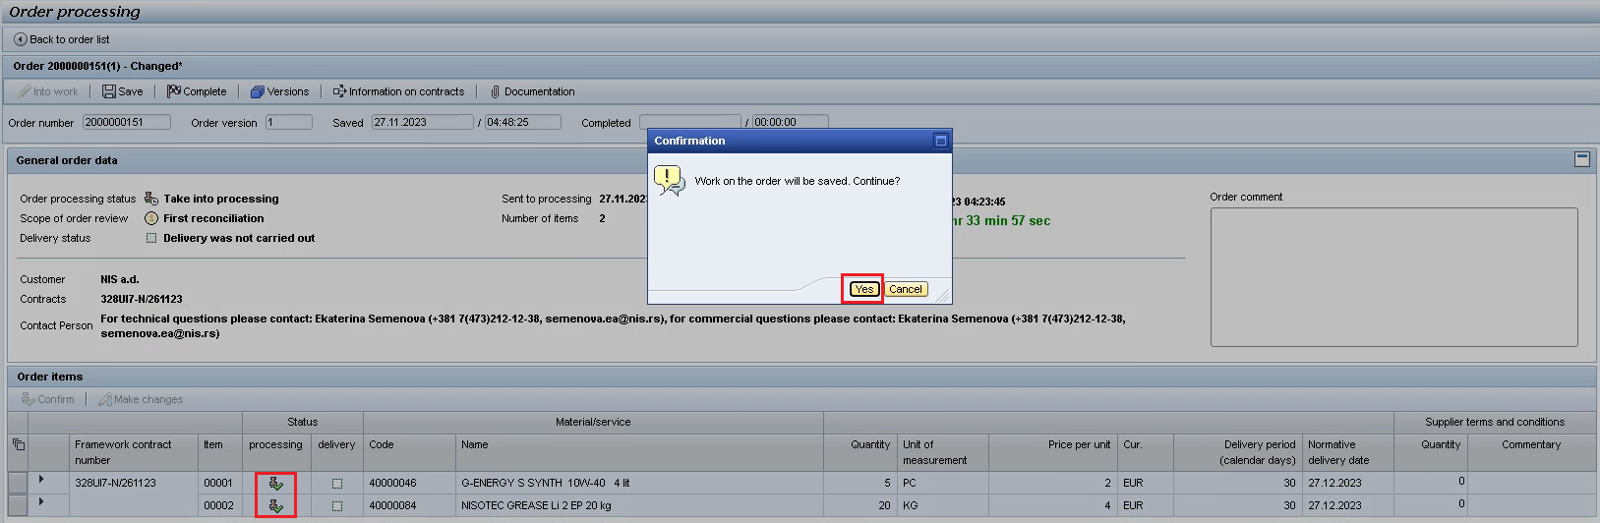
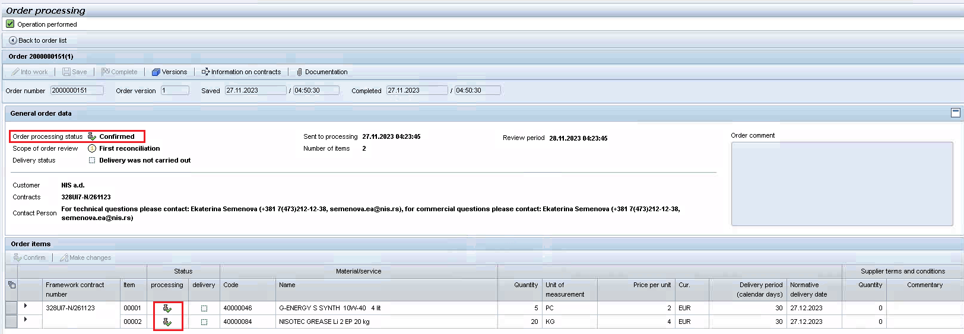
Information on KupiNa order confirmation by the Supplier will be automatically sent to the Customer.
If an item/items have not been confirmed (processing status “Not confirmed”), upon completion of processing, a check is run to establish whether Supplier’s terms and conditions are entered (quantity proposed by the Supplier and/or commentary):
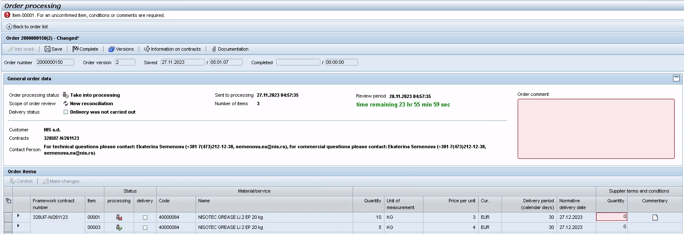
Supplier’s commentary can be specified either for an order item or for the item as a whole.
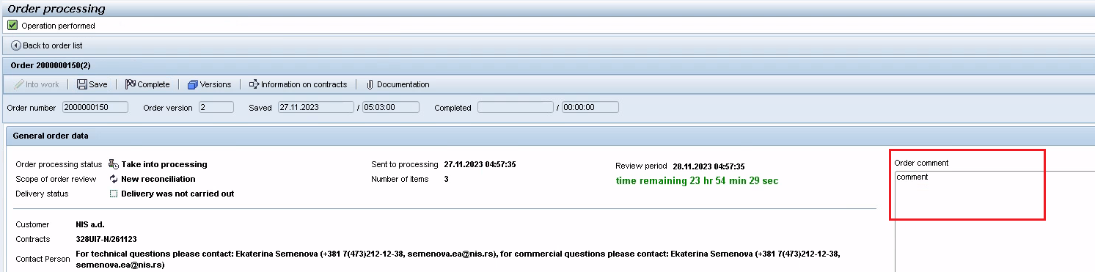
Important: an order for which the terms and conditions are not confirmed by the Supplier and for which Supplier has entered its comments and suggestions, will be delivered to the Customer for consideration and approval upon completion of processing.
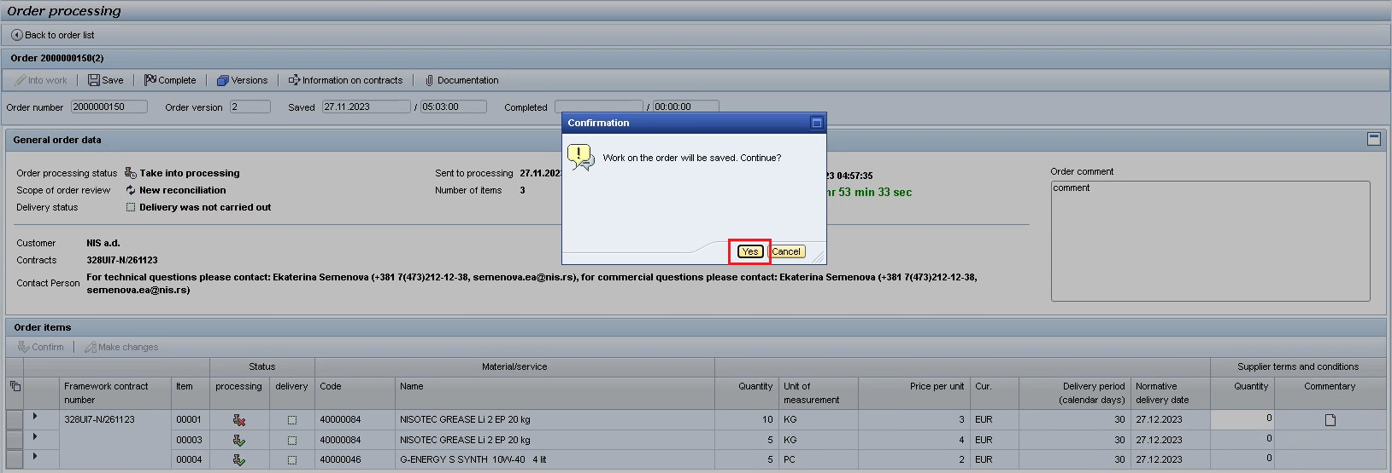
The order status is set to “Sent to the Customer for approval”.
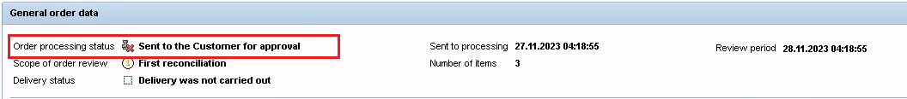

New Reconciliation of Order, Review of Order Versions
For orders that have been resent for processing and confirmation to the Supplier, “New reconciliation” indicator is shown on the screen together with the list of orders.
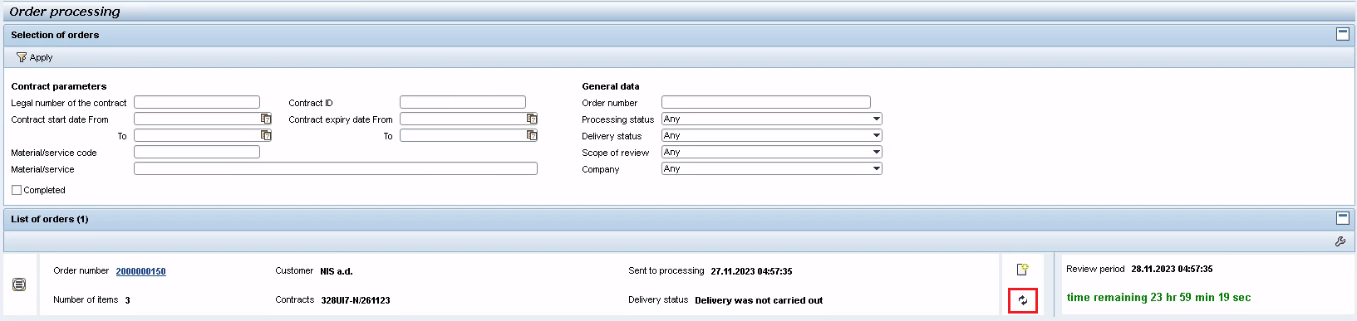
On the processing and confirmation screen, the status “New reconciliation” will show in the “Scope of order review” field
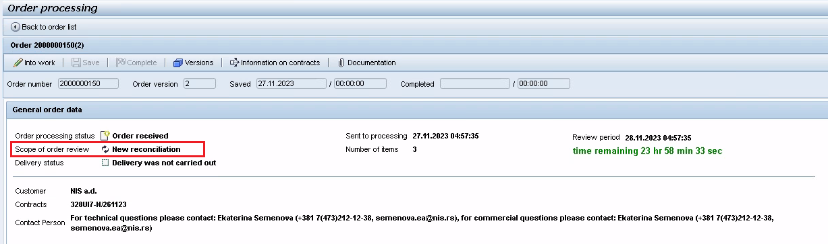
To view the versions of the order, click
Information screen containing all versions of the order will open.
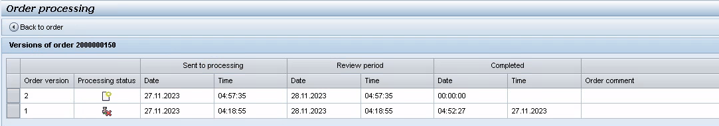

You can export the purchase order to PDF format by clicking the button
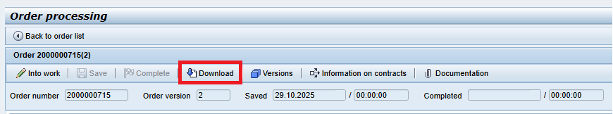

The purchase order will be automatically saved on your computer:
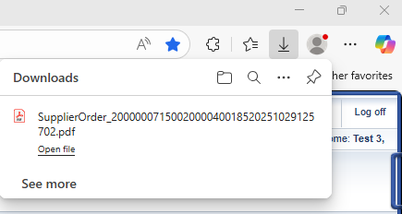

In downloaded file, you will see the purchase order:
