**User Guide**

**Registration and offer submission for service provider process selection on SAP SRM portal**

Table of contents

1. Purpose 3

2. Entering the electronic trading platform SAP Portal 4

2.1. Activation of an individual password during the first entry to the electronic trading platform/changing password after 60 days 4

2.2. Recovering lost password 6

2.3. E-mail change request 8

2.4. Operations guide 10

3. Working on SAP Portal 12

3.1. Viewing the list of procedures for service provider selection 12

3.2. Viewing information on the procedure: a list of lots and a package of documents of the organizing party 15

3.2.1. List of lots 16

3.2.2. The organizing party’s package of documents by procedure 17

3.3. Preparation of an offer for participation in the procedure: contact details 17

3.4. Preparation of an offer for participation in the procedure: technical questionnaire 18

3.5. Preparation of an offer for participation in the procedure: uploading a set of documents 22

3.6. Preparation of an offer for participation in the procedure: making a commercial part of the offer 24

4. Submitting a cost offer for participation in commercial negotiations 41

5. Offer return for editing, refusal from participation in service provider selection 46

5.1. Offer return for processing 46

5.2. Refusal form participation 46

# Purpose

This User Guide determines the sequence of actions for suppliers who have to interact with the system for selection of service providers for “NIS j.s.c. Novi Sad” and describes the steps a user has to take in order to:

* enter the electronic trading platform SAP Portal “NIS j.s.c. Novi Sad”, register an individual password;
* view the list of procedures for selection of service providers;
* download and view attachment documents to service provider selection procedure;
* view the list of lots for the procedure;
* upload supplier documents related to the procedure;
* create and submit offers for participation in the procedure;
* create an alternative supplier’s offer;
* return the offer for an update, offer modification;
* refuse from participation in service provider selection procedure.

# Entering the electronic trading platform SAP Portal

If the registration was successful and the user has received an individual login and password, the electronic trading platform of «NIS j.s.c. Novi Sad” is accessible by link **<https://srm.nis.rs>**

## Activation of an individual password during the first entry to the electronic trading platform/changing password after 60 days

In order to be registered on the electronic trading platform you are provided an initial password which is valid for the first entry only, First entry with individual password is possible within 10 days from e-mail notification that your account is created.

Go to [**https://srm.nis.rs**](https://srm.nis.rs), enter the user login and the initial password. After you have entered the user login and the initial password click on  button:

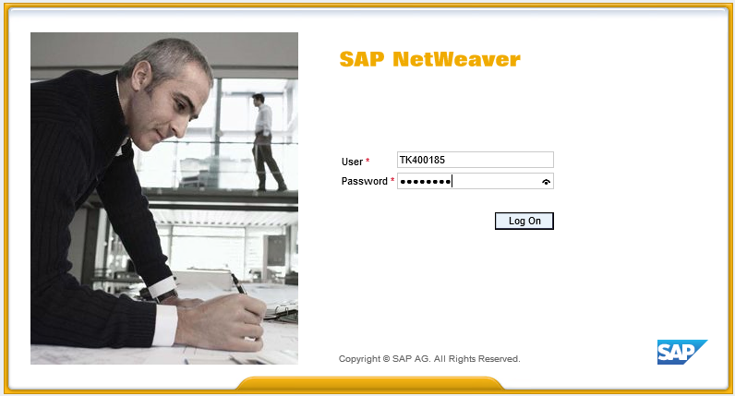

Then you will be requested to change the initial password for your **new individual password**:

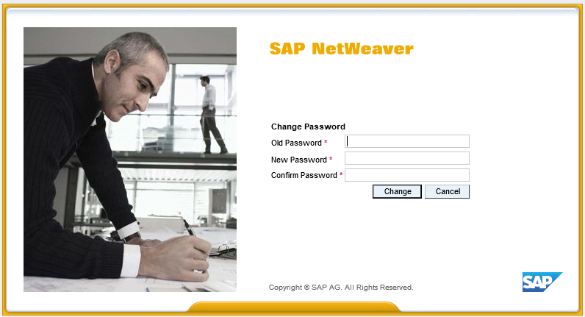

You change the initial password for the individual passport only when you enter SAP Portal for the first time:

* In “**Old Password**”  field enter the initial password which was sent to you y email.
* In “**New Password**”  field enter your new individual password. **Make the new password on your own, this will be your password for working on SAP Portal.**

Following rules apply for entering a new password:

a) Minimum 8 characters in length

b) Must include at least one number (0 to 9)

c) Must include at least four letters

d) Must not contain reserved words such as the name of the company "NIS" and the programme "SAP".

We recommend you not to use simple passwords (date of birth, combinaton of following signs, like "123","765","qwе").

After successfully entering the new password, use it in your future work. The initial password is used only for the first log-in.

* In “Confirm Password”  field enter again your new individual password.
* Click “**Change**” . If all fields are filled-in correctly, you new individual password will be activated. Then at subsequent entries on SAP Portal you always specify your new individual password.

If the data is not entered correctly, a message will be displayed :

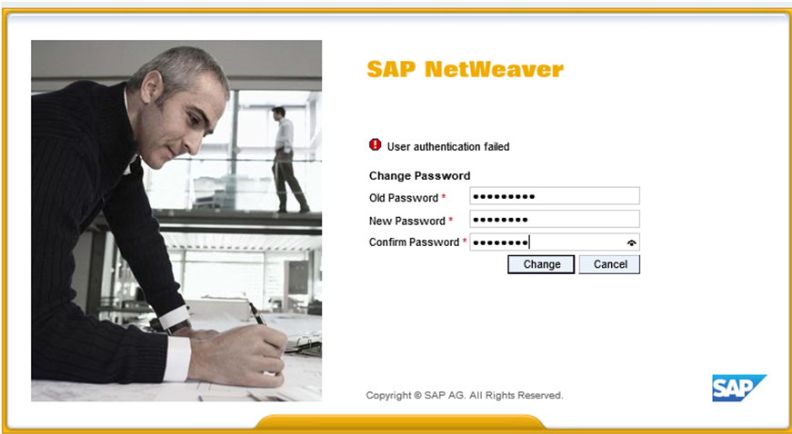

**In order to prevent abuse:**

**1. The initial password is valid for 10 days. In case you do not change the password in this period and enter a individual (if you have not entered SAP Portal ever) your password will be canceled and access will be automatically blocked.**

**2. The individual password is valid for 60 days. Upon expiration of this period, when applying to the SAP Portal, the system requires the change of the expired password into a new valid one. The procedure for changing the expired password into a new valid is the same as when changing the initial into a new one.**

**3. To avoid abuse, please do not write down your password and control the transfer of password to your employees.**

**4. If any of your employees left the company, we recommend changing the password.**

**5. We also recommend changing the password in any other occasion when you think it is needed.**

## Recovering lost password

If you happen to lose or forget your password, use the recovery password feature.

To send a request for recovering your password, click the  on the log-in page.

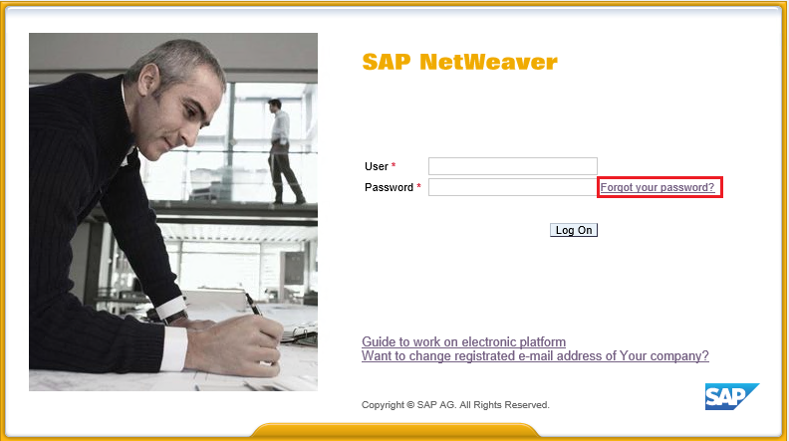

It will open a window with a form which you will have to fill to have your password recovered.

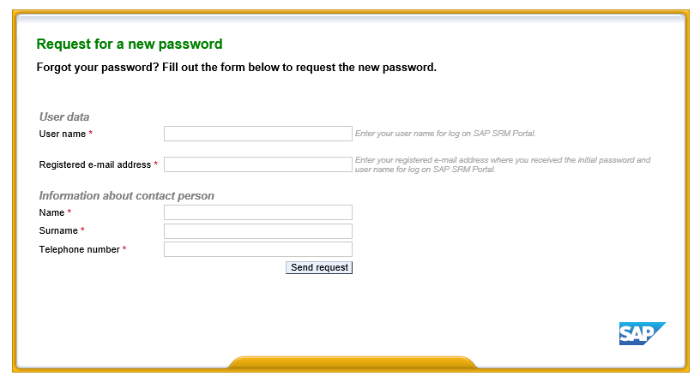

Fill out the user data and contact details.

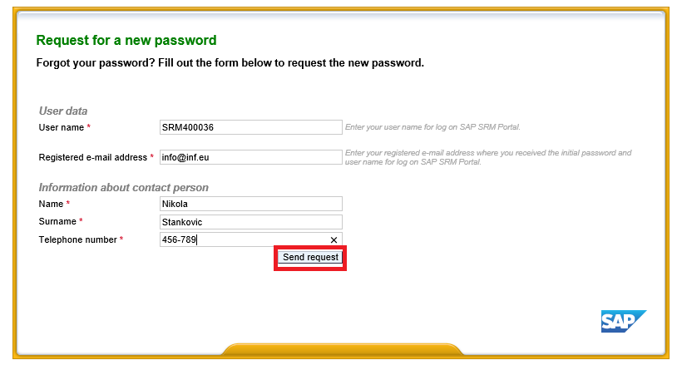

Mandatory fields are marked with this symbol .

Once you are done filling out mandatory fields, press . It will send your request for recovering your password.

After that, you will receive the initial password that needs to be changed to the individual as follows:

* Use the “**Old password”**  field to enter your initial password that was sent to your e-mail.
* Use the “**New password”**  field to enter your new personal password.
* Use “**Confirm password”**  field to re-enter your new personal password.

For new password cannot be entered one of the previous three used passwords (the system remembers the previous three used passwords and does not allow them to be reuse).

## E-mail change request

If your company has changed its e-mails, you can use the portal to request respective changes for your email address.

To send a request for changing your e-mail address, click on this link on the log-in page.

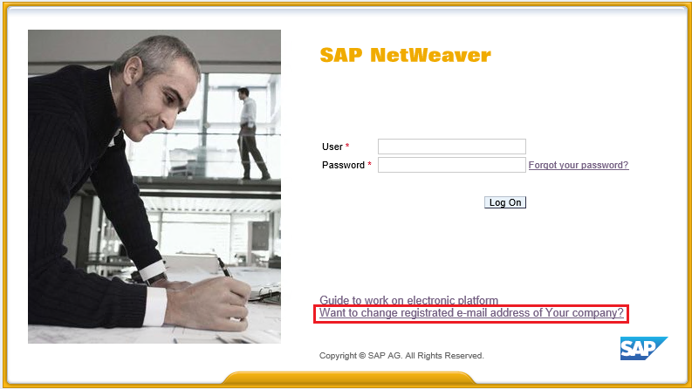

It will open a window with a form for changing your e-mail address.

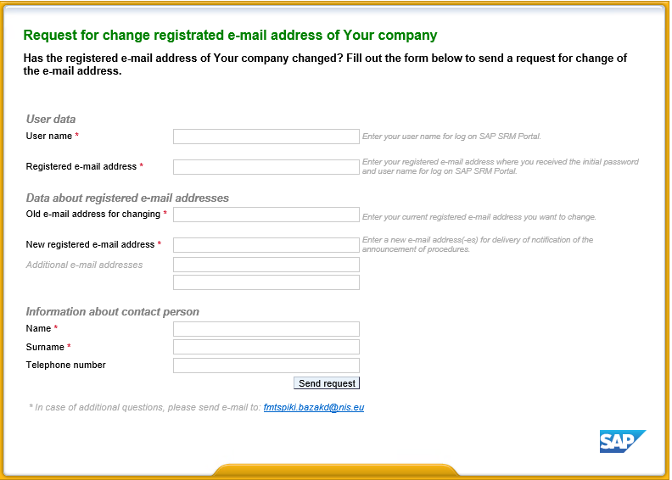

Fill out your data, the company’s new registered e-mail address and your contact information.

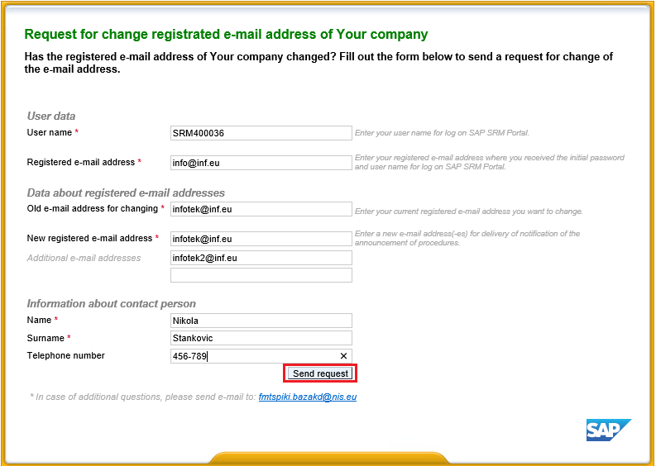

Once you fill out the mandatory fields, press . A request for a change of your e-mail address will be sent.

Note: if you have any questions, feel free to use the help feature by mailing at [fmtspiki.bazakd@nis.eu](mailto:fmtspiki.bazakd@nis.eu).

## Operations guide

There is a link on the portal that you can click to access the instructions on how to handle the requests for participation in bids for the supply of materiel and services. To access the instructions, click here.

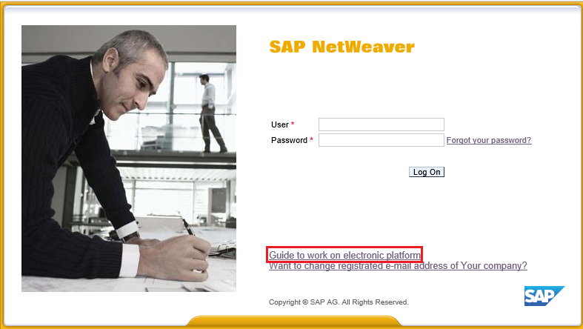

This link will take you to a page where you will have a chance to read or download instructions for suppliers in Serbian, English, and Russian.

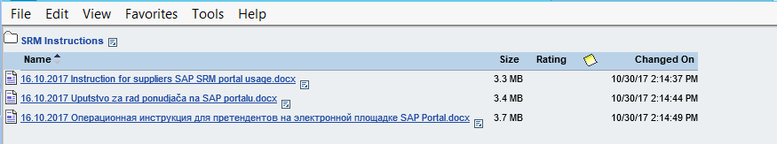

# Working on SAP Portal

## Viewing the list of procedures for service provider selection

After successful log on to SAP Portal, the user will have access to the individual workplace of participation in procedures for selection of materials/equipment suppliers and service providers.

To view the list of service provider selection go to tab «Procedures for prevision of services».

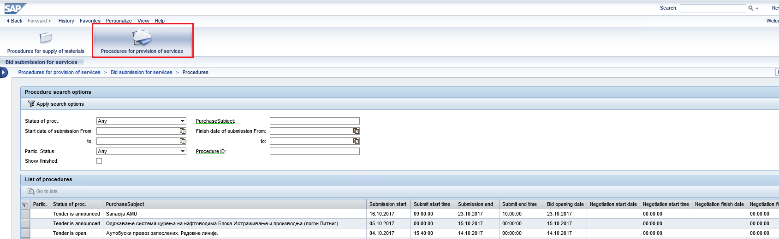

At the top of the screen you will see a list of filters for various attributes of procedures (procedure status, timeframe, subject of procurement, etc.):

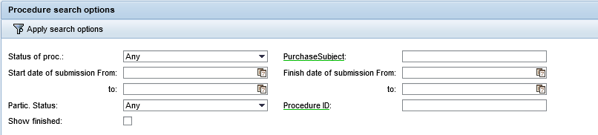

By default, active procedures are displayed in the list: the announced procedures and procedures, which are currently accepting initial offers or accepting updated offers during commercial negotiations.



To display the completed procedures for selecting service providers, set the indicator . It will show a list of procedures which no longer accept offers.



To use filters, set the value in the required field and click the button  .

Please note what value is set in the “Participation Status” field:

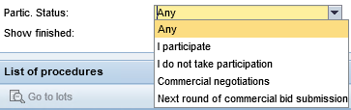

* If you want to select all procedures, select the status “All” and click the button .
* If you want to select procedures where you are participating or participated, select status “Participate” and click .

Procedures where you are participating / participated will be marked by symbol  in the list of procedures:



Procedures where you are participating / participated and which are at commercial negotiations stage will be marked by symbol  in the list of procedures.

The description of additional filters for various attributes of procedures is in the table below:

| **Field name** | **Description** |
| --- | --- |
| Procedure status | Procedure status at different stages.    Viewing the procedure and downloading the documentation is available on the "Announced" status. The submission of the proposal is available on the status of "Admission of offers is open." On the remaining statuses, the procedure and information on the offer are available for viewing. |
| Procurement subject | Enter the name of procurement subject. A search by fragment of the name is available, when fragment of the name is entered between two “*” symbols (asterisks), for example: |
| Offers admission start period: from … to | Offers admission start date. You fill this field by picking a date in the calendar. To open the calendar, click on :    You can specify a range of dates: |
| Offers admission finish period: from … to | Offers admission finish date. You fill this field by picking a date in the calendar. To open the calendar, click on :    You can specify a range of dates: |
| Participation status | Bidder’s participation status:    Values available:   * **All** - Displays all procedures available to the applicant * **I participate** - Displays procedures in which the bidder has already submitted an offer   (if there is a record of the offer in the log for the current procedure ID and the current counterparty code).   * **I don’t participate** - Displays procedures in which the bidder is not participating   (there is no record of the offer in the log for the current procedure ID and the current counterparty code).   * **Commercial negotiations** - Displays procedures in which the applicant takes part and for which a new stage was initiated (commercial negotiations). |
| Procedure ID | For a search, enter procedure system number    A search by fragment of the number is available, for example, the following value will display procedures with a value of "66" in the last two digits of the procedure number: |

**Note:** to form an offer for the selected procedure, you must perform the following actions:

* Download and view a package of application documents for the procedure for selecting a service provider, view the list of lots for the procedure, select the desired lot (see item 4.2).
* Enter the contact details of the person responsible for submitting the offer (see item 4.3).
* Fill in the bidder’s application form (see item 4.4).
* Upload the package of documents relevant to the procedure on the portal (see item 4.5).
* Prepare a commercial offer for the procedure and submit an offer (see item 4.6)

## Viewing information on the procedure: a list of lots and a package of documents of the organizing party

To view the information on the selection procedure, use additional filters related to attributes of procedures; in the list of procedures, find the desired one, select the line with the required procedure entry and click the button :



A data screen for the selected procedure will be displayed.

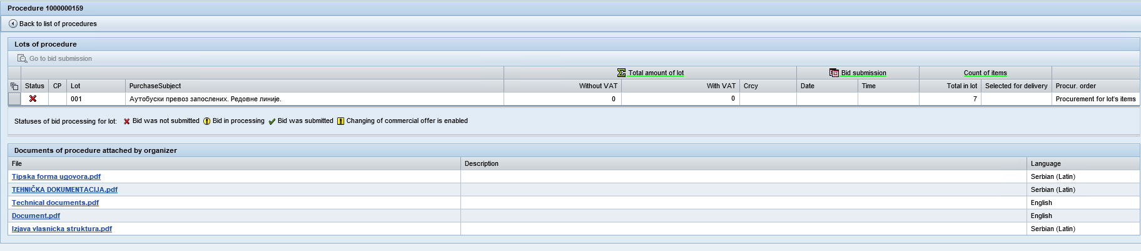

## List of lots

At the top of the screen you will see a list of lots and information on them, and at the bottom, a list of documents of the organizer for the selected procedure

The screen displays the following characteristics relevant to the lot:

| **Column** | **Description** |
| --- | --- |
| Status | Possible values for the field:  - there was no offer for participation in this lot;  - participation offer is under processing;  - offer has been submitted. |
| CN | Status showing that the organizer of the procedure has appointed Competitive Negotiations for this lot for participants |
| Lot | Lot number is specified |
| Subject of procurement | Subject of procurement name |
| Total cost for the lot | Total cost for the lot, VAT included and not included.  The information on the value in this field will be displayed only after the commercial offer for lot is created (saved) |
| Submission date | Offer submission date.  The information on the cost in this field will be displayed only after the commercial offer for lot is created (saved) |
| Submission time | Offer submission time.  The information on the cost in this field will be displayed only after the commercial offer for lot is created (saved) |
| Total number of items in the lot | Total number of items in the lot is shown |
| Number of items: selected for supply | The number of lot items that were selected by the bidder for delivery (having an active indicator in the "Mark" field) is displayed. Information in this field is displayed only after submitting a commercial offer for the lot |
| Order of procurement | Order of procurement: total for the lot or itemized |

## The organizing party’s package of documents by procedure

At the bottom of the screen, you will see a list of organizer documents related to the procedure:



To download the document, click the file name .

A file download dialog box will open. Click “Save” to download the document or “Open” to preview it.

## Preparation of an offer for participation in the procedure: contact details

To go to offer creation screen, as well as to view the offer, you must select the line with the required lot entry and click the button .



The screen with information on the lot that will open has four tabs:

* + 1. **Contact details**
    2. **Questionnaire**
    3. **Bidder’s documentation**
    4. **Commercial offer**

Each tab has a population indicator:

 - Data entered correctly and in full, information is saved

* - Data is incomplete or there are errors

The final submission of an offer is possible only after all the information tabs on the offer have been successfully processed

**Note:** preparation and submission of offers are possible when the procedure is on the status of “Admission of offers is open “Accepting proposals open”.

On the first tab "Contact details" it is required to enter contact details of the person responsible for submitting the offer, namely:

* E-mail address.
* Name and surname of the contact person.
* Contact phone number.

The tab will be automatically populated with the contact details of the supplier specified in the previous procedure in which it participated. Information is available for modification.

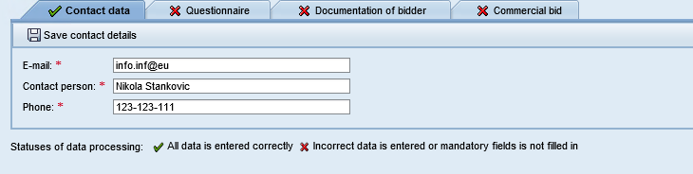

If the contact details have not been determined automatically or need to be modified, after you fill-in the tab fields, save the entered information by clicking the button .

In the window that opens, select the option to save contact information.

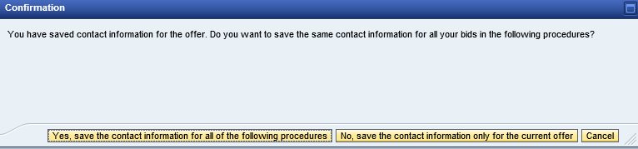

If you click on  button, the contact details that you specified will show by default in all procedures you are going to participate in future.

If you click on  button, the contact details that you specified will be saved for the current procedure only, and will not show by default in other procedures you are going to participate in future.

Information will be saved, the system will display a message .

After the information is successfully saved the tab indicator will change for .

If not all fields of the tab are filled-in, the indictor will stay . If you try to submit an offer, the system will indicate the errors.

## Preparation of an offer for participation in the procedure: technical questionnaire

To answer the questionnaire go to tab **“Technical questionnaire”**. You will see technical criteria specified for the lot, and the following info:

* Criterion name:

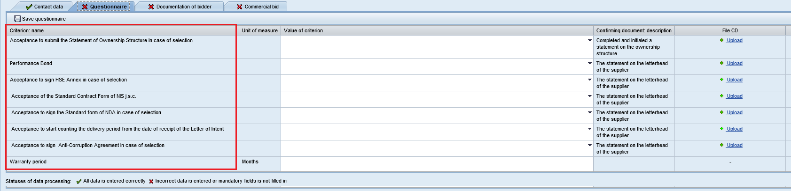

* Unit of measurement:

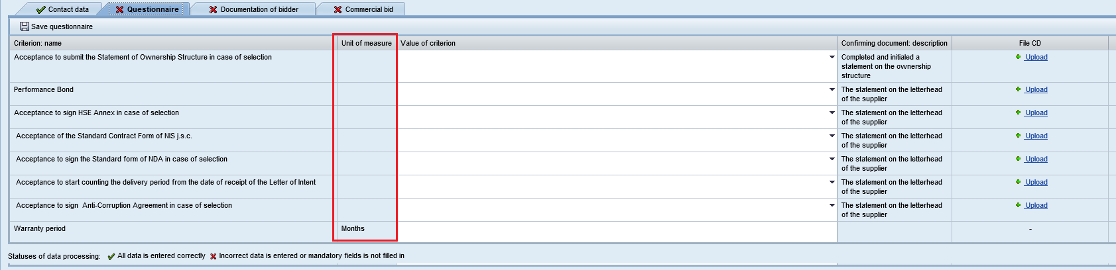

* Supporting document:

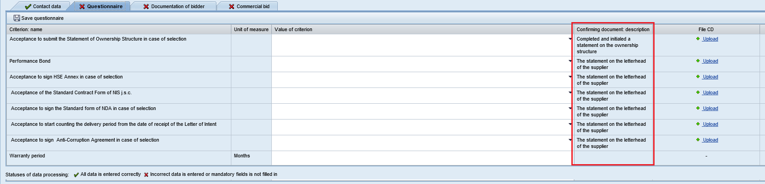

For each criterion in the "Criterion value" field, you must enter a value according to the unit of measurement specified for the criterion or select one of the options offered by the organizer from the drop-down list

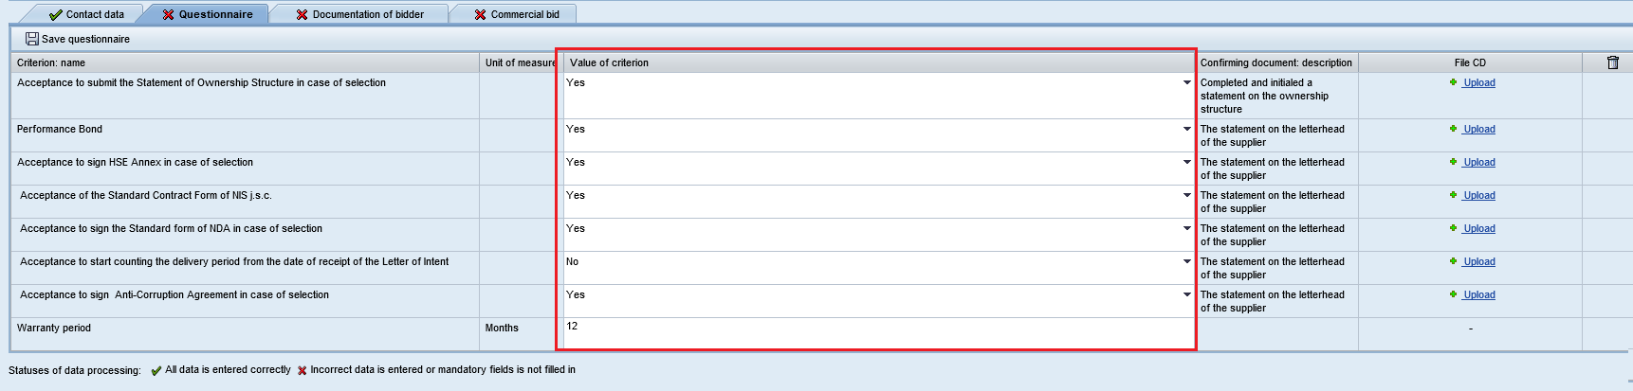

**Questionnaire criteria fill-in rules:**

* The value of the criterion shall be consistent with the unit of measurement.
* The delimiter for a fractional value of a criterion is the symbol “.” (point).
* If you see  in criterion value field it means that you can only choose from the drop-down list

In addition to your answer you can upload a supporting document. To do this, click on  in “SD file” field.

**Note:** It is not necessary to attach a supporting document.

To upload a supporting document, click on “Upload” button:

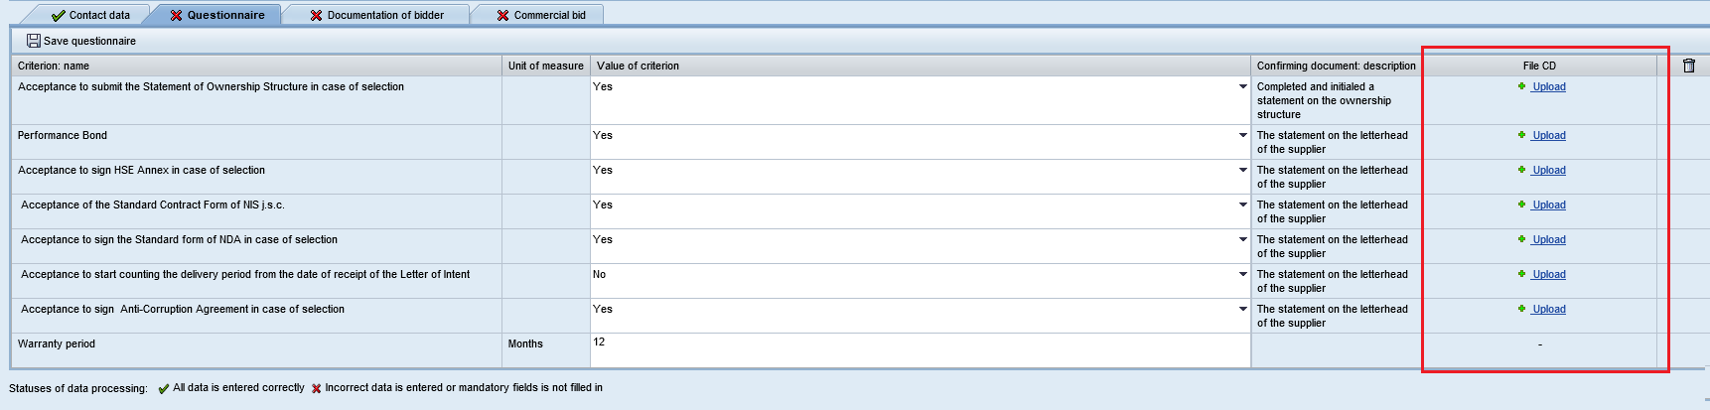

**Note: the maximum size of one file is 20 Mb.**

An upload dialog box will open. To upload the file click “Browse”:

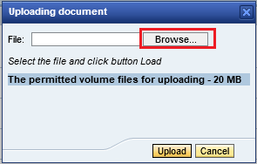

Select the file on your PC and click on “Open” button.

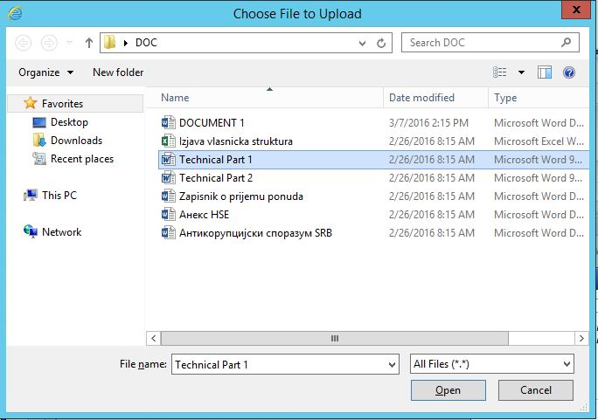

Click on “Upload” button:

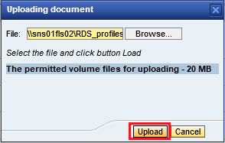

To cancel uploading and to close the dialog box click on “Cancel”:

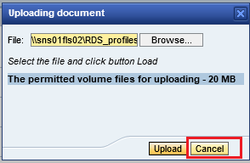

To delete a document you have uploaded by mistake click on  and upload a document again.



You can also attach supporting documents to the questionnaire criteria by uploading the documentation from your Personal Office.

To do so, click the button . Suppose there are attached files for a particular type of supporting document in the Personal Office and they are valid as of the opening date, such documentation is automatically attached to the questionnaire criteria with the attribute . If the document is not suitable in terms of validity (its validity period expires before the date of proposal opening for the procedure), the indicator . Clicking on the indicator will open a message like: .

After you have answered all questions of the questionnaire save the information by clicking on . If all information is entered correctly it will be saved and the system will display .

If answers to all criteria have been given and supporting documents were uploaded, the tab will change its indicator for :



If not all answers were given and not all supporting documents were uploaded, the tab’s indicator will stay . If you try to submit an offer, the system will indicate the errors.

## Preparation of an offer for participation in the procedure: uploading a set of documents

To attach a set of documents go to **“Bidder’s documentation”** tab.

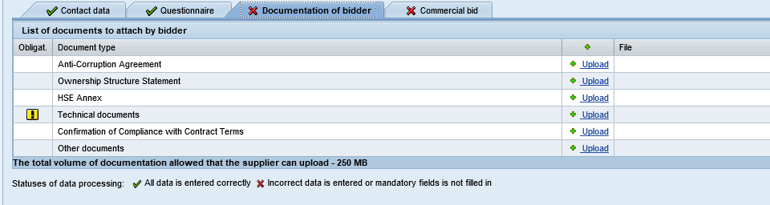

In this tab you see the list of required documents which can be uploaded. The indicator  means that uploading this document is mandatory.

**Note: the maximum size of one file is 20 Mb, the maximum size of the entire set of documents is 250 Mb.**

To upload the attachment click on “Upload” button . An upload window will open.

To select a file click on “Browse” button:



Select a file on your PC and click on “Open” button to confirm your selection.



Click on “Upload” button:



To cancel the uploading and close the window click on “Cancel”:



Technical document will be uploaded:

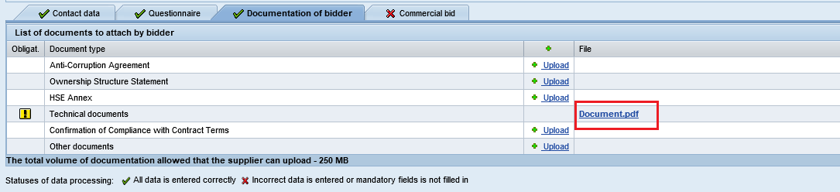

To delete an uploaded attachment click on :

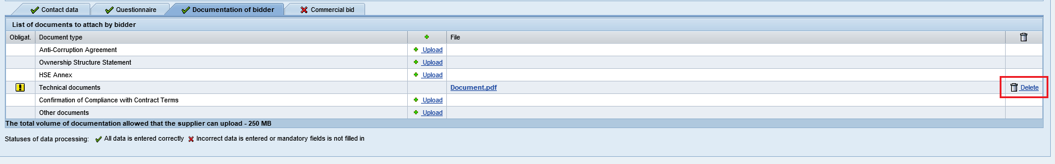

You can also attach supporting documents to the questionnaire criteria by uploading the documentation from your Personal Office.

To do so, click the button . Suppose there are attached files for a particular type of supporting document in the Personal Office and they are valid as of the opening date, such documentation is automatically attached to the questionnaire criteria with the attribute . If the document is not suitable in terms of validity (its validity period expires before the date of proposal opening for the procedure), the indicator . Clicking on the indicator will open a message like: .

After you have uploaded all documents marked with  as mandatory, the “Bidder’s documentation” tab will be considered filled-in.

The tab indicator will change for :



## Preparation of an offer for participation in the procedure: making a commercial part of the offer

To make the commercial part of your offer go to **“Commercial offer”** tab.

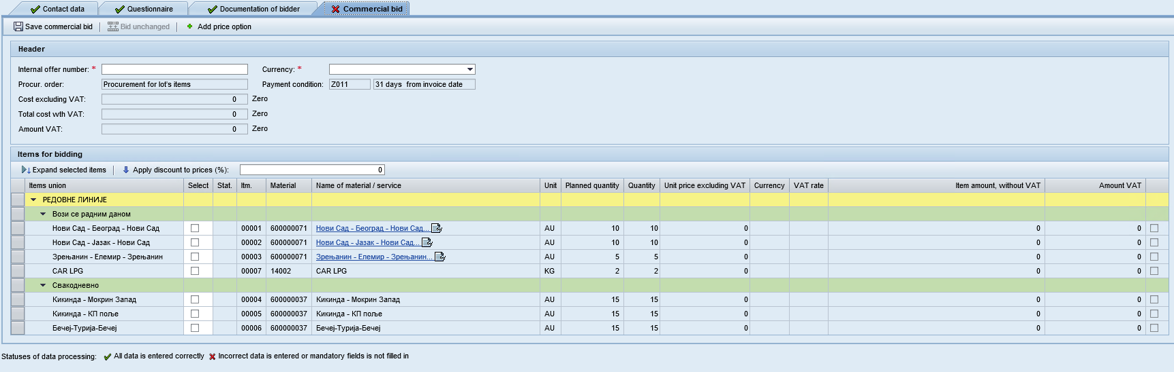

The fields that have to be filled-in are marked with .

At the top of the screen, enter some general information on your offer:

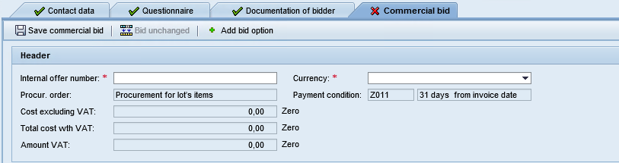

Internal number of the offer

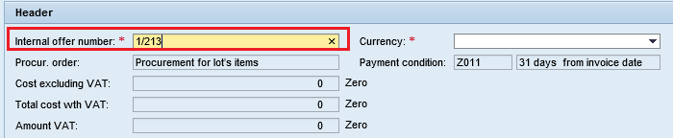

From the drop-down list, select the currency you are going to use for the offer.

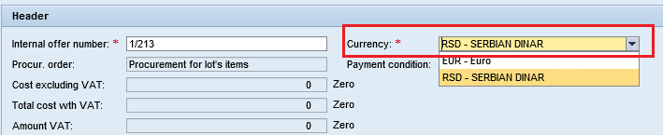

At the bottom of the offer, enter information on the items of the offer:

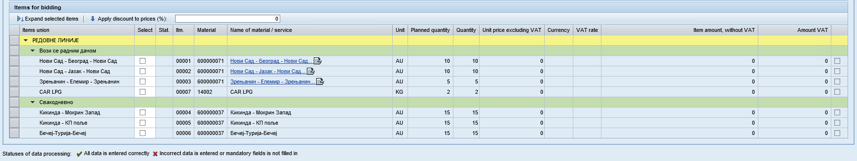

**Note:** When you point the cursor at the field, you will see a tooltip with a description:

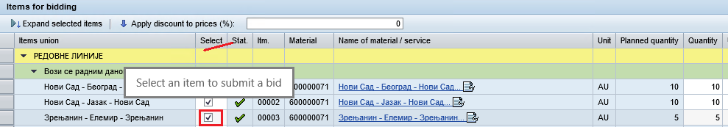

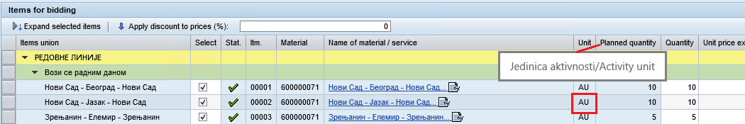

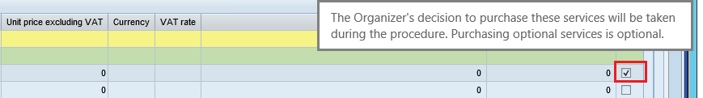

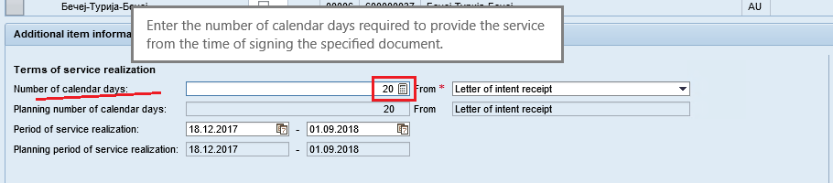

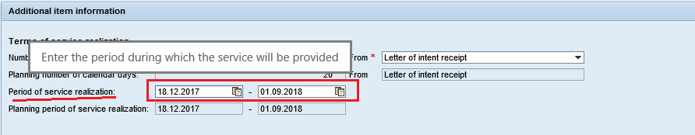

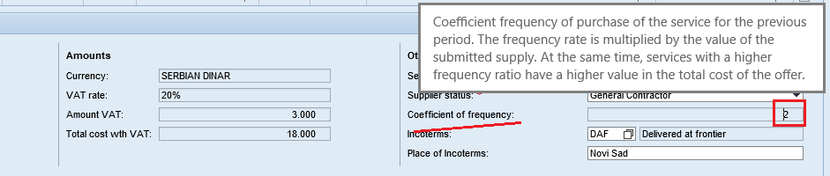

If the items of the offer form a structure, to show or hide items of different levels of the structure, you can use buttons /

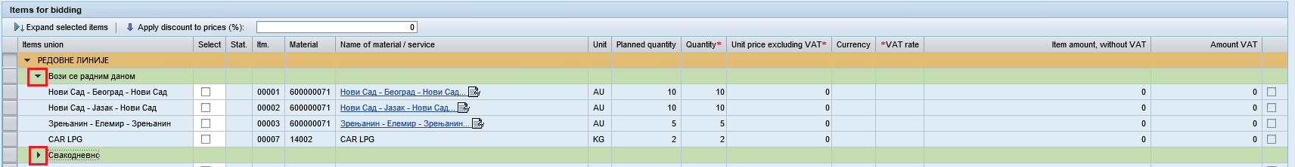

**Note:** if the Organizer of the procedure has determined the itemized procurement of services as the condition, the offer can be submitted for the selected list of items. To determine the list of items for which a commercial offer will be submitted, set an indicator in the field "Select".

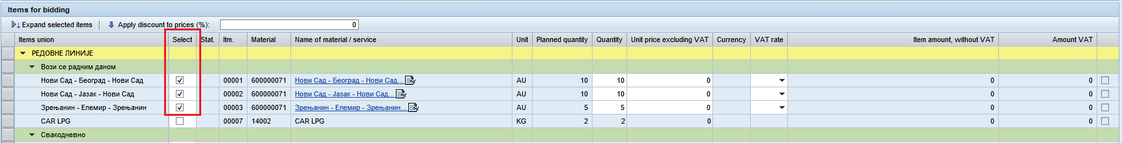

In the title part of the item, you have to fill-in the following information:

* offered quantity
* Unit price, VAT not included
* VAT rate.



After you have filled the data at the top of the item, proceed to filling in the detailed information on the item. To open detailed information on an item, click the line with the item.

Detailed information related to procurement of services:

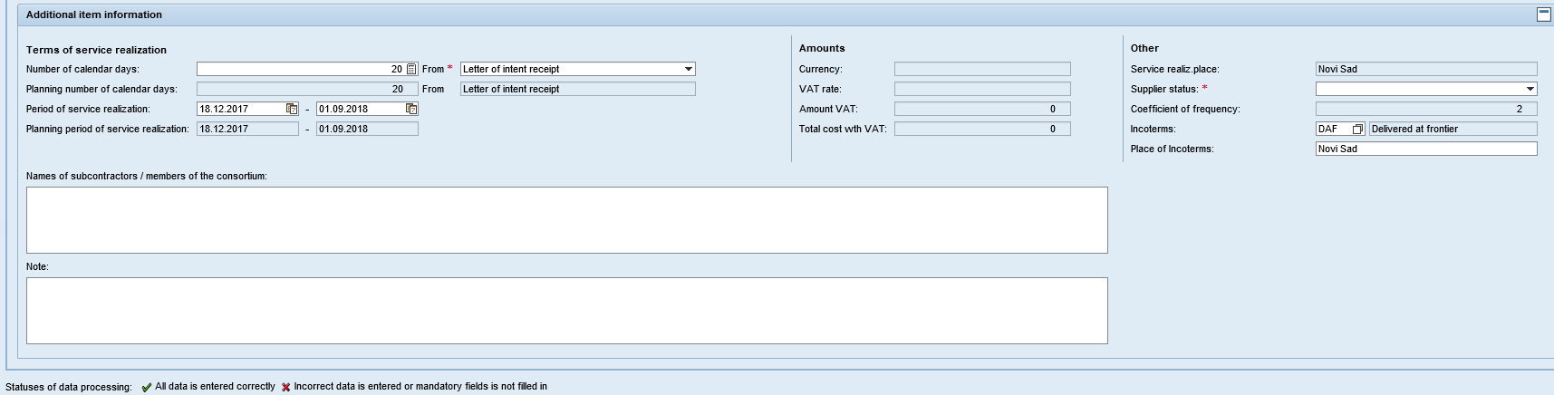

Note: if the purchase items have been generated using the norm-hours, then when you specify a proposal for this item, please also fill-in the mandatory fields "Norn-hours for installation" and "Price for norm-hours".

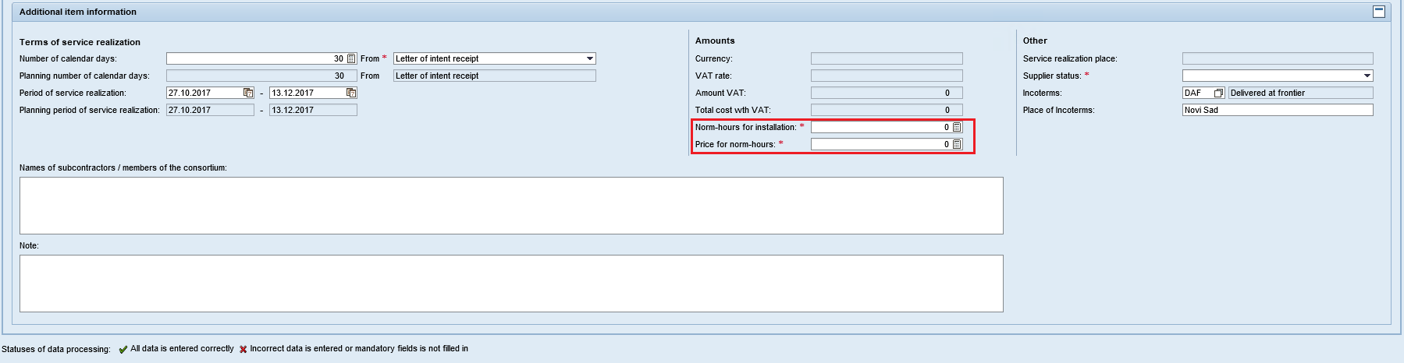

Detailed information related to procurement of materials:

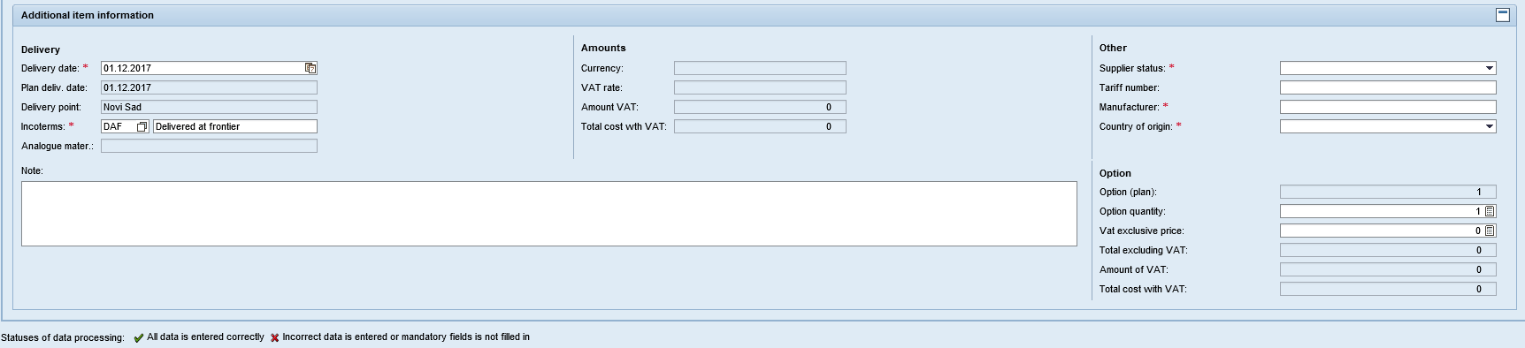

Mass Data Entry:

After selecting one or several lot positions in the "Commercial Bid" tab, clicking the "Mass Entry" button  will open a window with a list of fields available for mass entry:

1. Number of calendar days (numeric field, to be filled in manually)
2. From (to be filled in from the predefined list of options).

The "Mass Entry" button will become active when at least one position is selected

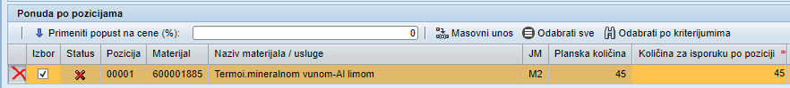

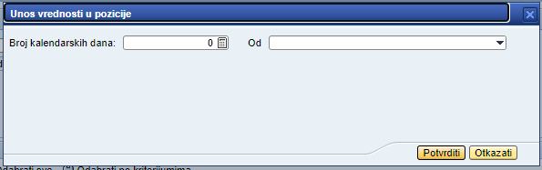

If MTR and service positions are selected, the following mass entry fields will appear on the screen:

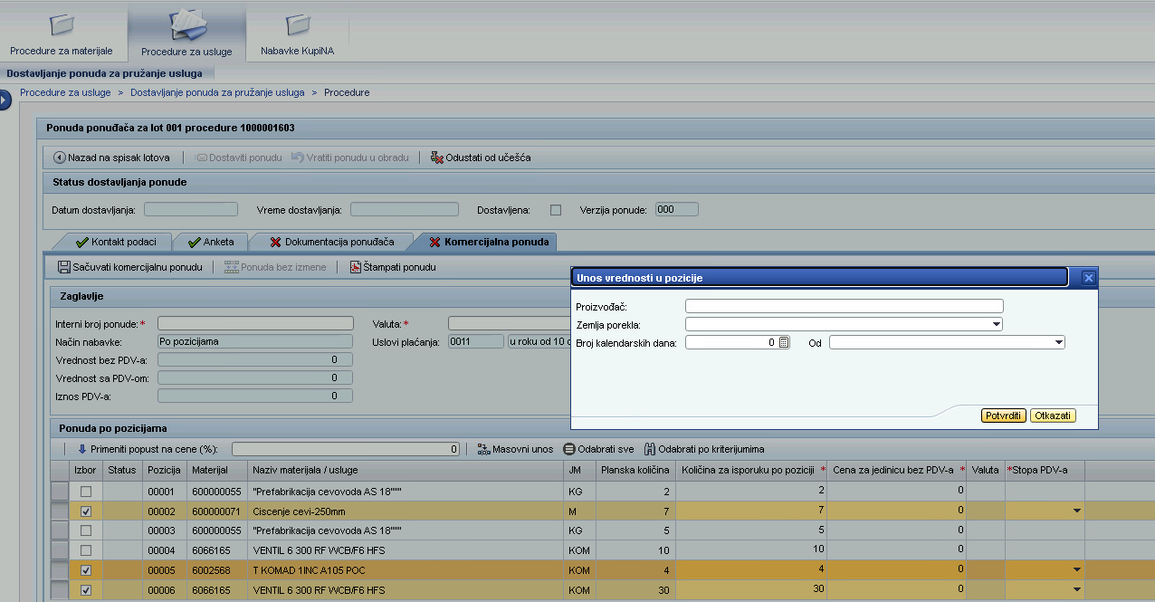

If only MTR positions are selected, the following mass entry fields will appear on the screen:

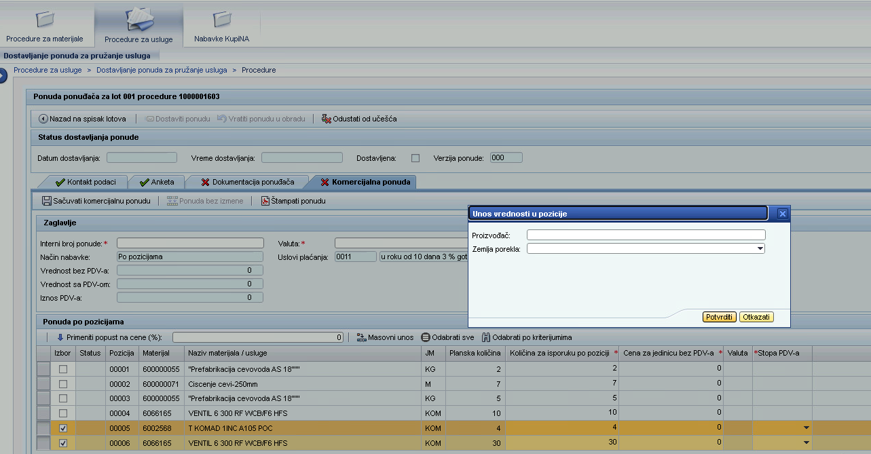

After clicking the "Confirm" button, the entered field values will be filled in at the selected positions.

One or more fields can be filled in on the screen. If only one of the fields is filled in on the screen, then the previously entered values for the other fields in all rows will remain unchanged. If a value is already specified in any row, it will be replaced with a new value.

See below the description of fields, informational and requiring to be filled-in, for services and materials:

| **Field name** | **Description** |
| --- | --- |
| **Item name** | |
| Selection | If the organizing party has specified the lot to be purchased in full, the selection of individual lot items will be unavailable (the "Select" field is not available for editing, all lot positions are selected by default). The offer is submitted for all positions of the lot.  If the organizing party has specified the lot to be purchased by items, it will be possible to select individual line items for the offer. To do this, put the indicator in the "Select" field. The fields of the selected items will be available for editing. |
| Status | Shows the result of checking the status of fill-in of the selected items, only selected items will be checked (with active  indicator in “Selection” field):  - the selected items is not filled-in or is filled-in incorrectly.  - the selected items is filled-in correctly |
| Item | Item number is shown |
| Material | Code of material/service is shown |
| Material/service name | Name of material/service is shown. If a detailed description of service/material is available, you will see icon  «Show detailed description» in material name line. When you click  a window with detailed description will open. |
| Unit of measurement | Unit of measurement for the specified material/service is shown |
| Planned quantity | The planned number for the current item is shown |
| Quantity per item | If a lot it to be purchased by items, it is possible to enter an amount different from the specified.  If a lot it to be purchased as a whole lot, the field is not available for filling and by default is filled with a value equal to the planned quantity |
| Unit price, VAT not included | You have to specify the unit price for material/service |
| Currency | Shows currency chosen for the offer |
| VAT rate | Select VAT rate (0% or 20%) |
| Item cost, VAT not included | The cost of the item without VAT is automatically calculated when saved based on price data and the quantity of material / service |
| Optional service | If the lot item is optional, the following indicator will be displayed |
| **Extra data for the service procurement item** | |
| **Service provision timeframe** | |
| Number of calendar days after document signing | Specify the number of calendar days to be counted from the moment the selected document is signed. You don’t specify the number of calendar days if you selected document “According to Terms of Reference”. |
| Document name | Specify the document from the moment of signing of which the specified number of calendar days is counted. Select from a pre-configured list of documents. |
| Number of calendar days (planned) | It shows the number of calendar days to be counted from the moment the selected document is signed. The number of calendar days will not be shown if you selected document “According to Terms of Reference”. |
| Document name (planned) | The document from the moment of signing of which the specified number of calendar days is counted, will be shown. |
| Period | Specify date of service provision start and completion |
| Period (planned) | The planned dates of service provision start and completion are shown |
| **Costs** | |
| Currency | Currency chosen for the offer is shown |
| VAT rate | VAT rate for the chosen item is shown |
| VAT amount | VAT amount for the chosen item is shown |
| Item cost, VAT included | Item cost is shown, VAT included |
| Norm-hours for installation | Specify the number of Norm-hours for installation |
| Price for norm-hours | Specify the price for norm-hours |
| **Extra** | |
| Service provision location | Service location is indicated |
| Provider status | Provider status is indicated |
| Incoterms | By default, Incoterms value specified by the organizer is displayed. The field is available for modification; if necessary, you can specify a different value by using the directory .  After selecting a code from the directory, Incoterms name will appear automatically  Note: the fields "Incoterms" and "Incoterms at frontier" are optional, but if one of the fields is filled-in, the second field must also be indicated. |
| Incoterms at frontier | By default it is filled with the planned value specified by the procedure organizer. Incoterms at frontier is available for modification. Note: the fields "Incoterms" and "Incoterms at frontier" are optional, but if one of the fields is filled-in, the second field must also be indicated. |
| Subcontractors / members of consortium | Specify names of subcontractors/ members of consortium.  Note: if the supplier's status is specified as "Subcontractors involvement" or "Consortium", the field "Name of subcontractors / consortium members" is mandatory. |
| Frequency of use | The value of the frequency of the service usage frequency is displayed (if in the selection conditions the Organizer chooses the corresponding option) |
| Note | If necessary, in the field “Note” you can enter an additional text note to the offer for the position |
| **More information on service procurement item** | |
| **Delivery** | |
| Delivery date | Specify delivery date |
| Planned delivery date | Planned delivery date is shown |
| Delivery location | Delivery location is shown. |
| Incoterms | By default, the value of the Incoterms specified by the organizer is displayed. The field is available for editing, and you can specify a different value: if so, use the directory.  After selecting the code from the directory, the name of the Incoterms will be shown automatically. The specified name can be edited. |
| Equivalent material | You can specify an equivalent material, if the Organizer has included this option |
| Note | В If necessary, in the field “Note” you can enter an additional text note to the offer for the position |
| **Costs** | |
| Currency | Currency chosen for the offer is shown |
| VAT rate | VAT rate for the chosen item is shown |
| VAT amount | VAT amount for the chosen item is shown |
| Item cost, VAT included | Item cost is shown, VAT included |
| **Extra** | |
| Supplier status | Shows the selected status of the supplier |
| Tariff number | You can specify a tariff number here |
| Manufacturer | Specify the manufacturer |
| Country of origin | Specify the country of origin by picking it from the directory :    In the opened directory, select the value or use the search, specifying the value in the first line and click :    Double-click the value to select it:    The field will be filled with the value selected. |
| **Option**  *\*this block will be shown if the Organizer has decided that an optional quantity can be specified* | |
| Option (plan) | The field indicates the planned optional quantity for the item that the procedure organizer specified |
| Option | The field specifies the optional (additional) quantity for delivery.  By default, the value of the optional quantity is equal to the planned optional quantity, but it is possible to change the value by specifying the desired quantity.  It is possible to specify a value of 0. |
| Unit price, VAT not included | It is required to specify the unit price for the optional quantity.  If an optional quantity is specified (the value is not zero), the price per unit of the option must be specified. |
| Cost, VAT not included | After saving, the automatically calculated cost for the optional quantity without VAT is displayed in the field |
| VAT amount | After saving, the automatically calculated amount of VAT for the option is displayed in the field |
| Cost, VAT included | After saving, the automatically calculated cost for the optional quantity is shown in the field, including VAT |

After entering all required information, click on the button “Save the offer”.

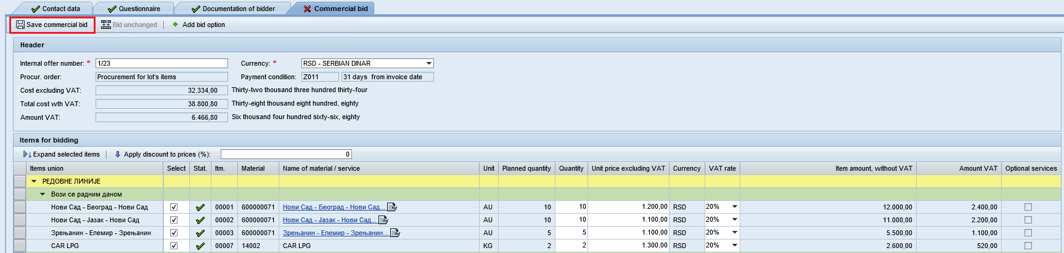

The information will be saved, the system will display the message .

If the fields are filled-in correctly, after saving they will be marked with status:

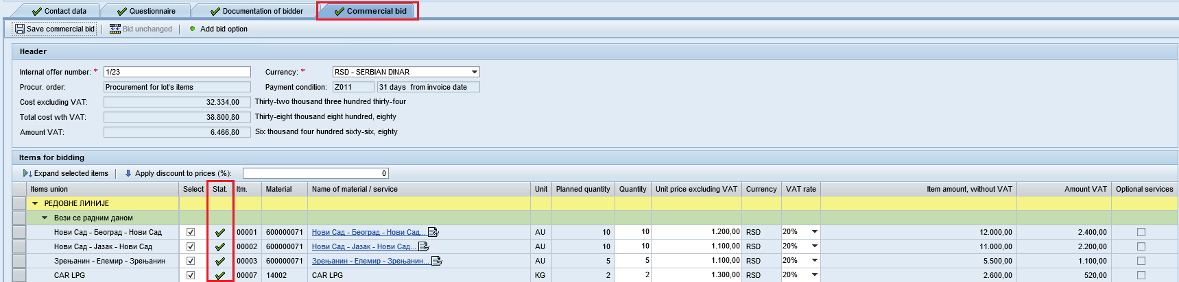

The fields of the header part of the offer after saving will be filled automatically, the entered data will be checked:

* The total cost of offer without VAT (numerical value and amount in words).
* The total cost of the offer with VAT (numerical value and amount in words).
* The total amount of VAT.

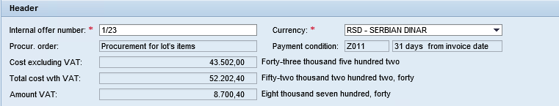

If the fields are filled-in correctly and in full, after saving the tab will be marked with status 

After saving, commercial bid can be downloaded as a separate file and saved to desktop. For downloading the bid, click on the option "Print the bid" .

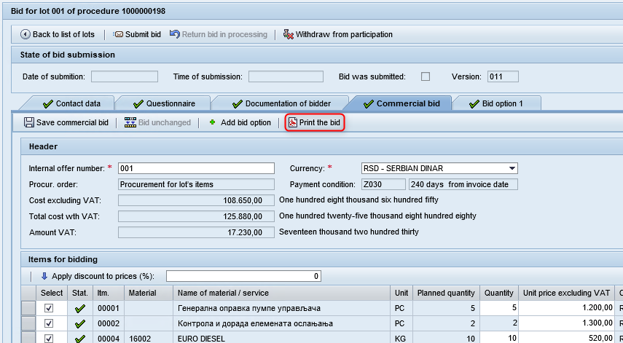

The system automatically generates a PDF file with data of commercial bid.

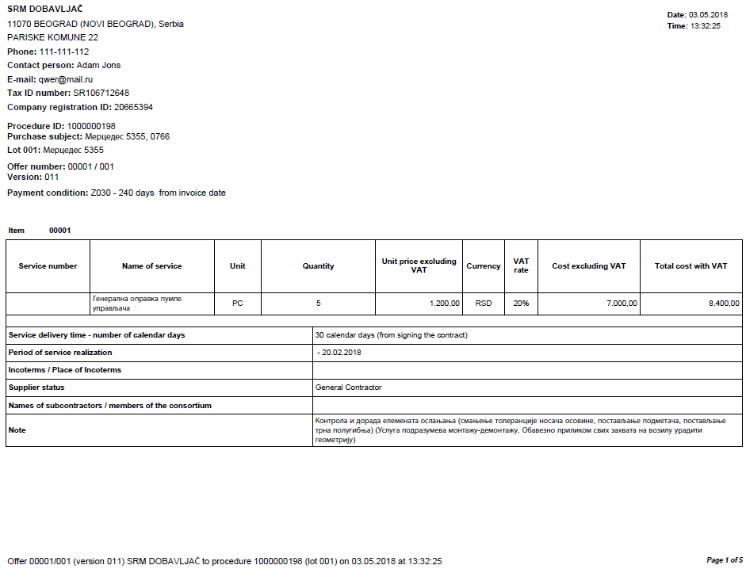

**Creating an alternative offer**

If the Organizer of the procedure has provided for the possibility of the supplier submitting alternative proposals, an additional button will be available on the “Commercial offer” tab 

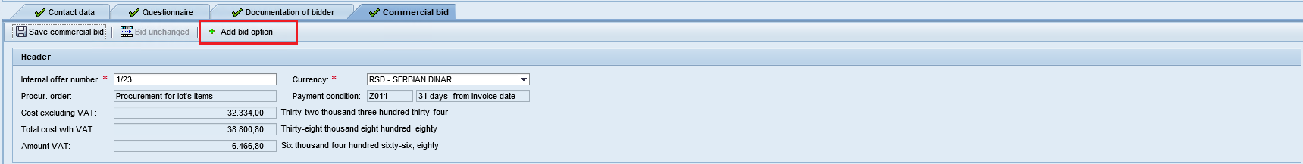

To create and an alternative offer, click . A new tab will open on screen, “Bid option 1”.

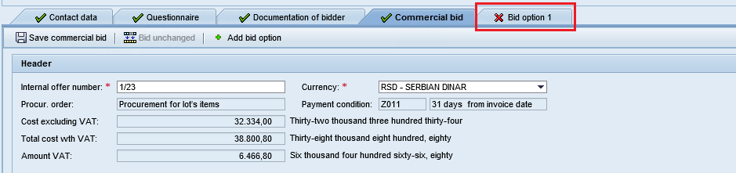

The information on the alternative offer is the same as for the main commercial offer, but also, specify the terms of the alternative offer validity.

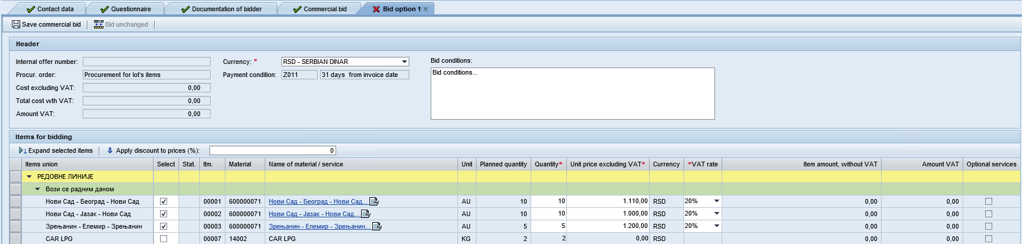

After entering all of the mandatory information for the alternative offer click on “Save the offer” button .

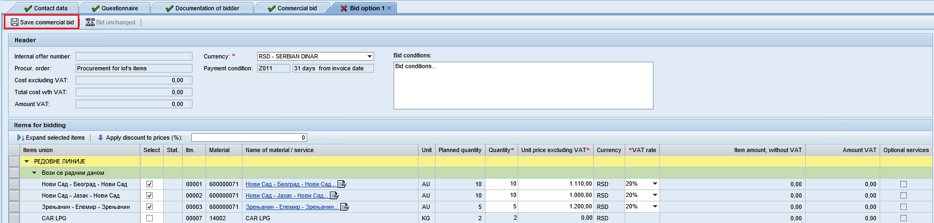

The information will be saved, the system will display the message .

To add another alternative offer, use  button once again.

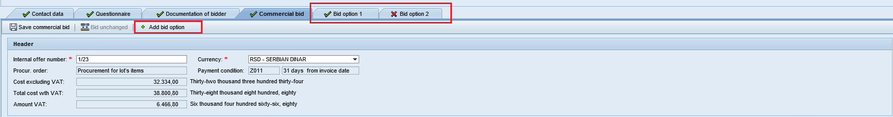

**Note:** the supplier can submit up to five alternative offers.

After saving, alternative commercial bid can be downloaded as a separate file and saved to desktop. For downloading the bid, click on the option "Print the bid" .

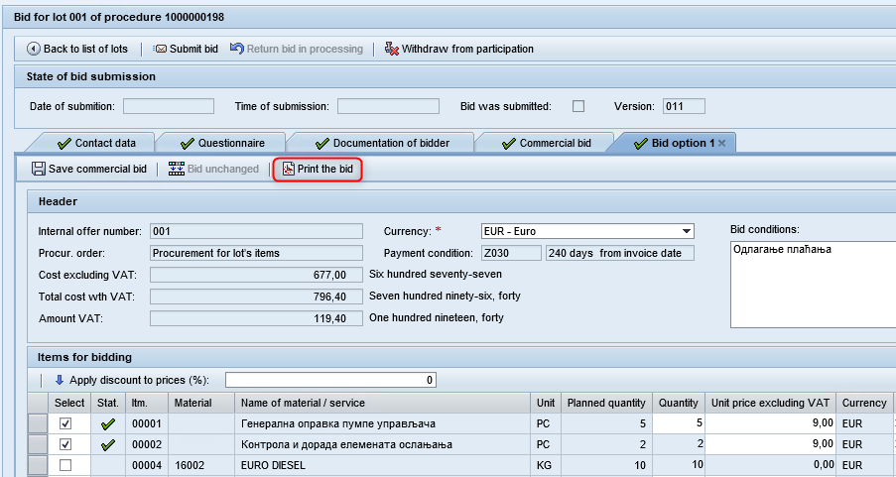

The system automatically generates a PDF file with data of alternative commercial bid.

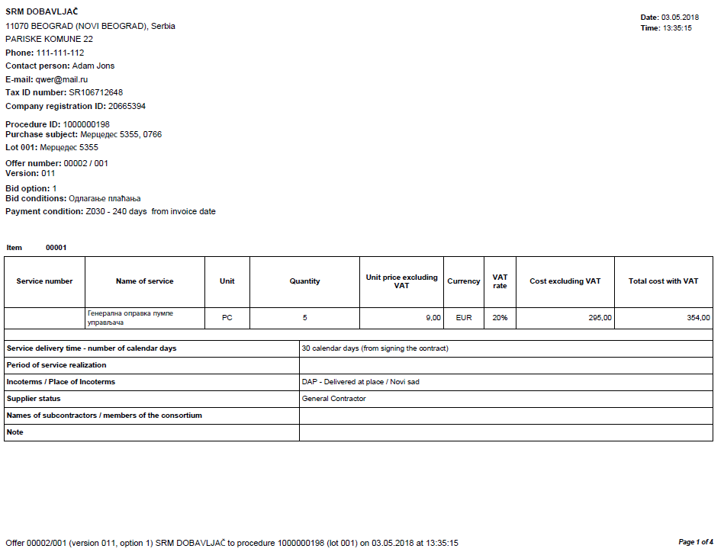

**Submittal of an offer**

An offer can be submitted only if all the blocks of the offer have been successfully processed (contact details, technical questionnaire, applicant's documentation, commercial proposal). In order to submit the proposal for consideration to the procedure organizer, click the "Submit Offer" button :

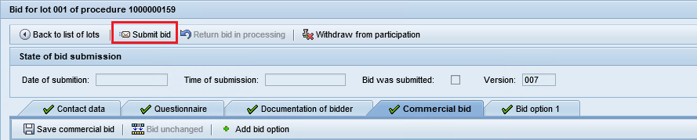

When you click the button, data entered in the attachment will be checked.

If some errors occurred in submission of the offer, they will be shown at the top of the screen:



Specify the required information, save the attachment and click .

If no errors occurred during submission of the offer, the offer will be submitted successfully. A message will appear showing the lot number and the total cost of the commercial offer, VAT not included:

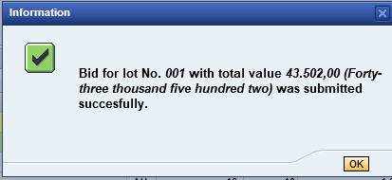

To close the dialog box, click . If the data was entered correctly and in full, a message will appear saying that the offer has been successfully submitted: .

After the offer has been submitted, it is available for viewing only. The last version of the submitted offer will be show at the top of the screen.:

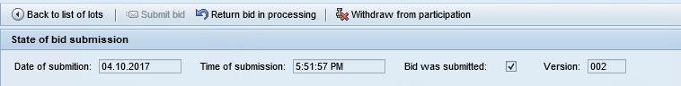

You can go back to lots of the procedure by clicking on .

**NOTE:** If procedure Organizer enabled the option, after offer submission, you will have info if offer by position at that moment is Leader compared to other offers .

If the offer is the leading one at the moment of submittal, the field ”Leader” will be marked with indicator . If the offer is not the leading one at the moment of submittal, the indicator will be like this: :

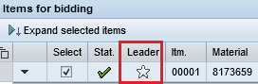

If the Organizer did not provide for such an option, after submitting the offer, information will not be available on whether the proposal for the item is currently the leader among the others or not.

# Submitting a cost offer for participation in commercial negotiations

The procedure for which the organizer initiated the commercial negotiations phase / second round of offer acceptance is indicated by a special indicator on the first screen of the workstation in the list of procedures:



The commercial negotiations stage is shown as a separate line in the list of lots:



The procedure for which the organizer has initiated the second round of receiving bids is marked with a special indicator on the first screen of a workstation in the list of procedures:

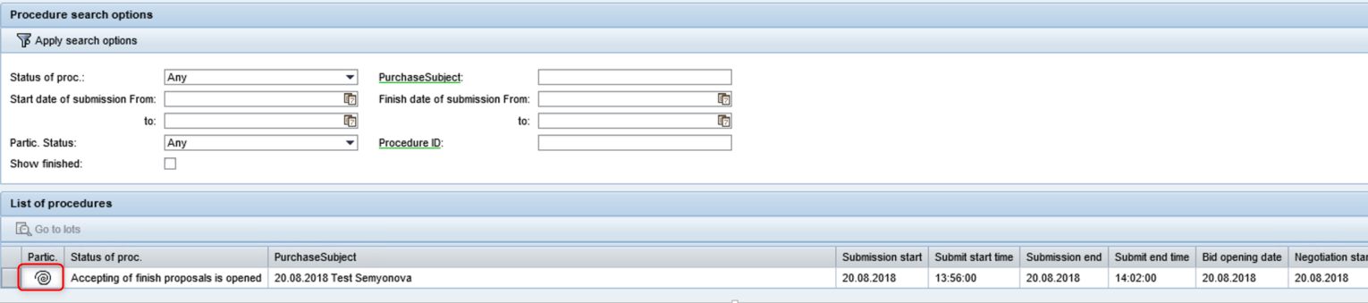

Second round is also highlighted as a separate line in the lot list:

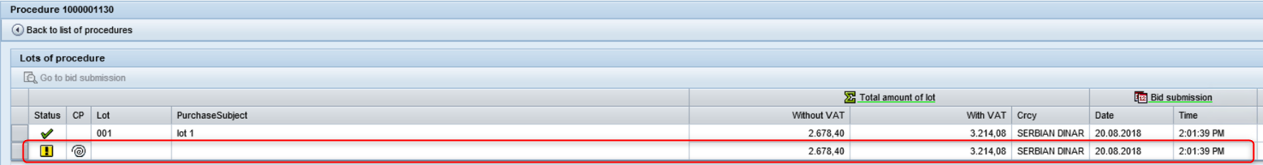

In case of extensions of deadlines for receipt of bids in the second round, suppliers will receive due notification. The text of the message to suppliers for the second round contains the names of appropriate responsible persons.

**Only bidders who passed the technical evaluation with a positive result can submit a new offer.**

The second round for the submission of bids is not visible on the portal to those suppliers that have not been accepted in the technical evaluation .

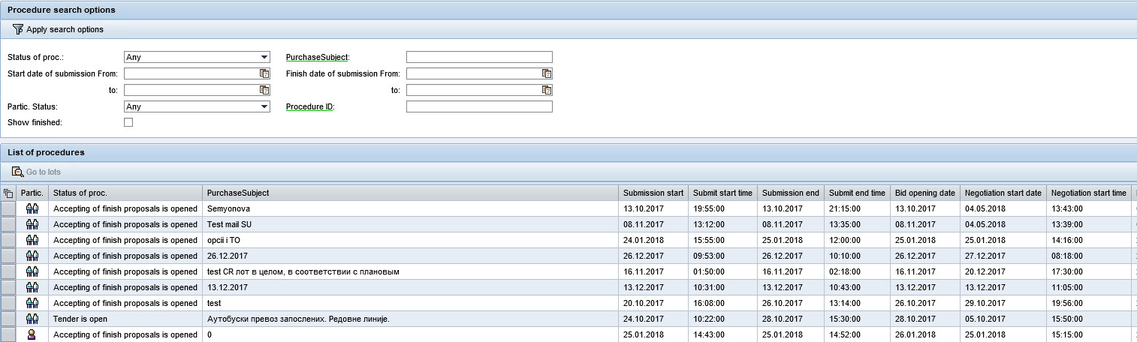

A new stage of the procedure is shown with indicator cid:image005.png@01D22EAC.339AC7C0 - “Editing the commercial offer is available”.



By default, for the current stage of commercial negotiations / the second round of offers admission the costs from the last version of the offer are displayed.

To submit a new cost offer, select in the list of lots the commercial offers stage and click :



During the commercial negotiations / the second round of offers admission you can create a new version of the commercial offer and submit a new version of the offer. To do this, bring back the offer to editing mode by clicking on :

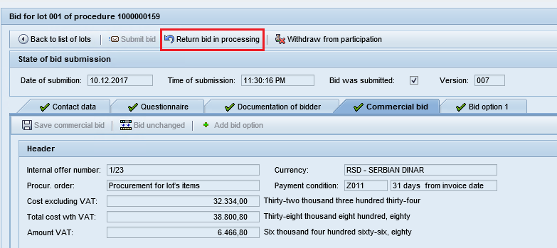

A new version of the offer will be created:

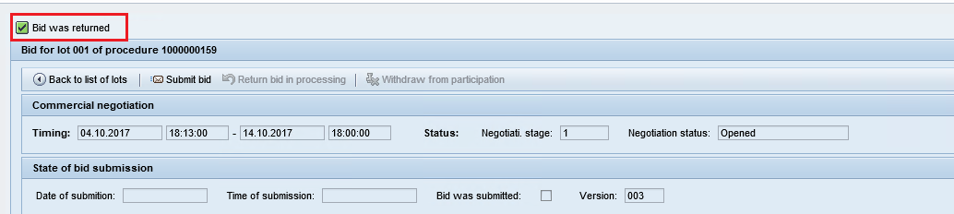

Timeframe for accepting new cost offers are displayed at the top of the screen.

The documentation for the commercial negotiations / the second round of offers admission is available (if the download is required for the current procedure), and the formation of a new commercial offer.

The “Commercial offer” tab displays the previous version of the offer. It is possible to specify new prices for a unit, prices for an optional quantity (if an option was provided for the current procedure), it is also possible to change the value of the service/material delivery date:

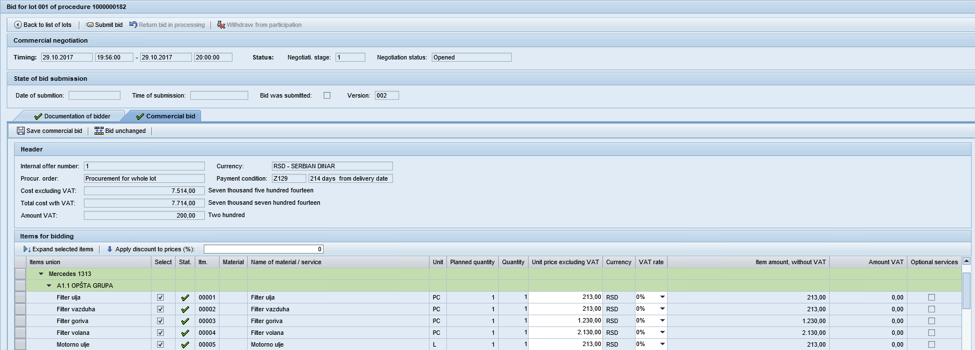

Depending on the participation terms defined by the referent for the lot, at the AO stage the field “Quantity” may be accessible for changing.

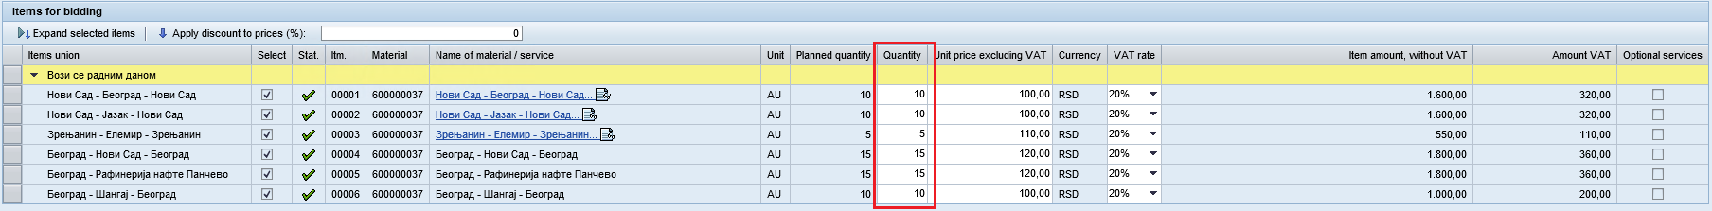

If the referent mentioned the possibility of any changes to the quantity at the stage of commercial negotiations, the supplier may put any value in the Quantity field.

If the referent mentioned the possibility of changing the quantity at the commercial negotiations stage in accorcance with the planned value, the supplier may only fill the Quantity field with a value that would be equal to the value in the field “Planned Quantity.” Otherwise, when submitting an application, a error message like this will appear.

If the referent mentioned that no changes to the quantity may be done at the commercial negotiations stage, the Quantity field will be unavailable for changing.

When you introduce an updated offer, you can use the option to specify discounts for the offer. To recalculate the cost of the offer, taking into account the discount, specify the required discount value and click on the button “Apply discount to prices”.

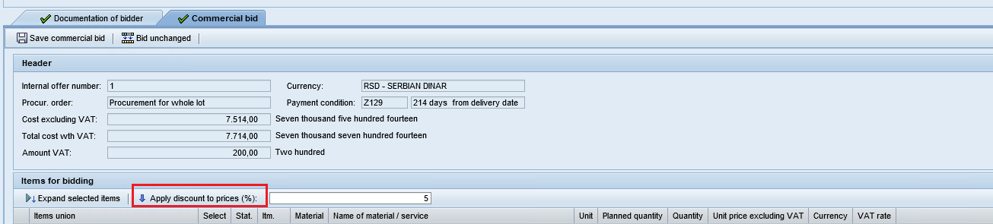

After you have specified new costs, save and submit the new version of the offer:

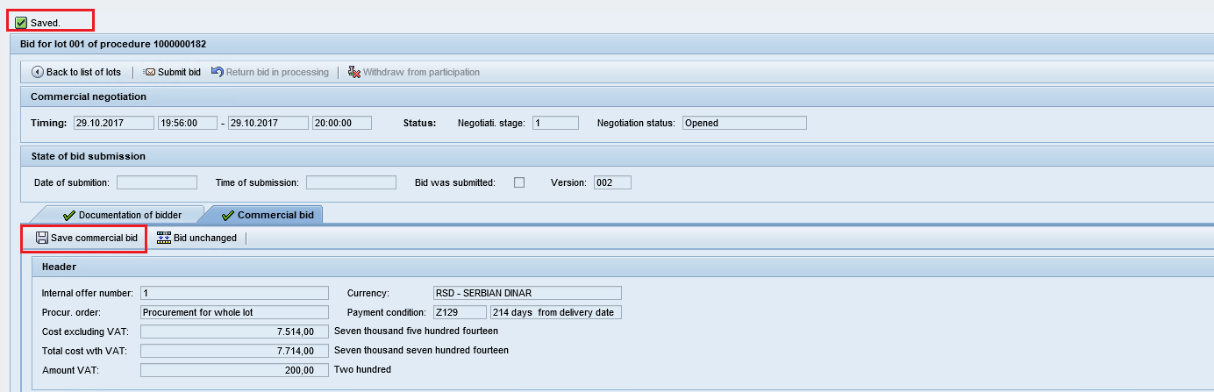

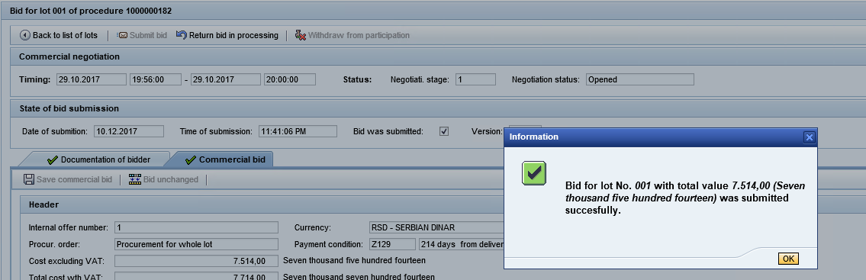

Until the date and time of offers admission closure comes, you are able to edit and resubmit your offer.

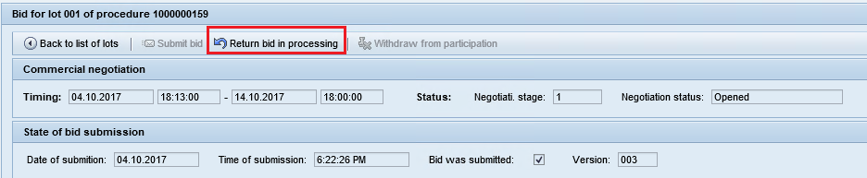

After the date and time of offers admission closure comes you will not be able to submit an offer.

After the new cost offer has been submitted, new costs are shown in the list of lots for the Commercial negotiations cost:

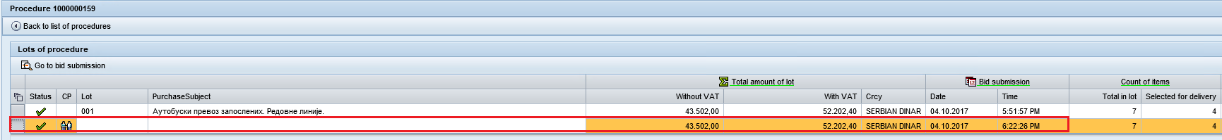

**Note:**

1. **A proposal can only be submitted for positions that have been positively evaluated technically. As to items for which the technical evaluation has not been completed, information from the offer of the previous stage of the procedure is available for viewing.**
2. **If the offer in the framework of commercial negotiations does not change, it is possible to copy the previous offer: click the “Offer does not change” button on the top toolbar. After clicking the button, the prices from the offer of the previous step of the procedure are automatically indicated.**
3. **The submission and return to editing of a new cost offer within the framework of commercial negotiations is available only within the time span specified by the organizer.**

# Offer return for editing, refusal from participation in service provider selection

## Offer return for processing

In order to return the offer to editing mode to make some changes, click on “Return for editing”:

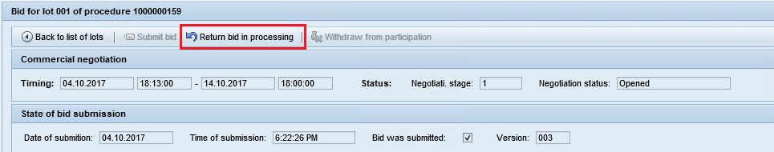

The offer will be back for editing, the version of the offer will have the next sequential number.

All information on the offer will become accessible for editing. The button “Submit proposal will become active again”.

Make the necessary edits to the offer and resubmit it by clicking on .

**Note:** the function of bringing the offer for editing is available only if the procedure in on the status “Admission of offers is open”.

## Refusal form participation

In order to refuse from participation in the procedure, click on  (“Refuse to participate”) button:

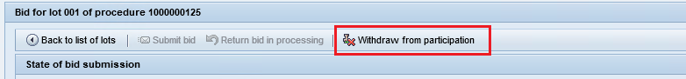

A window will open to confirm your refusal and to indicate the reason for that:

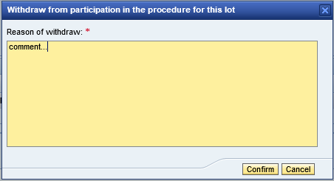

To cancel your refusal attempt and close the window, click on “Cancel” button .

To refuse from participation in the procedure, enter the text explaining the reason for refusal and click on “Confirm” button . Your refusal will be accepted, and a message will appear at the top of the screen .

**Note:** The function of refusal is available only if the procedure is on the status “Admission of offers is open”. If required, after you have confirmed refusal from participation you can return the offer to editing by clicking on . The function is available only while admission of offers for the current procedure is still active.