**Operating Procedure**

**OI.SRM.02-001. Procedure for the registration and submission of bids for Materials Vendor selection process**

Table of Contents

1. Purpose 3

2. Login to SAP Portal e-market place 4

2.1. Personal password activation at initial login to the e-market/changing password after 60 days 4

2.2. Recovering lost password 6

2.3. E-mail change request 8

2.4. Operations guide 10

3. Operating the SAP Portal e-market place 12

3.1. Viewing the list of MVS procedures 12

3.2. Viewing procedure details: List of lots and the package of Tendering Authotity’s documents 15

3.3. Preparing the bid: Specifying contact details 17

3.4. Preparing the bid: Filling in the Technological Profile 18

3.5. Preparing the bid: Uploading a package of documents 22

3.6. Preparing the bid: Formalizing the Commercial Bid 25

4. Submission of a new value bids for participation in commercial negotiations 35

5. Returning the bid to processing and withdrawing from the MVS procedure 42

5.1. Returning the bid to processing 42

5.2. Withdrawing from the procedure 42

# Purpose

This Instruction determines the sequence of actions by the bidders who interface with the NIS j.s.c. Novi Sad’s System for the registration and submission of bids for Materials Vendor selection processes and describes the sequence of user’s actions whenever performing the following activities:

* Logging in to NIS j.s.c. Novi Sad’s SAP Portal e-market place; registration and personal password;
* Viewing the list of Materials Vendor Selection (MVS) procedures;
* Downloading and viewing the documents attached to the MVS procedure;
* Viewing the list of lots for the procedure;
* Downloading and uploading, by Bidder, of procedure-related documents;
* Generating and submitting a bid;
* creating an alternative provider’s proposal;
* Returning the bid for re-processing and changing;
* Withdrawal from the MVS procedure.

# Login to SAP Portal e-market place

In case the registration is successful and personal login and password has been obtained, access to NIS j.s.c. Novi Sad e-market will be available at: [**https://srm.nis.rs/**](https://srm.nis.rs/)

## Personal password activation at initial login to the e-market/changing password after 60 days

To register at the e-market place, you will be provided an initial password that will only be valid for initial login before personal password is activated.

Click on <https://srm.nis.rs/>,enter User ID and initial password. Once the User ID and initial password is entered, click :

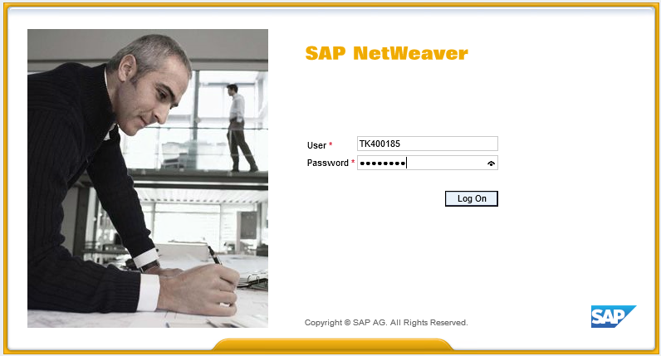

Then you will have to change the initial password for a **new personal password**:

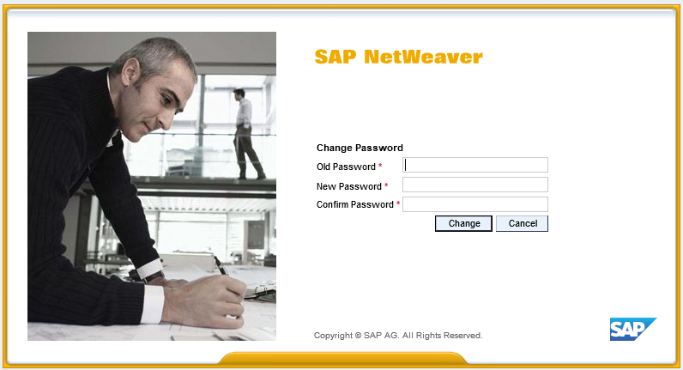

Changing the initial password for a personal one will only occur at the initial logon to SAP Portal:

* Use the “**Old password”**  field to enter your initial password that was sent to your e-mail.
* Use the “**New password”**  field to enter your new personal password. **Make your personal password on your own; you will use that password to work with SAP Portal.**

Following rules apply for entering a new password:

a) Minimum 8 characters in length

b) Must include at least one number (0 to 9)

c) Must include at least four letters

d) Must not contain reserved words such as the name of the company "NIS" and the programme "SAP".

We recommend you not to use simple passwords (date of birth, combinaton of following signs, like "123","765","qwе").

After successfully entering the new password, use it in your future work. The initial password is used only for the first log-in.

* Use “**Confirm password”**  field to re-enter your new personal password.
* Click “**Change**” . If all the fields are correctly completed, your new personal passport will be activated. Thereafter, you will always enter your new personal password to log in to SAP Portal.

If incorrect data were entered, you will see the message: :

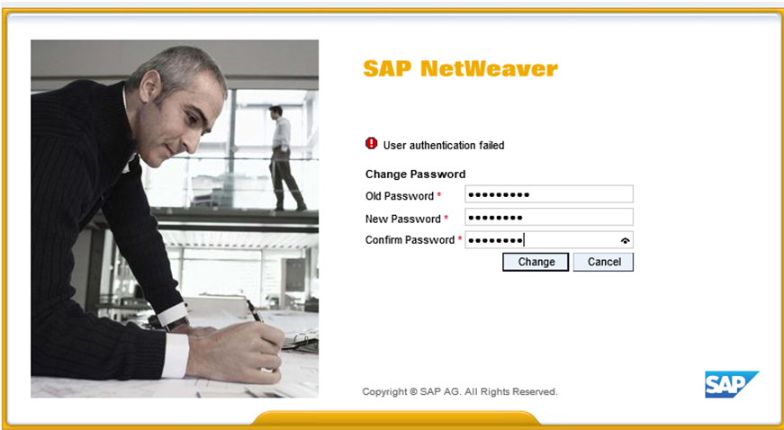

**In order to prevent abuse:**

**1. The initial password is valid for 10 days. In case you do not change the password in this period and enter a individual (if you have not entered SAP Portal ever) your password will be canceled and access will be automatically blocked.**

**2. The individual password is valid for 60 days. Upon expiration of this period, when applying to the SAP Portal, the system requires the change of the expired password into a new valid one. The procedure for changing the expired password into a new valid is the same as when changing the initial into a new one.**

**3. To avoid abuse, please do not write down your password and control the transfer of password to your employees.**

**4. If any of your employees left the company, we recommend changing the password.**

**5. We also recommend changing the password in any other occasion when you think it is needed.**

## Recovering lost password

If you happen to lose or forget your password, use the recovery password feature.

To send a request for recovering your password, click the  on the log-in page.

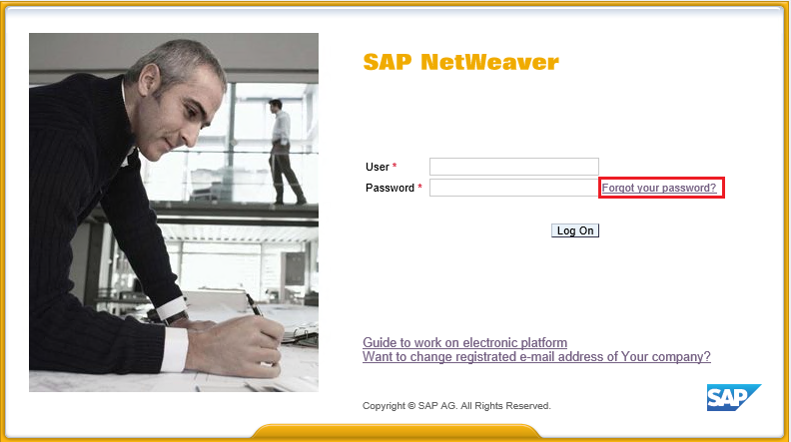

It will open a window with a form which you will have to fill to have your password recovered.

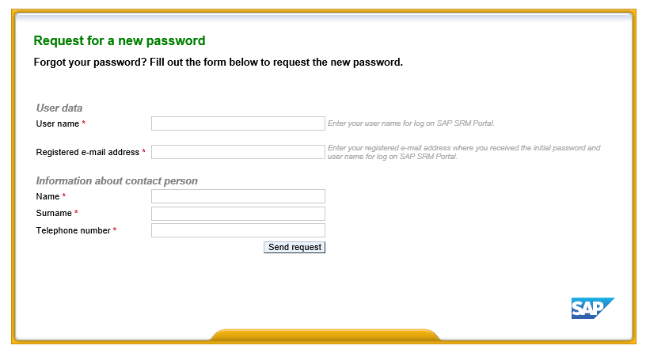

Fill out the user data and contact details.

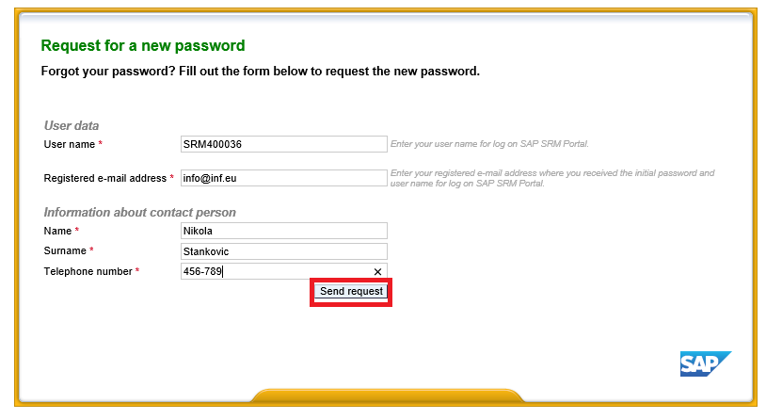

Mandatory fields are marked with this symbol .

Once you are done filling out mandatory fields, press . It will send your request for recovering your password.

After that, you will receive the initial password that needs to be changed to the individual as follows:

* Use the “**Old password”**  field to enter your initial password that was sent to your e-mail.
* Use the “**New password”**  field to enter your new personal password.
* Use “**Confirm password”**  field to re-enter your new personal password.

For new password cannot be entered one of the previous three used passwords (the system remembers the previous three used passwords and does not allow them to be reuse).

## E-mail change request

If your company has changed its e-mails, you can use the portal to request respective changes for your email address.

To send a request for changing your e-mail address, click on this link on the log-in page.

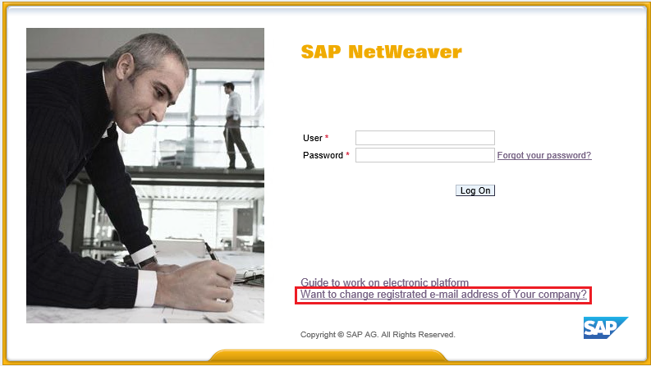

It will open a window with a form for changing your e-mail address.

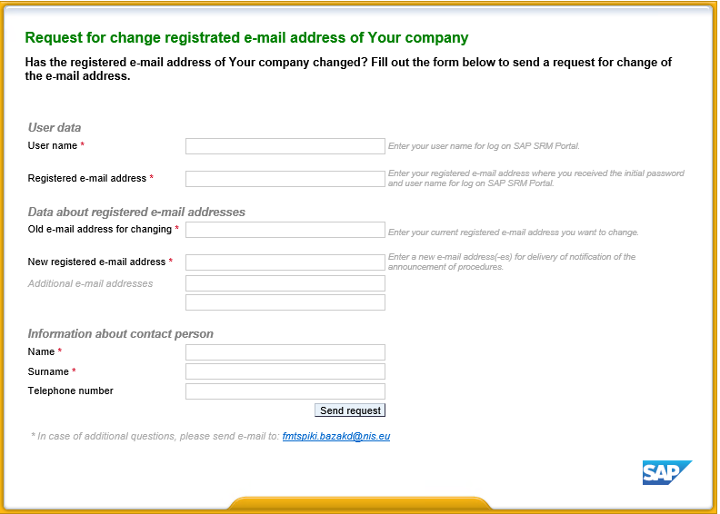

Fill out your data, the company’s new registered e-mail address and your contact information.

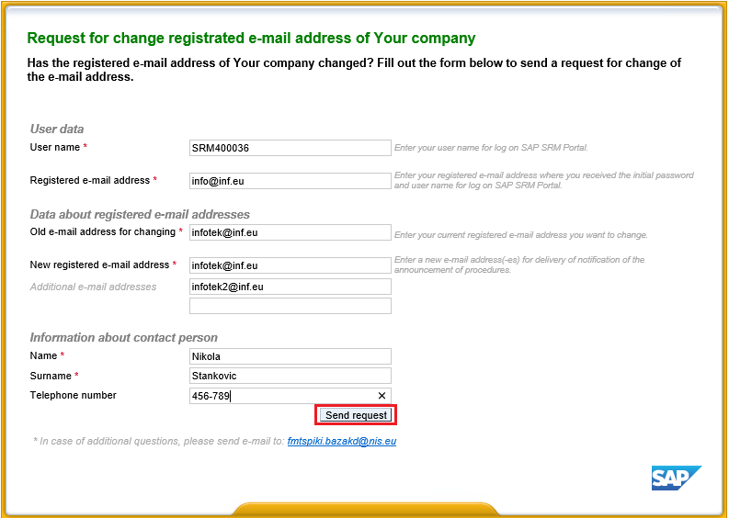

Once you fill out the mandatory fields, press . A request for a change of your e-mail address will be sent.

Note: if you have any questions, feel free to use the help feature by mailing at [fmtspiki.bazakd@nis.eu](mailto:fmtspiki.bazakd@nis.eu).

## Operations guide

There is a link on the portal that you can click to access the instructions on how to handle the requests for participation in bids for the supply of materiel and services. To access the instructions, click here.

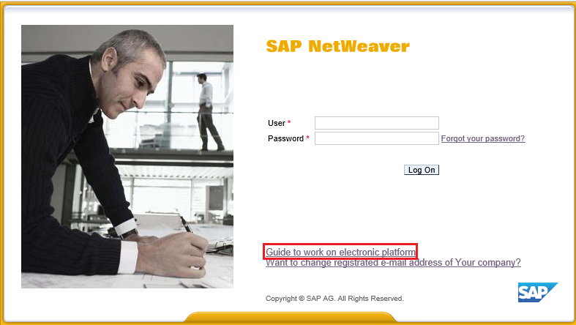

This link will take you to a page where you will have a chance to read or download instructions for suppliers in Serbian, English, and Russian.

# Operating the SAP Portal e-market place

## Viewing the list of MVS procedures

Having successfully logged on to SAP Portal system, the user gets access to personal workbench to participate in the Materials Vendor and Services selection procedures:

To view the list of procedures for selecting a material vendor, go to tab «Procedure for supply of materials.».

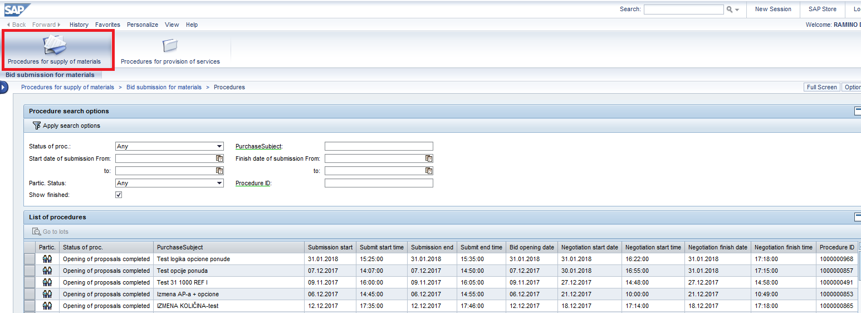

The upper part of the screen contains the list of filters for various attributes of the procedures (e.g., status of the procedure, timelines, procured items etc.):

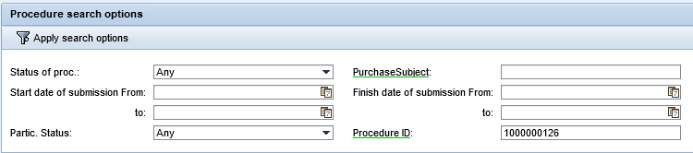

By default, the list will show active procedures: announced procerdures and procedures for which receipt of initial proposals or updated commercial proposals is underway.



To view completed procedures of material vendor selection put a tick in front of  indicator. The list of procedures which are no longer receiving proposals will be displayed.



Enter the value in relevant field and click  to use the filters.

Mind the value specified in the “Participation status” field:

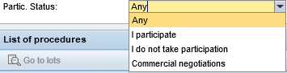

* Select the status “All” and click  to select all the procedures.
* Select “I participate” status and click  to select the procedures in which you have participated.

The procedures in which you have participated will be shown in the list of procedures marked with the symbol .

Procedures in the implementation of which you take / took part and with regard to which the commercial negotiations are conducted, are displayed in the list of procedures with a symbol .

See the table below for the description of additional filters based on various attributes of the procedures:

| **Field name** | **Description** |
| --- | --- |
| Status | Status of the procedure at various stages of implementation.    Documentation may be viewed and downloaded on the “Invited” status. The bid may be submitted on the “Acceptance of bids” status. In case of another status, the procedure and bid-related information is available only for viewing. |
| Procured item | Enter the procurement item. Mask search is available, the keyword fragment may be entered between two asterisks “*”, for example: |
| Bid opening date: from … till | Bid opening date. The field is completed by choosing a date from calendar. Click  to open the calendar:    A range of dates may be specified: |
| Bid closing date: from … till | Bid closing date. The field is completed by choosing a date from calendar. Click  to open the calendar:    A range of dates may be specified: |
| Bidding status | Bidder’s status:    Available values:   * **All** – View all the procedures available to the Bidder; * **I participate** – View the procedures, for which the Bidder has already submitted a bid.   (i.e., where a bid has been logged for current procedure ID and Contractor’s current code).   * **I do not take participation** – View the procedures in which the Bidder doesn’t participate   (e.g., no bid has been logged for current procedure ID and Contractor’s current code).   * **Commercial negotiations** – View the procedures, in which the Bidder participates and for which a new stage (i.e., commercial negotiations) has been initiated. |
| ID procedures | Enter system name of the procedure to search.    Mask search of a number is available, e.g., procedures ending with “66” will be listed if the following value is entered: |

**Note:** The following actions should be performed to generate a bid for the selected procedure:

* Download and view a package of documents attached to the MVS procedure, view the list of lots to the procedure and select relevant lot (See Clause 4.2).
* Enter contact details of the person responsible for submitting the bid (See Clause 4.3).
* Fill in the Bidder’s participation form (See Clause 4.4).
* Upload the package of documents to the procedure to the Portal (See Clause 4.5).
* Prepare and submit a Commercial Bid for the procedure (See Clause 4.6).

## Viewing procedure details: List of lots and the package of Tendering Authotity’s documents

Having applied additional filters for procedure attributes as necessary, find relevant procedure in the list of procedures and highlight the line containing the procedure entry, and then click «Go to lots» to view information concerning the selection procedure.



A screen will pop up to contain details of the selected procedure.

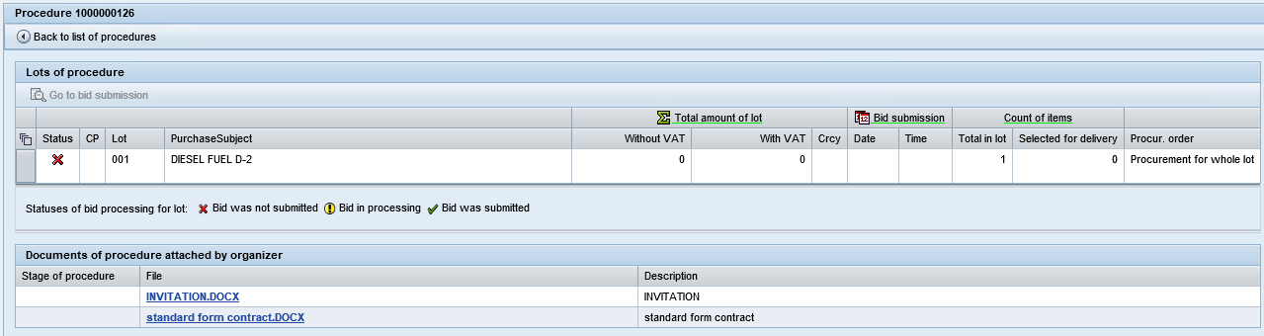

* + 1. **List of lots**

The upper part of the screen will show the list of lots and related information; the lower section of the screen will list the Tendering Authority’s documents related to the selected procedure.

The screen represents the following characteristics for the lot:

| **Column name** | **Description** |
| --- | --- |
| Status | Values available for the field:  - No bid has been generated for the lot;  - The bid is being processed;  - The bid for the lot has been submitted. |
| CN | This status indicates that the Tendering Authority has initiated competitive negotiations for the lot. |
| Lot | Specifies the lot number |
| Procured item | Description of the item to be procured |
| Total lot price | Total price under the lot, inclusive and exclusive of VAT.  Price details in the field will be shown only once the commercial bid has been generated / saved for the lot. |
| Bidding date | Date on which the bid for participation was submitted.  Price details in the field will be shown only once the commercial bid has been generated / saved for the lot |
| Bidding time | Time at which the bid for participation was submitted.  Price details in the field will be shown only once the Commercial Bid has been generated / saved for the lot |
| Total items in the lot | Displays the total number of items for the selected lot |
| Number of items: selected for delivery | Displays the number of items in the lot that have been selected by Bidder for delivery (i.e., those marked with active “Check” mark). Details in this field will be displayed only once the commercial bid has been submitted for the lot. |
| Procurement procedure | Procurement procedure is specified: for the lot in general / per item |

* + 1. **Package of Tendering Authority’s documents for the procedure**

The list of Tendering Authority’s documents for the procedure is displayed at the bottom of the screen:

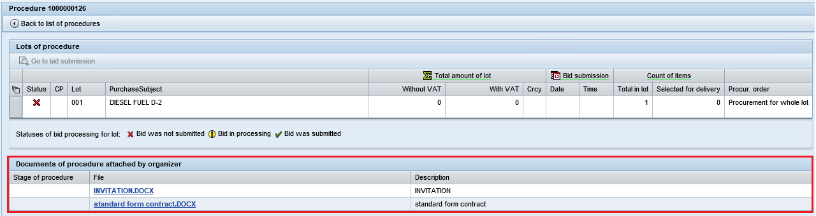

Click on the filename  to download the document.

File download window will pop up. Click “Save” to download the document or “Open” to preview.

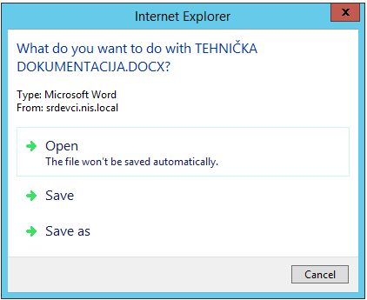

## Preparing the bid: Specifying contact details

Highlight the line containing relevant lot entry and click  to proceed to generating the bid, as well as to view the bid.

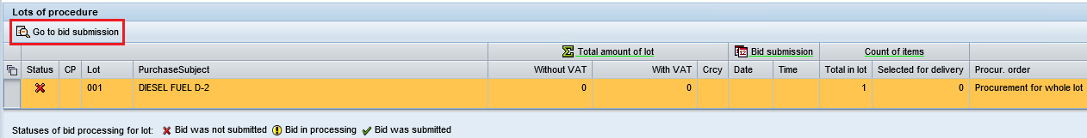

The popup screen containing a bid for the selected lot includes four tabs:

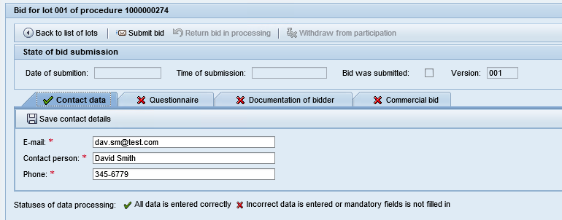

The tab will be automatically populated with the contact details of the supplier specified in the previous procedure in which it participated. Information is available for modification.

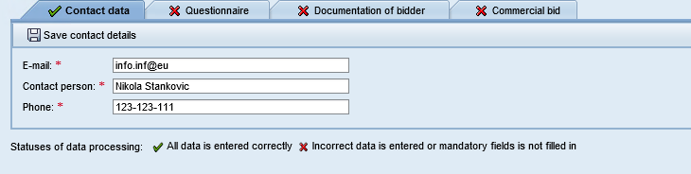

If the contact details have not been determined automatically or need to be modified, after you fill-in the tab fields, save the entered information by clicking the button .

In the window that opens, select the option to save contact information.

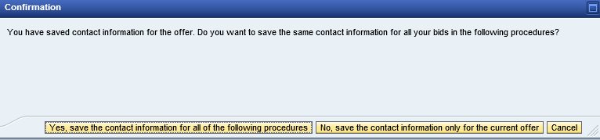

If you click on  button, the contact details that you specified will show by default in all procedures you are going to participate in future.

If you click on  button, the contact details that you specified will be saved for the current procedure only, and will not show by default in other procedures you are going to participate in future.

Information will be saved, the system will display a message .

After the information is successfully saved the tab indicator will change for .

If not all fields of the tab are filled-in, the indictor will stay . If you try to submit an offer, the system will indicate the errors.

## Preparing the bid: Filling in the Technological Profile

Go to the **“Technological profile”** tab to fill in the profile. Technological criteria will be displayed for the lot and the following information will be available:

* Description of the criterion:

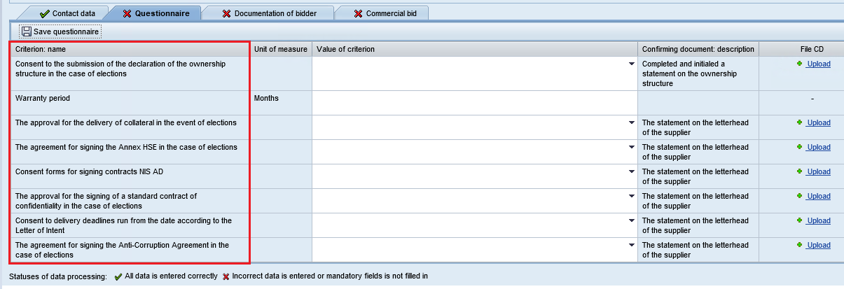

* Unit of measurement:

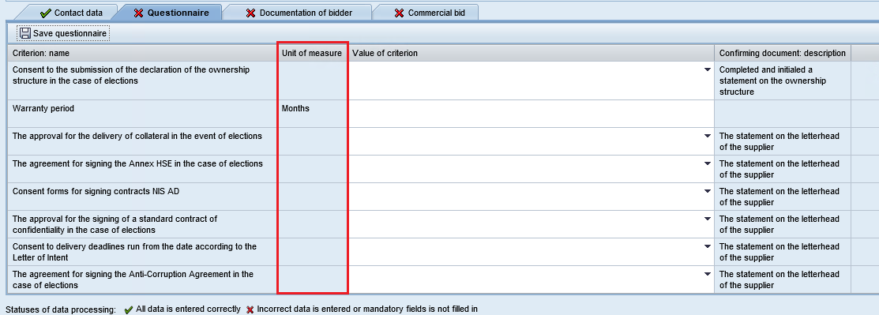

* Confirming document:

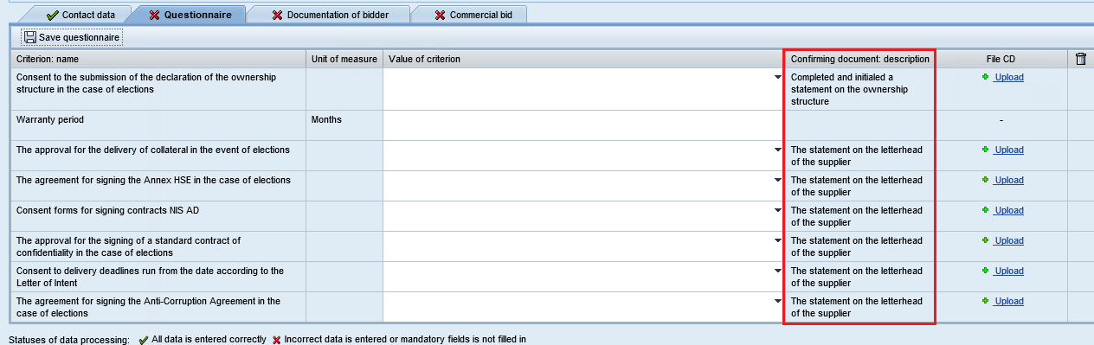

For each criterion in the “Value of criterion” field, you should enter the value as per the unit of measurement attributed to that criterion or select an option from the drop-down list recommended by the Tendering Authority.

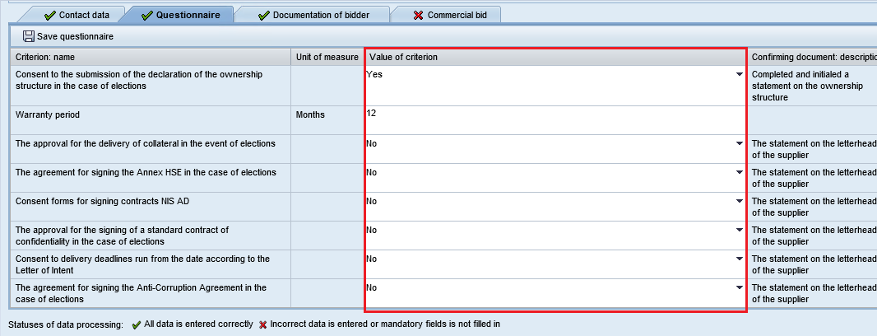

**How to fill in the criteria for the profile:**

* A criterion value should be entered as per relevant unit of measurement.
* “.” (a dot) will be used as a separator for fractional values.
* If you see a  (drop-down element) in the “Criterion value” field, that means that you may only opt from the dropdown list of values.
* Note: It is not mandatory to attach a supporting document.
* To attach a document click on  button to upload a file.

Click “Upload” to upload a supporting document:

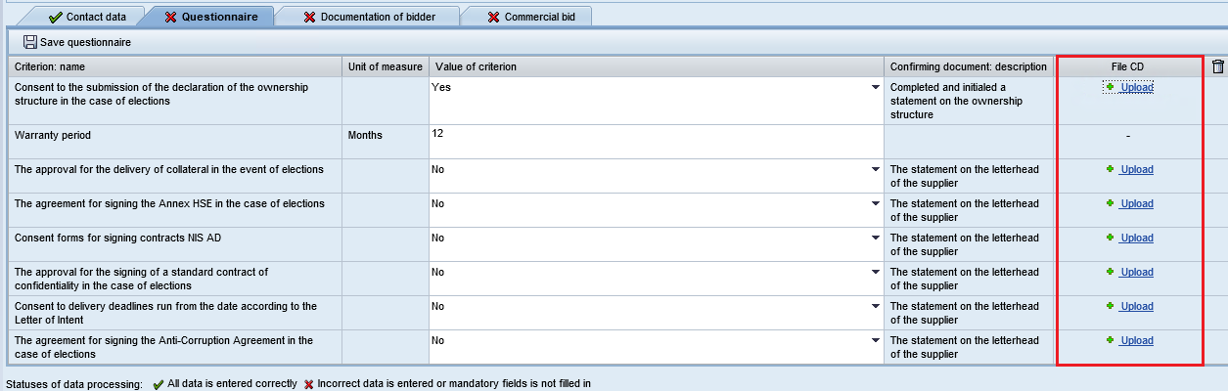

**Please note: the maximum size of uploaded file - 20 MB.**

An upload window will pop up. Click “Browse” to upload:

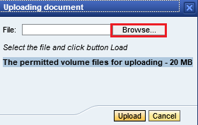

Browse your PC to choose a file to upload and click “Open” to confirm your choice.

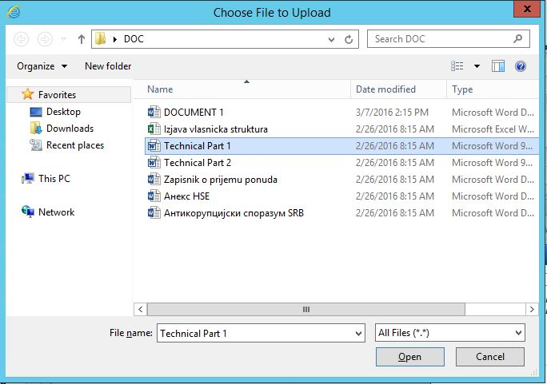

Click “Upload”:

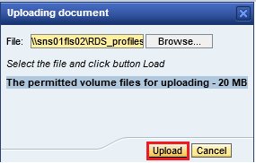

Click “Cancel” to cancel uploading and close the window:

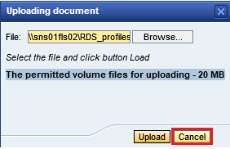

Click  to delete the file uploaded by mistake and upload again.

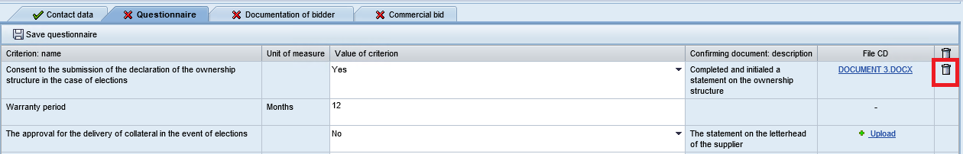

You can also attach supporting documents to the questionnaire criteria by uploading the documentation from your Personal Office.

To do so, click the button . Suppose there are attached files for a particular type of supporting document in the Personal Office and they are valid as of the opening date, such documentation is automatically attached to the questionnaire criteria with the attribute . If the document is not suitable in terms of validity (its validity period expires before the date of proposal opening for the procedure), the indicator . Clicking on the indicator will open a message like: .

Once all the answers have been entered in the profile, click  to save the information you have entered.

If all the information has been entered correctly, the information will be saved and the system will return the message .

If answers to all the criteria are given, and if all supporting documents are attached, the tab will change indicator to :

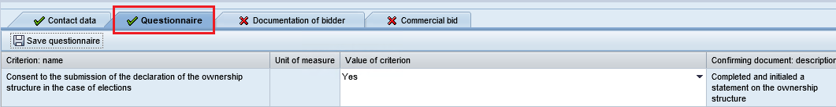

Unless all the answers are given and unless all supporting documents are attached, the tab indicator will remain  after saving. In the event of attempted bid submission, the system will display an error in filling in of the data.

## Preparing the bid: Uploading a package of documents

Go to **“Documentation of bidder”** tab to attach a package of documents.

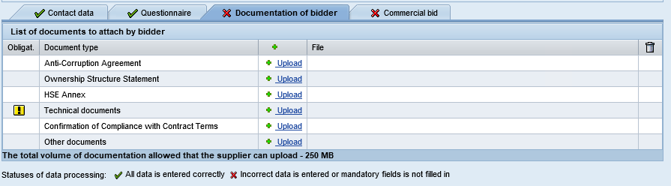

The tab represents the list of required documents and allows them to be uploaded. The  indicator means, that uploading that type of attachment is mandatory.

**Please note: the maximum size of uploaded file - 20 MB, the maximum size of the entire package of documents uploaded - 250 MB.**

Choose the required type of attachment and click “Upload” . An upload window will open. An upload window will pop up. Click “Browse” to upload:



Browse your PC to choose a file to upload and click “Open” to confirm your choice.



Click “Upload”:



Click “Cancel” to cancel uploading and close the window:



The document will be uploaded:

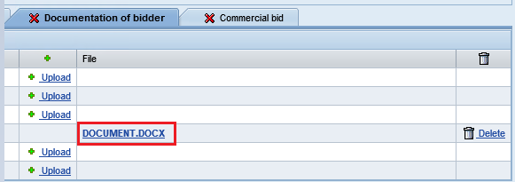

Click  to delete the uploaded attachment:

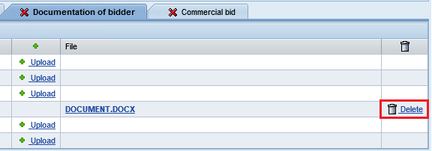

You can also attach supporting documents to the questionnaire criteria by uploading the documentation from your Personal Office.

To do so, click the button . Suppose there are attached files for a particular type of supporting document in the Personal Office and they are valid as of the opening date, such documentation is automatically attached to the questionnaire criteria with the attribute . If the document is not suitable in terms of validity (its validity period expires before the date of proposal opening for the procedure), the indicator . Clicking on the indicator will open a message like: .

As soon as all of the mandatory documents marked  are uploaded, the “Bidder’s documentation” tab will be deemed completed, tab indicator will change to: 

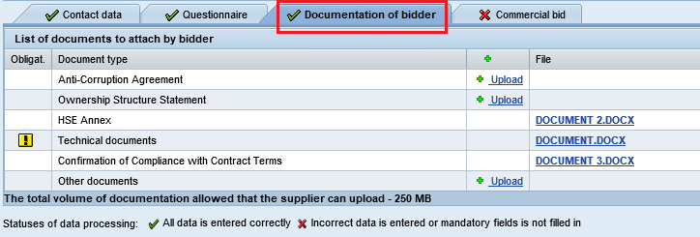

## Preparing the bid: Formalizing the Commercial Bid

Go to the **Commercial bid** tab to generate the commercial bid.

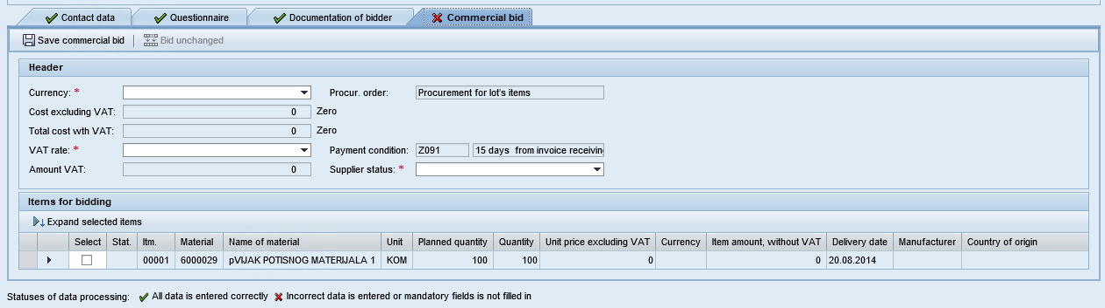

Mandatory fields are marked .

Use the upper part of the screen to fill in general information about the bid:

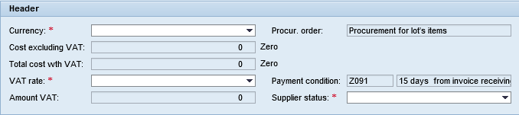

1. Use drop-down menu to choose the bid currency.

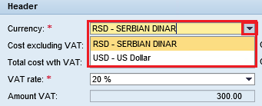

1. Specify VAT rate – choose a value from the drop-down list:

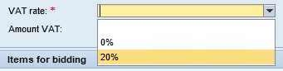

1. Specify the Supplier status - choose from the drop-down menu:

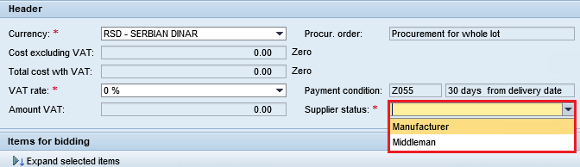

1. Payment terms may be changed as necessary provided that such option has been envisaged by the Tendering Authority. Use a guide to choose a new value for the payment term: .

Details of the bid items should be entered in the lower part of the screen:



The following mandatory data has to be entered in the header of an item:

* Unit price exclusive of VAT.
* Manufacturer of the requested material.
* Minimum delivery period (days).
* Document, from the date of signing/submission of which the count of calendar days for delivery will start .
* Manufacturer
* Country of origin

Mass Data Entry:

After selecting one or several lot positions in the "Commercial Bid" tab, clicking on the "Mass Entry" button  will open a window with a list of fields available for mass entry:

1. Manufacturer (text field, to be filled in manually)
2. Country of origin (the field is filled in from the standard SAP ERP codebook)
3. Minimum number of calendar days of delivery (numeric field, to be filled in manually)
4. Calculating the delivery time from (to be filled in from the predefined list of options).

The "Mass Entry" button  will become active when at least one lot position is selected:

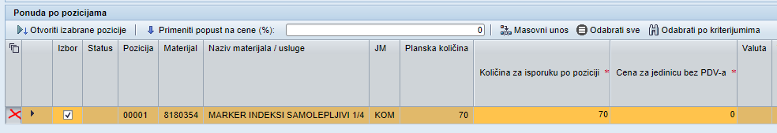

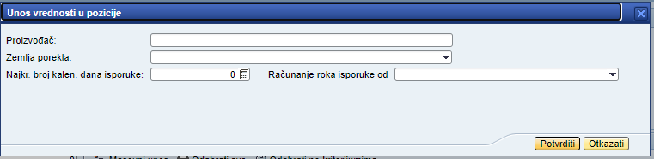

After clicking the "Confirm" button, the entered field values will be filled in at the selected positions.

One or more fields can be filled in on the screen. If only one of the fields is filled in on the screen, then the previously entered values for the other fields in all rows will remain unchanged. If a value is already specified in any row, it will be replaced with a new value.

For procedures that are at the stage of commercial negotiations, the "Mass Entry" button will be available for:

* Number of calendar days of delivery
* Countdown of delivery time from.

The fields "Manufacturer" and "Country of origin" will not be available, as they cannot be changed at the stage of commercial negotiations.

Having completed the header of an item, proceed to entering the item details. Click on  to open details of the item. Click on  to open all of the selected items. Below is the description of lot item fields (informative/mandatory):

| **Field name** | **Description** | |
| --- | --- | --- |
| **Item header** | | |
| Selection | If the Tendering Authority envisages procurement under the lot in general, then no selection of individual items of the lot will be available (the “Selection”field will be unavailable for change and all of the lot positions will be chosen). The bid will be submitted for all of the lot items.  Should the Tendering Authority envisage procurement by items, then individual items of the lot will be available for selection for submitting the bid. Place a check mark  in the “Selection” field for that purpose.  Fields of elected items will be available for editing. | |
| Status | Displays the verification results for selected items completion status, only selected items are checked (items with active indicator  in the field “Selection”):  selected item is left blank or is filled in incorrectly.  selected item is filled correctly. | |
| Item | Indicates the item number | |
| Material | Indicates the code of the material | |
| Name of the material | Indicates the name of the material | |
| Unit of measurement | Indicates the unit of measurement for the specified material | |
| Planned amount | Indicates the planned amount of the current item | |
| Amount per items | In case of itemized procurement of the lot, an amount may be entered that may differ from the pre-set amount.  Where the lot is to be procured as a whole, the field will not be available for completion and its default value will equal the planned amount. | |
| Unit price exclusive of VAT | Unit price of the material has to be specified | |
| Currency | Indicates the currency chosen to submit the bid | |
| Item price exclusive of VAT | Item price less VAT will be calculated automatically when data is saved; the calculation will be based on the price and quality of the material. | |
| Required delivery date | The scheduled value of the required delivery date is displayed. The field is inaccessible for editing | |
| The minimum number of calendar days for delivery | You have to specify the number of calendar days which will be counted from the moment the selected document is signed. The number of calendar days is not specified if you selected the document “According to Technical Assigment”. | |
| Calculating delivery time of | You have to specify the number of calendar days which will be counted from the moment the selected document is signed. Selection from pre-defined list of documents |  |
| Deadline for signing a document | Is computed automatically using the formula: «Zahtevani datum isporuke» - «Najkraći broj kalendarskih dana za isporuku». The field is inaccessible for editing | |
|  |  | |
| Manufacturer | Manufacturer of the material shall be specified | |
| Country of origin | Country of origin of the material should be selected by selecting a value from the directory:  Select the value in the directory or search by entering the value in the first line and by clicking :    Double-click on the found value to select it:    The selected value will appear in the field: | |
| **Delivery** | | |
| Planned date of delivery | Indicates the planned date of delivery | |
| Place of delivery | Indicates the place of delivery | |
| Incoterms | The default value will be the Incoterms value specified by the Tendering Authority. The field will be available for changing; Make use of the guide to specify another value.  Once the code is selected from the guide, the Incoterms details will be specified automatically. The specified value may be corrected. | |
| **Price** | | |
| Currency | Indicates the currency chosen for the bid to be submitted. | |
| VAT amount | Indicates VAT amount for the selected item | |
| Item price inclusive of VAT | Indicates price inclusive of VAT for the selected item | |
| **Further details** | | |
| Analog material | An option to enter the name of the analog material if such option has been envisaged by the Tendering Authority | |
| Vendor’s status | Indicates the vendor’s status | |
| Tariff number | An option to enter the tariff number | |
| **Option**  *\*Block is displayed if the optional quantity is envisaged by the Organizer* | | |
| Option  (plan) | The field contains planned optional quantity for the items determined by the Organizer of procedure. | |
| Option | The field contains the optional (additional) quantity for delivery.  The default value of the optional quantity is equal to the planned optional quantity, but it is possible to change the value by entering the required quantity.  Value 0 can be entered. | |
| Unit price excluding VAT | Unit price for the optional quantity should be entered.  If the optional quantity is entered (value other than zero), the unit price of the option must always be specified. | |
| Price exclusive of VAT | After saving the field displays the automatically calculated price of the optional quantity exclusive of VAT | |
| The amount of VAT | After saving, the field displays automatically calculated amount of VAT for the option | |
| Price inclusive of VAT | After saving the field displays automatically calculated price for the optional quantity inclusive of VAT | |
| Note | If required, additional note, in the form of text, can be entered for the bid per items in the field “Note” | |

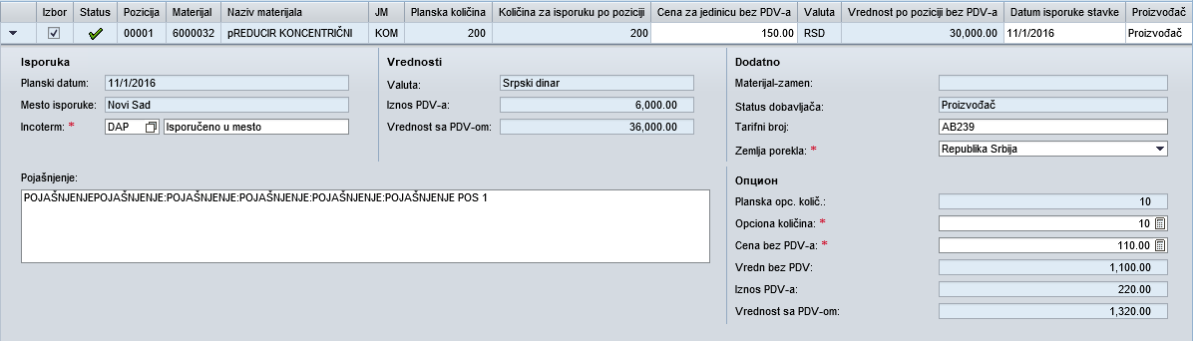

Once you have entered all the mandatory information, click the “Save Commercial Bid” button: . The data will be saved and the system will return the message: .

If the selected items are filled correctly after saving they will have status 

After saving, the fields in the header section of the bid will be filled automatically and the entered data will be checked:

* Total price of the bid exclusive of VAT (numerical value and amount in words).
* Total price of the bid inclusive of VAT (numerical value and amount in words).
* Total amount of VAT.

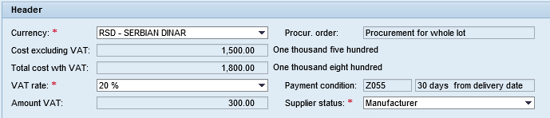

If the bid is filled in correctly and the information is entered in full, the tab will have status  after saving.

**Creating an alternative proposal**

If the Procedure administrator has given the provider a possibility to submit alternative proposals, the “Commercial Proposal” tab will have avalable the following button: .

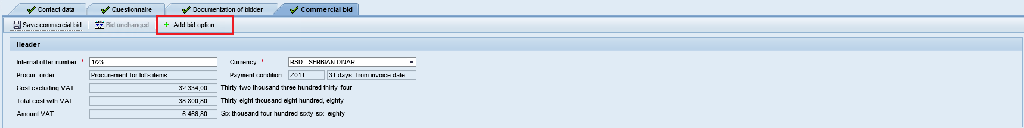

To create an alternative poposal, click on . A new tab “Price option” will appear.

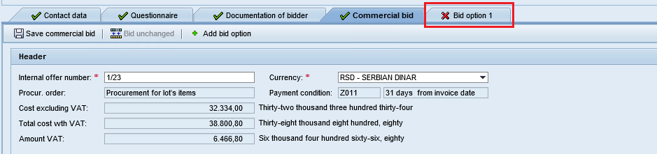

Information pertaining to the alternative proposal is entered the same way as for the main commercial proposal, and in addition you specify the terms of the alternative proposal.

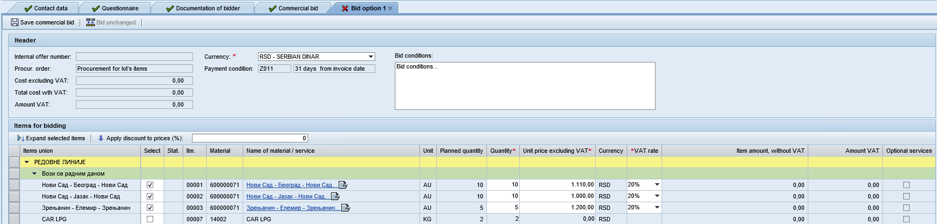

After you have entered all mandatory information for the alternative proposal, click on button “Save Commercial Proposal” .

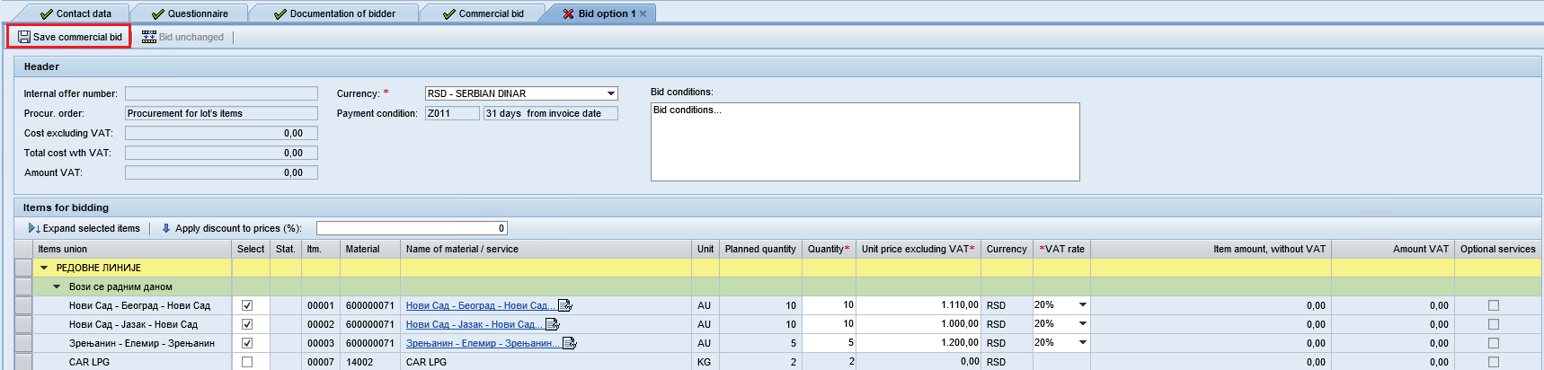

The information will be saved, a message  will appear.

To add another alternative proposal, on “Commercial Proposal” tab click on  once again.

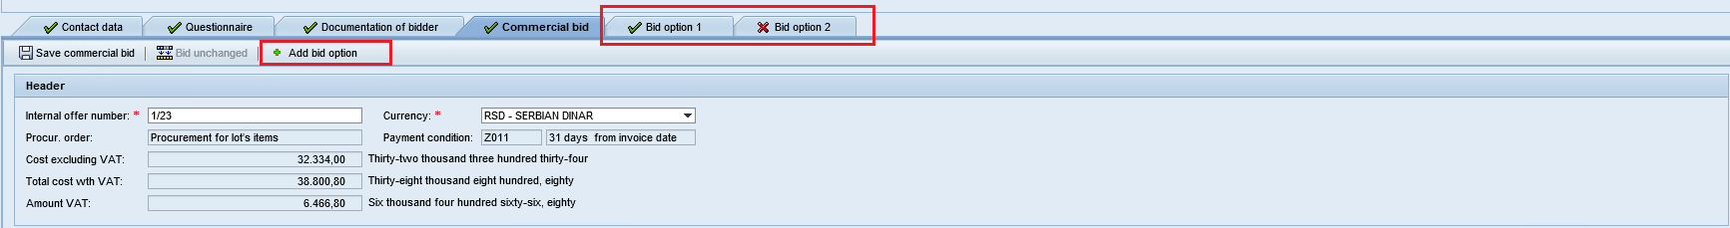

**Note:** provider is allowed to submit several alternative proposals.

To delete an alternative proposal, point the mouse at the top right corner of the alternative proposal tab and click on  that will appear. In the dialog box to open select «Da». The alternative proposal will be deleted.

**Submitting the bid**

A bid may only be submitted if all the blocks of the bid (i.e., Contact Details, Technological Profile, Bidder’s Documentation and Commercial Bid) have been processed.

Click “Submit the Bid”  to submit the bid to the Tendering Authority:

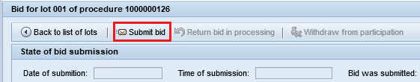

On clicking the button, the data entries will be checked.

If errors occur during bid submission, they will be displayed at the top of screen:

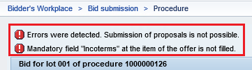

Enter the required information, save the bid and click .

If no errors occur during bid submission, the bid will be successfully submitted. The message will appear that the bid has been successfully submitted and the number of lot and total value of the bid exclusive of VAT will appear.

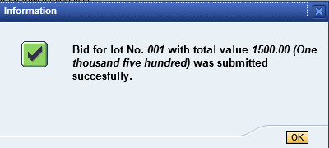

To close an info window, click .

If the data are entered correctly and in full, a system message will appear indicating that the bid has been successfully submitted: 

Once submitted, the bid will be available for viewing only. The upper part of the screen will display information about the submission of the recent version of the bid:

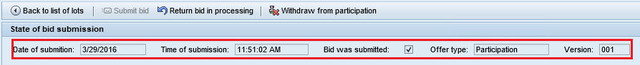

You may click  to return to the list of the lots related to the procedure.

**Note:** After bid submission, information will be available on whether the bid concerned is currently ranked as the leading bid, if such an option has been envisaged by the Organizer of procedure.

If the bid is ranked as the leading bid at the moment of its submission, the indicator  will be displayed in the field “Leader”. If the bid is not ranked as the leading bid at the moment of its submission, the indicator  will be displayed in the field “Leader”.

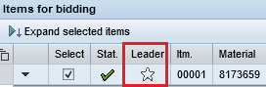

If the Organizer has not envisaged such an option, after bid submission no information will be available on whether the bid is currently ranked as the best compared to others.

# Submission of a new value bids for participation in commercial negotiations

The procedure for which the Organizer has initiated the stage of commercial negotiations has a special indicator on the initial screen of a work place in the list of procedures. 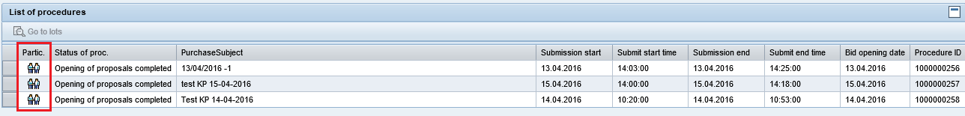

The stage of commercial negotiations is also highlighted as a separate line in the list of lots.

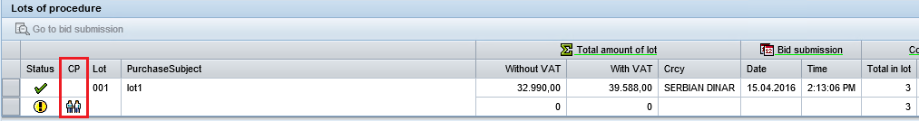

The procedure for which the organiser has initiated the second round of proposal submission is marked with a special indicator on the first screen of the workplace in the list of procedures:

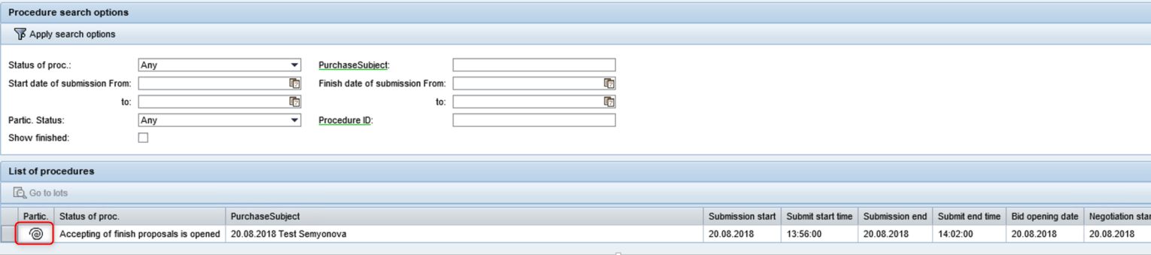

The second round of proposal submission is also highlighted as a separate line in the list of lots:

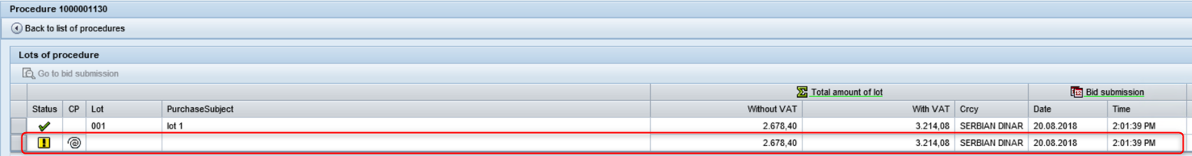

In case of an extension of the deadline for submission of proposals in the second round, suppliers will be notified accordingly. The relevant business area responsible persons are indicated in the text of the notice to suppliers for the second round

Submitting a new offer is only possible for suppliers who have received a positive technical evaluation

The portal does not display the second round of the proposal submission for a bidders whose technical evaluation was negative:

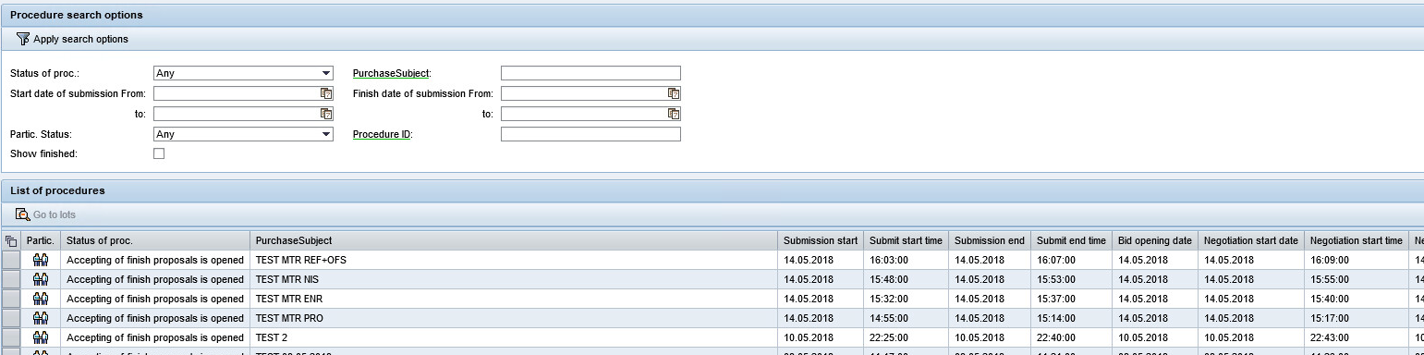

New stage of procedure is indicated with cid:image005.png@01D22EAC.339AC7C0 - “Change of commercial bid is available”



By default, prices from the most recent bid version submitted by the bidder appear for the current stage of commercial negotiations (CN). The supplier selects the stage of commercial negotiations and moves on to bid submission.

To submit a new price bid, select the stage of commercial negotiations in the list of lots and click “Go to bid submission” :

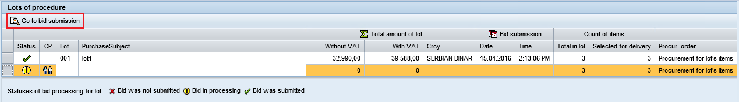

Suppler can make a new version of commercial bid during the stage of commercial negotiations and can submit a new bid version. To do so, the supplier withdraws the bid and returns it to processing by clicking 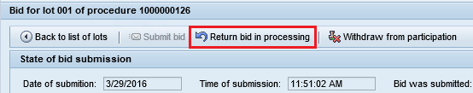



New bid version is created

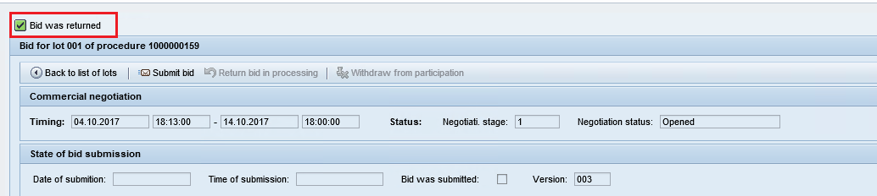

Deadline for receipt of new price bids is displayed at the top of the screen.

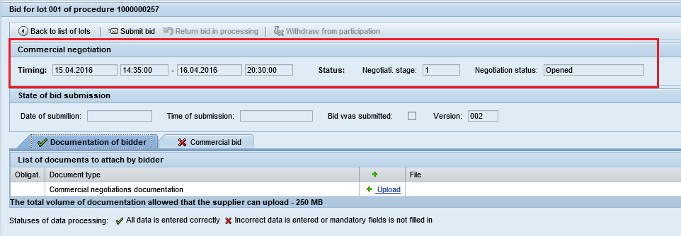

**Please note: submission and return to processing of a new price bid within the scope of commercial negotiations is only available within the deadline specified by the Organizer.**

Uploading of documentation for a stage of commercial negotiations is available (if such uploads are provided for the current procedure), as well as the creation of a new commercial bid.

Information for a stage of commercial negotiations can be indicated in two tabs: “Documentation of bidder” and “Commercial bid”.

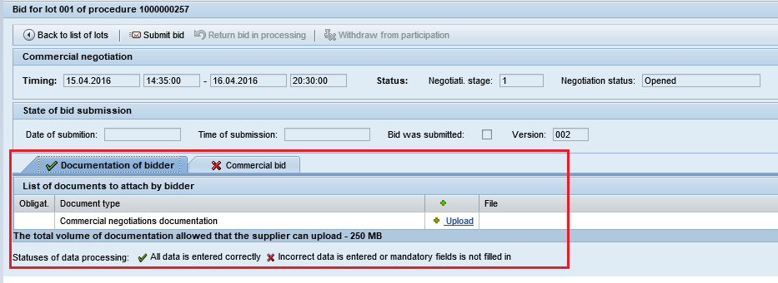

Uploading of the documentation of the bidder is carried out similarly to the first stage of procedure (Uploading of documentation is described in more detail in section 4.5. of this Instruction)

Previous bid version appears in the tab “Commercial bid”. The supplier can indicate new unit prices, prices for optional quantity (if such an option is envisaged by the Organizer for the current procedure), the change of “Incoterms” field and payment conditions is also available (if the amendments to the terms of payment has been envisaged by the Organizer of procedure):

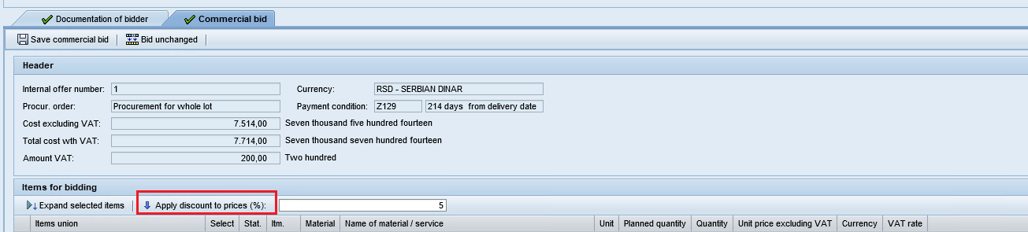

Depending on the terms of participation specified by the Administrator for the Lot of the Procedure, “Quantity” may be available for editing during Commeprcial Proposal phase.



If the Administrator has specified that any change of Quantity is allowed during Commercial Negotiations phase, the provider may specify any value in “Quantity” field.

If the Administrator has specified that during Commercial Negotiations phase the Quantity can be set according to the planned value only, the provider can specify in “Quantity” field only the same value as in “Planned quantity” field. Otherwise en error message will appear when the proposal is submitted 

If the Administrator has specified that during Commercial Negotiation phase it is impossible to change Quantity, “Quantity” field will be inaccessible for editing.

When adding an updated quotation, you can use an option to specify a discount for the quotation. To recalculate the price of the offer with the discount, specify the required discount value and click on the ‘Apply discount to prices’ button.

After entering new prices the supplier will save the new bid version and will then submit the bid:

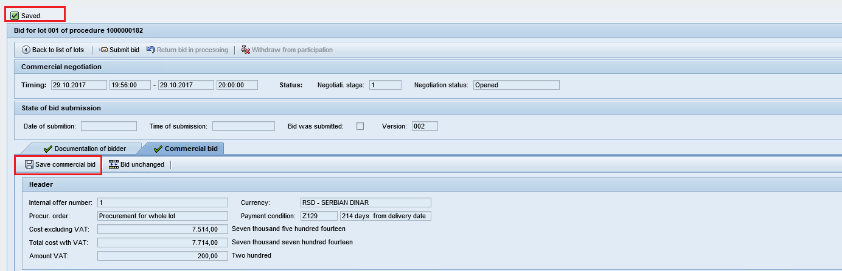

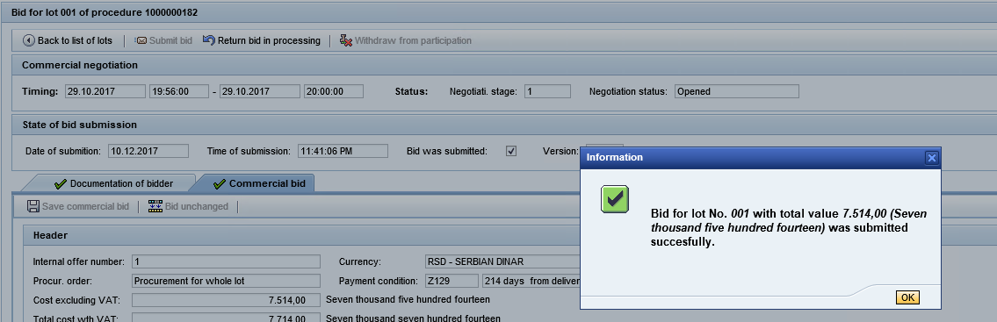

The supplier can return the bid to processing and amend the bid by entering new prices before the deadline for receipt of new bids.

After expiration of the deadline for receipt of new commercial bids, the supplier cannot submit its bid.

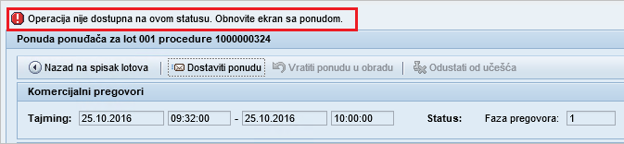

If the Organizer of procedure has envisaged the extension of the deadline for receipt of new commercial bids, the system automatically sends a notification to those suppliers who have already received positive technical evaluation and who are permitted to participate in this stage of commercial negotiations.

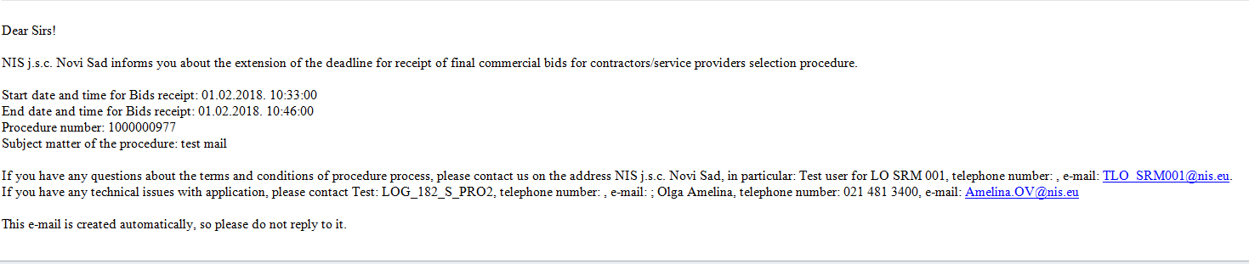

Each supplier receives a separate notification. The notification is sent to all addresses listed by suppliers in the list of qualified suppliers. The copy of the letter also contains the e-mail address of a contact person specified by the supplier during bid submission.

After the submission of a new bid with prices, such new prices are fixed on the supplier’s desktop in the list of lots for the stage of commercial negotiations.

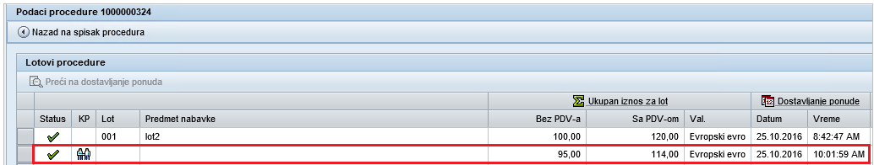

Note: Suppliers who have not received positive technical evaluation are not eligible to submit updated commercial bids. In those suppliers, desk top displays the data only according to the old bid version, and such suppliers are not allowed to move on to the stage of commercial negotiations.

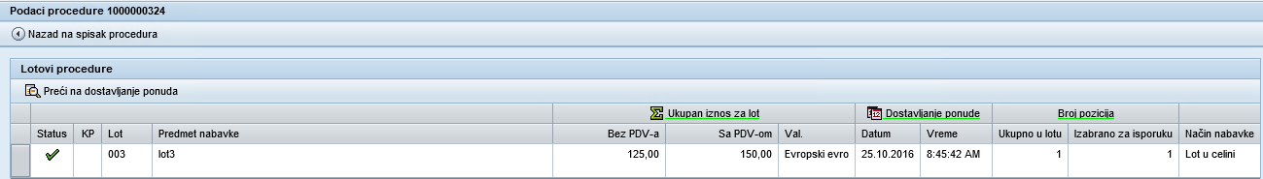

Old bid can only be provided for inspection:

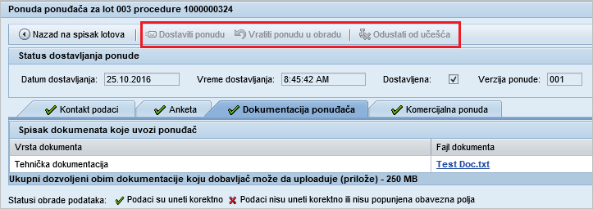

**Please note: submission of bids is only available for the positions which have received positive technical evaluation. For positions which have not passed the technical evaluation, only information from the bid related to the previous stage of the procedure is available for inspection.**

* cid:image003.png@01D1B69B.E6398350In the case that bid after commercial negotiations not be changed, it is possible to copy a previous bid: click the button on the top panel. After clicking the icon, the value of the bids of the previous phase procedure will be automatically shown. In order to send the bid click on button

# Returning the bid to processing and withdrawing from the MVS procedure

## Returning the bid to processing

Click  to return the bid and change it:



The bid will return to processing and the bid version will be attributed the next index number: .

All the information referring to the bid will become available for correction. The button  will become active again.

Make the necessary changes in the bid and re-submit the bid by clicking the  button.

**Note:** The function “Return bid in processing” is only available at the “Tender is open” status of the selection procedure.

## Withdrawing from the procedure

Click the “Withdraw from the procedure”  button to withdraw from the procedure:

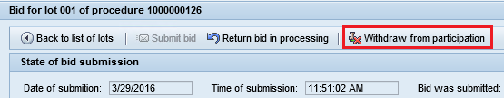

A window will pop up for you to confirm your withdrawal and specify causes:

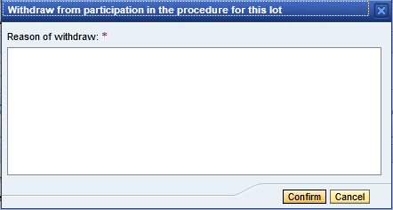

To interrupt the refusal of participation and close the window, press the button .

To refuse to take part in the procedure, type the text of the reasons for refusal and confirm the refusal by the answer . Will be made a refusal to participate, an information message will be displayed at the top of the screen 

**Note:** The withdrawal function is only available at the “Tender is open” status of the selection procedure. If necessary, after refusal of participation the bid can be returned in process by clicking **.** This function is available while receiving bids is opened to the current procedure.